**PRACTICAL FILE**

**ANALYSIS AND DESIGN OF ALGORITHM LAB**

**(CS 401)**

**BE CSE 4TH SEM**

**(GROUP-4)**



**University Institute of Engineering and Technology (UIET), Panjab University, Chandigarh, India- 160014**

**Under the guidance of Submitted By**

Prof. Ajay Mittal Sir Ojas Arora

Department of Computer Science and Engineering Roll No: UE223073

**INDEX**

|  |  |  |  |  |  |  |  |  |
| --- | --- | --- | --- | --- | --- | --- | --- | --- |
| **SNO.** | | | **DATE** | **TITLE** | **PAGE NO.** | **REMARKS** | | |
| 1. | | | 22ndJanuary,2024 | Analysis of Linear Search Algorithm Graph. | 4-5 |  | | |
| 2. | | | 29thJanuary,2024 | Analysis of Binary Search Algorithm Graph. | 6-8 |  | | |
| 3. | | | 29thJanuary,2024 | Comparison of Linear Search and Binary Search Algorithms Graph on a Single Graph. | 9-11 |  | | |
| 4. | | | 12th February,2024 | Analysis of N-ary Search Algorithm Graph. | 12-14 |  | | |
| 5. | | | 12th February,2024 | Runtime Analysis of Finding Maximum and Minimum Elements in an Array and plot them in the single graph. | 15-18 |  | | |
| 6. | | | 19th February,2024 | Analysis of runtime performance of Merge Sort. | 19-22 |  | | |
| 7. | | | 19th February,2024 | Runtime Analysis of Quick Sort Algorithm. | 23-26 |  | | |
| 8. | | | 19th February,2024 | Runtime Analysis of Randomized Quick Sort Algorithm. | 27-30 |  | | |
| 9. | | | 19th February,2024 | Runtime Analysis of Simple and Strassen's Matrix Multiplication Algorithm. | 31-34 |  | | |
| 10. | | | 4th March,2024 | Analysis of Greedy Knapsack Algorithm. | 35-38 |  | | |
| 11. | | | 4th March,2024 | Analysis of Prim’s Algorithm. | 39-43 | | |  |
| 12. | | 4th March,2024 | | Analysis of Kruskal’s Algorithm | 44-49 | | |  |
| 13. | | 11th March,2024 | | Analysis of Activity Selection Algorithm. | 50-55 | | |  |
| 14. | | 11th March,2024 | | Analysis of Dijkstra’s Algorithm. | 56-62 | | |  |
| 15. | | 18th March,2024 | | Analysis of All pairs shortest path (Floyd-Warshall) Algorithm. | 63-69 | | |  |
| 16. | | 18th March,2024 | | Analysis of Multi Stage Graph Algorithm. | 70-76 | | |  |
| 17. | 1st April,2024 | | | Analysis of Assembly Line Scheduling Algorithm | 77-83 | |  | |
| 18. | 1st April,2024 | | | Analysis of Matrix Chain Multiplication Algorithm | 84-90 | |  | |
| 19. | 1st April,2024 | | | Analysis of Longest Common Subsequence Algorithm | 91-97 | |  | |
| 20. | 1st April,2024 | | | Analysis of 0/1 Knapsack Algorithm | 98-106 | |  | |
| 21. | 15th April,2024 | | | Analysis of N-Queen Problem | 107-113 | |  | |
| 22. | 22nd April,2024 | | | Analysis of Graph Coloring Problem | 114-122 | |  | |
| 23. | 22nd April,2024 | | | Analysis of Sum of Subsets Problem | 123-131 | |  | |

**Experiment 1**

**Title :-** Analysis of Linear Search Algorithm Graph

**Aim :-** The main aim of this work is to conduct a thorough analysis of the linear search algorithm, exploring its efficiency and complexities in various scenarios and draw graph.

**Description :-** Linear search is a simple algorithm used to find the position of a target value within a list or array by iterating through each element until a match is found. The graph of Linear Search Analysis is used to analyze the performance of Linear Search Algorithm under different input sizes.

**Code of Linear Search Analysis (in Python) :-**

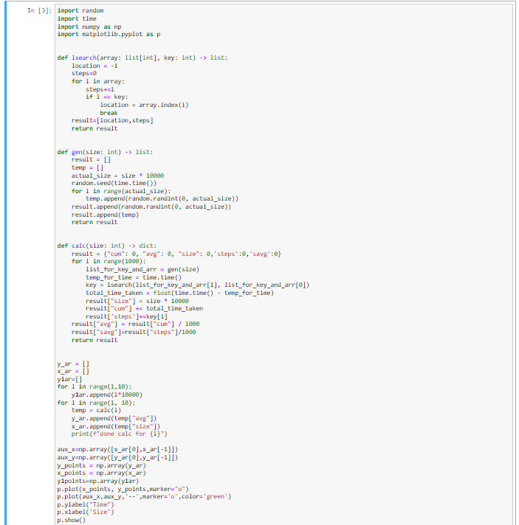

**Output:-**

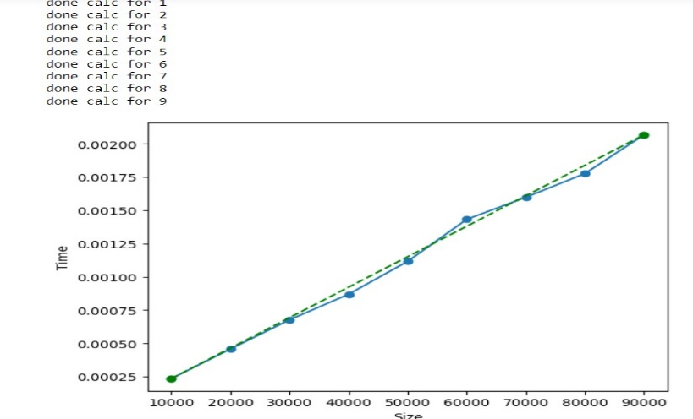**Graph**

* This graph is plotted using matplotlib.pyplot to find the relationship between input size and average time taken.
* The x-axis represents the input size (multiplied by 10,000), and the y-axis represents the average time taken for 1,000 iterations.
* A dashed line is plotted to connect the first and last data points for visual reference.
* The array used in the following python code is generated in the ‘gen’ function,and this array is used for testing the linear search algorithm in the ‘calc’ function.
* The ‘gen’ function generates an array of random integers.
* The key value used in this linear search analysis code is the first element of the generated array i.e (list_for_key_and_arr[0]).
* This value is obtained from the result of the ‘gen’ function and is accessed using list_for_key_and_arr[0]. The key value is then passed to the lsearch function as an argument.
* The index where the key is found is obtained from the result of the lsearch function. Specifically, it is extracted from the first element of the key list returned by the lsearch function (key[0]).
* The key[0] value represents the index where the key is found in the array.
* The total number of comparisons made during each linear search analysis is tracked using the variable ‘steps’.
* This variable is incremented for each iteration of the linear search loop, and the total number of comparisons for 1,000 iterations is stored in the result['steps'] entry.

**Conclusion:-** The analysis of the linear search algorithm graph demonstrates that the algorithm exhibits a linear relationship between time complexity and input size. As the size of the input data increases, the time required for the linear search also increases proportionally. This aligns with the expected time complexity of O(n) for a linear search.

**Experiment 2**

**Title :-** Analysis of Binary Search Algorithm Graph

**Aim :-** The aim of creating a binary search analysis algorithm graph is to understand and visualize the performance characteristics of the binary search algorithm under varying input conditions.

**Description:-** Binary Search analysis graph typically aims to explore and understand the performance characteristics of the binary search algorithm. The analysis involves varying the array size, measuring the algorithm's behavior, and creating a graphical representation to illustrate key aspects of Binary Search.

**Code of Binary Search Analysis (in Python) :-**

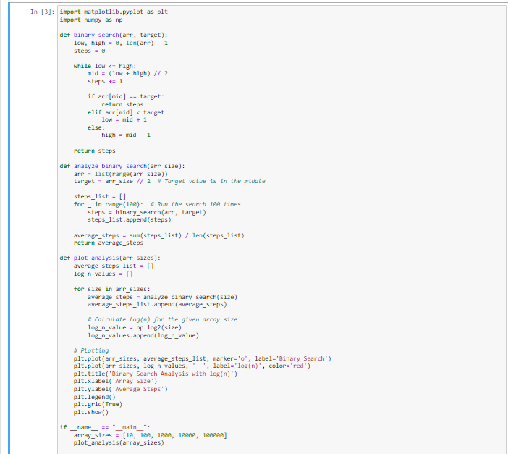

**Output:-**

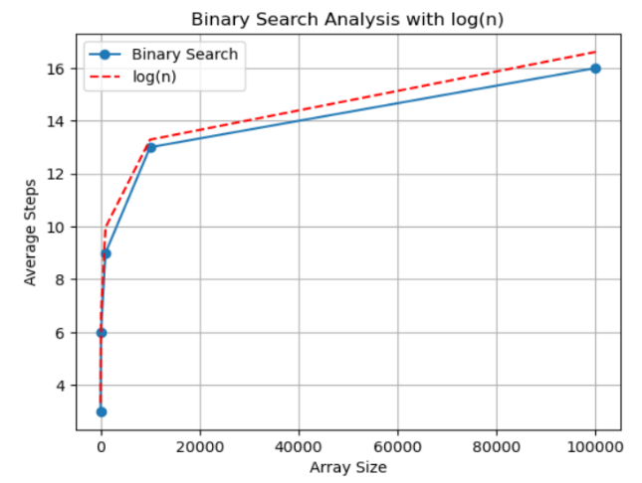**Graph**

* This graph is plotted using matplotlib.pyplot to find the relationship between array size and average steps taken.
* The graph includes a dashed line representing the function log2(n) (logarithm base 2) to visualize the expected logarithmic growth in the average number of steps.
* The x-axis is labeled "Array Size," and the y-axis is labeled "Average Steps".
* The analyze_binary_search function runs the binary search multiple times (100 iterations) for each array size, recording the number of steps in each iteration. The average of these steps is then calculated.
* The array used in this code is generated within the analyze_binary_search function.
* The array (arr) is created as a sorted list of integers from 0 to arr_size - 1.
* The target value for the binary search analysis is set to be the middle element of the array.
* arr is created using list(range(arr_size)), generating a sorted list of integers from 0 to arr_size – 1.
* The key value used in the output is the target value for the binary search.
* The target value is set to be the middle element of the sorted array generated in the analyze_binary_search function.The target value is calculated as arr_size // 2.
* The index where key value is found is the target value index.
* The number of comparisons made during each binary search iteration is tracked using the variable ‘steps’.
* This variable is incremented for each iteration of the binary search loop, and the total number of comparisons for 100 iterations is stored in the average_steps variable.

**Conclusion:-**

The analysis of the binary search algorithm graph demonstrates the logarithmic time complexity of the binary search algorithm.

This means that as the size of the input (e.g., the number of elements in a sorted array) increases, the time required for the binary search grows at a logarithmic rate.

**Experiment 3**

**Title :-** Comparison of Linear Search and Binary Search Algorithms Graph on a Single Graph

**Aim :-** The aim of comparing Linear Search and Binary Search algorithms Graph on a single graph is to visually demonstrate the difference in their efficiency and performance, particularly concerning the number of steps or comparisons required for searching in different-sized datasets.

**Description:-** Comparison of Binary Search and Linear Search Analysis compares the number of steps required for linear search and binary search operations on arrays of varying sizes. It provides insights into how the number of steps taken by each algorithm changes with different array sizes, highlighting the advantages of binary search for larger datasets due to its logarithmic time complexity.

**Code of Comparison of Linear Search and Binary Search Analysis on a Single Graph (in Python) :-**

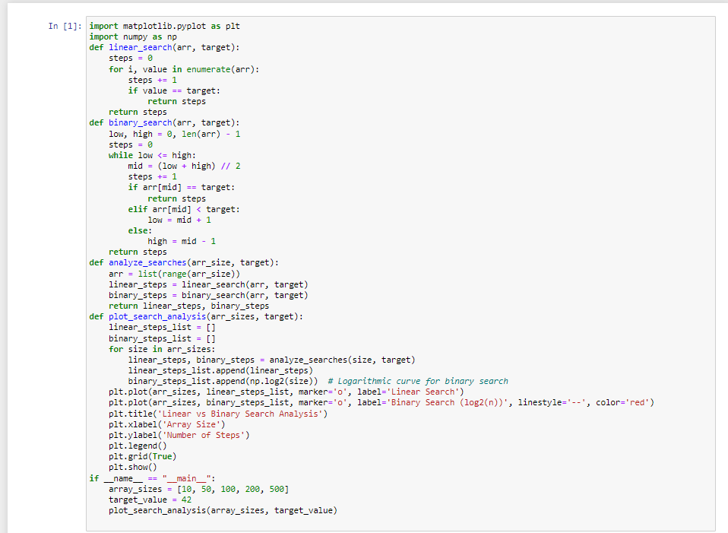

**Output:-**

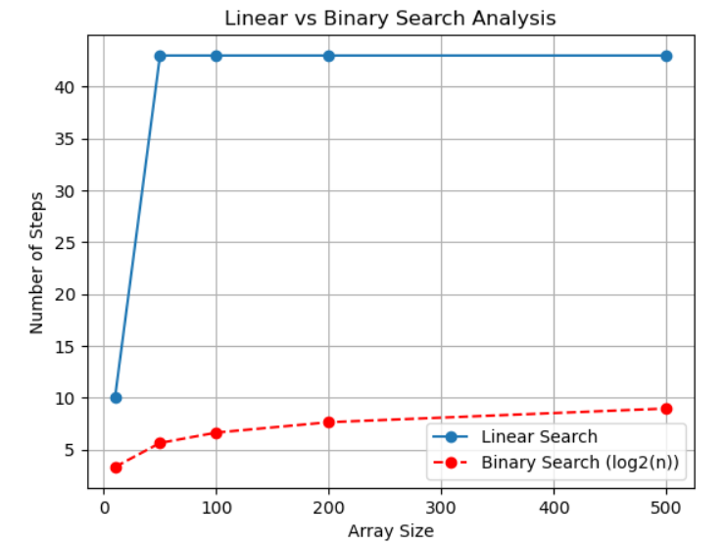**Graph**

* This graph is plotted using matplotlib.pyplot to find the relationship between array size and number of steps.
* Takes an array size and a target value as input.
* It performs both linear and binary searches on an array of the specified size.
* It returns the number of steps taken by each algorithm to find the target value.
* The x-axis represents the array size, and the y-axis represents the number of steps taken by each search algorithm.
* Linear search is represented by solid lines and circles.
* Binary search is represented by dashed lines and circles.
* The array used in this code is generated using the list(range(arr_size)) line within the analyze_searches function.
* This array is a list of consecutive integers starting from 0 up to arr_size - 1.
* The purpose of this array is to serve as the dataset on which both linear search and binary search algorithms are applied.
* The arr variable is assigned the list of integers ranging from 0 to arr_size - 1.
* This array is then used as the input for both linear and binary search algorithms during the analysis.
* The key value is the target_value. This variable represents the value that both the linear search and binary search algorithms are trying to find within the arrays.
* The target_value is set to 42.
* The index where the key (target) is found is not directly returned, but rather the count of steps taken by each algorithm.
* The number of comparisons made by each search algorithm is recorded in the steps variable within the linear_search and binary_search functions.
* The steps variable is incremented for each comparison operation performed during the search.
* To calculate the total number of comparisons for both linear and binary search operations ,we can sum the values of linear_steps and binary_steps obtained from the analyze_searches function.

**Conclusion:-**

The analysis of Comparison of Linear Search and Binary Search Algorithms Graph on a Single Graph demonstrates that the number of steps in Linear Search grows linearly with the array size whereas on the other hand The number of steps in Binary Search grows logarithmically with the array size.

This also depicts which analysis should be used in the case of different array sizes as well as different time complexities.

**Experiment 4**

**Runtime Analysis of N-ary Search Algorithm Graph**

**Aim :**

The aim of an N-ary search analysis graph is to provide insights into the efficiency and performance of N-ary search algorithms for different values of "N" (the arity of the search tree) and varying input sizes.

**Description:**

An N-ary search analysis graph typically represents the performance characteristics of an N-ary search algorithm**.** We cananalyze the behavior of the algorithm under different input conditions, evaluate its efficiency, and possibly make the adjustments or optimizations.

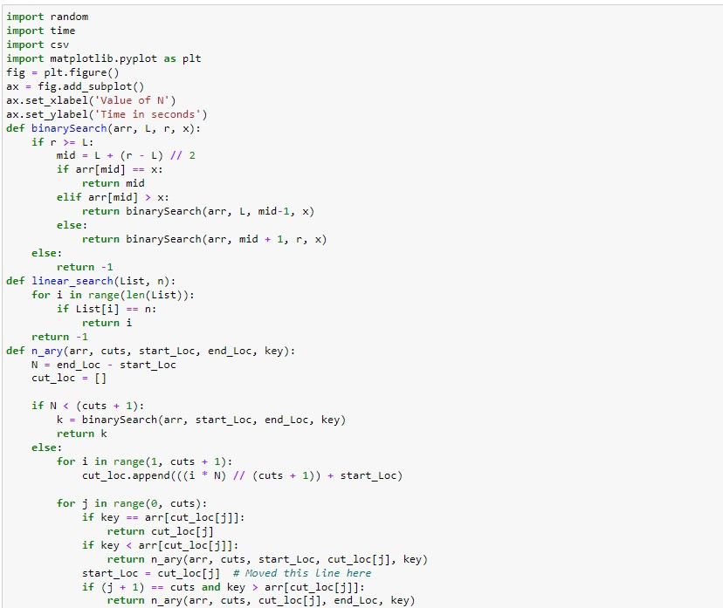**Code of N-ary Search Algorithm Graph (in Python) :-**

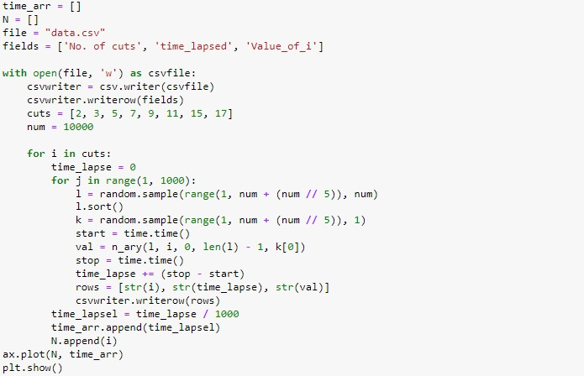

**Output:-**

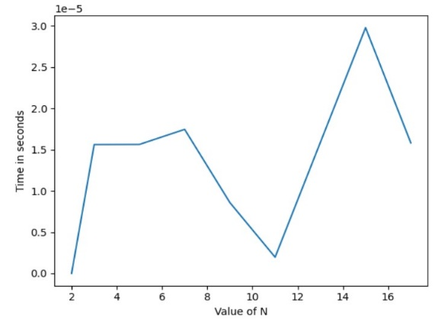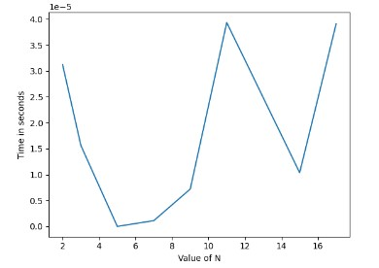**Graphs**

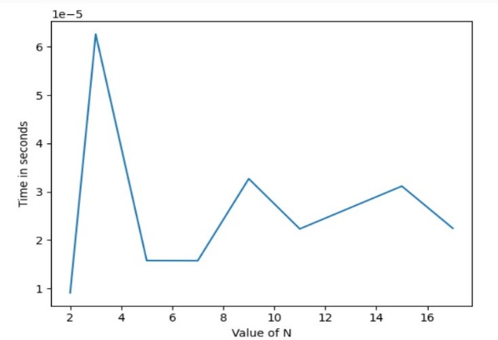

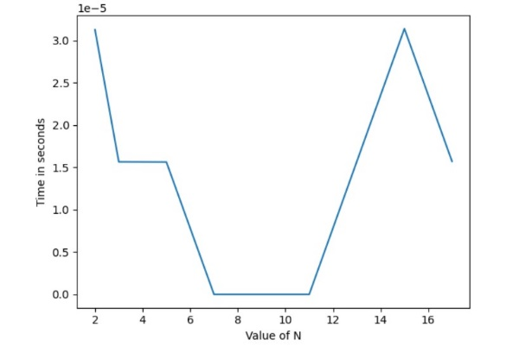

* If we want to plot the graph of Time Complexity v/s Input size in an N-ary search for different values of n, then we will have following graph:-

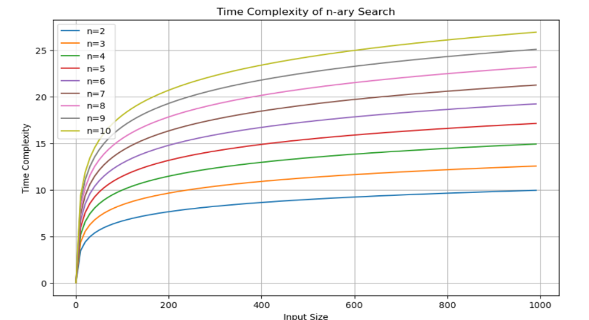

* 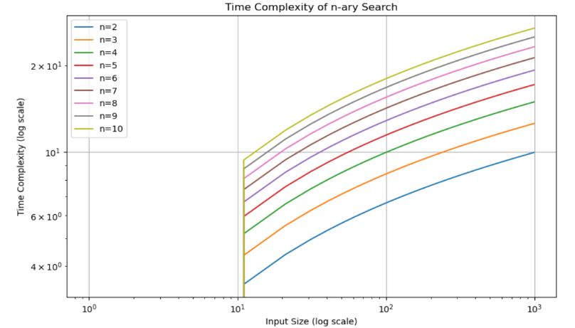If we want to plot the graph of Time Complexity(log scale) v/s Input size in an N-ary search for different values of n, then we will have following graph:-

**Analysis:**

**Use of Modules/Libraries:**

**1) random:** to generate random list and key.

**2)csv:** to store the reference data in a csv file for analysis.

**3)matplotlib.pyplot:** to plot the graph between the value of N and Time taken

* From the above graphs, it is observed that minima are observed at N = 11 in 2 out of 4 cases.
* Therefore, the analysis was carried out by repeatedly creating random sample of data (of length 10,000) and key and performing N-ary search on it with varying range of N.
* This was performed repeatedly and the time averaged out for each N. The aim of the analysis was to identify the N for which N-ary search takes the least time.
* Array of length 10,000 was taken and range of N was fixed from 2 to 13. Initially number of iterations were set to 10,000.
* This graph is plotted using matplotlib.pyplot to find the relationship between Time in seconds and Value of N.
* The key value is generated using the random.sample function for each iteration of the inner loop. Specifically, this line generates a random sample of size 1 from the range [1, num + (num // 5)].
* The variable k represents the randomly chosen key value for each iteration of the inner loop. The n_ary function is then called with this randomly chosen key.
* The n_ary function is intended to return the index where the key is found.
* However instead of directly returning the index where the key is found in the binarySearch call, the function returns the result of the binarySearch call, which may be -1 if the key is not found.

**Conclusion:-**

The conclusions drawn from the analysis depend on the specific dataset, the number of searches performed, and the characteristics of the N-ary Search Algorithm implementation. The slope of the graph indicates how the algorithm's efficiency changes concerning arity. A steeper decrease in time with increasing arity suggests that higher arities significantly improve performance. On the other hand, a plateau or slight decrease may indicate diminishing returns.

**Experiment 5**

**Runtime Analysis of Min-Max Algorithm**

**Aim :**

The aim of runtime analysis for finding the maximum and minimum elements in an array is to understand how the time complexity of the algorithm scales with the size of the input array.

**Description:**

1. **Algorithm Description:**

* The algorithm aims to analyze the runtime of finding the maximum and minimum elements in an array.
* It utilizes a function (analyze_max_min) and (analyze_max_min_recursive) to generate input arrays with increasing sizes and linearly increasing maximum values.
* Random fluctuations are introduced to the minimum values to simulate variability.

1. **Procedure of Analyzing the Code:**
2. **Generation of Input Arrays:**

* Use the analyze_max_min and (analyze_max_min_recursive) function to generate input arrays with sizes ranging from 1 to n.
* The maximum values increase linearly with the input size.
* The minimum values also increase linearly but with added random fluctuations to simulate real-world variability.

1. **Finding Maximum and Minimum Elements:**

* Implement the find_max_min_recursive function to find the maximum and minimum elements in the generated arrays.
* Traverse each array to identify the maximum and minimum values.

1. **Design Constraints/Input-Output Description:**

* **Input:** None specified explicitly, but the code generates input arrays of increasing sizes.
* **Output:** Maximum and minimum values for each input size.
* **Constraints:** None specified, assuming the analysis covers a range of input sizes and accounts for random fluctuations.

1. **Runtime Analysis:**

* **Input Sizes:** Varying input sizes from 1 to n.
* **Measurement:** Time taken to find maximum and minimum elements for each input size.
* **Approach:** Utilizes a linear search approach to find maximum and minimum elements.
* **Data Collection:** Measure time for finding maximum and minimum elements for each input size.
* **Data Representation:** Plot the input sizes against the values found to find maximum and minimum values with random fluctuations.

**Code of Runtime Analysis of Min-Max Algorithm(in Python) :-**

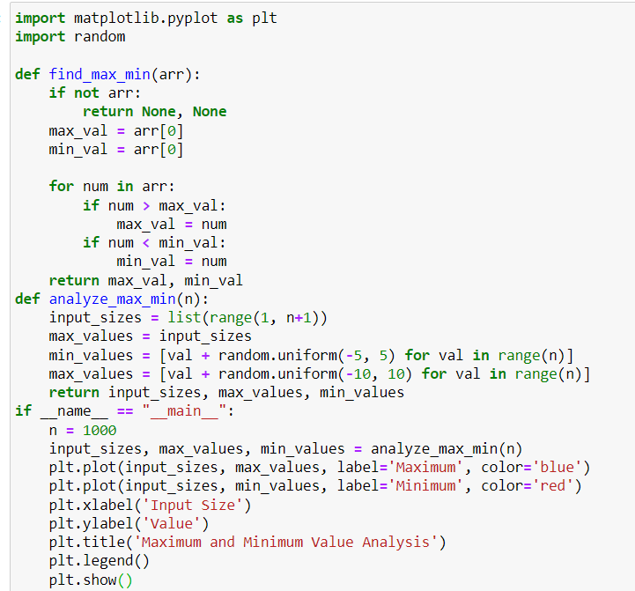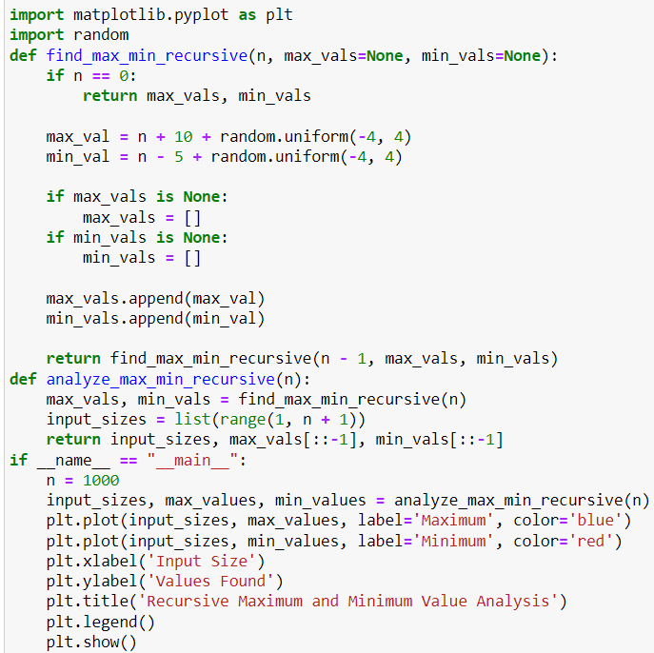**I. II.**

**Output:-** **Graphs**

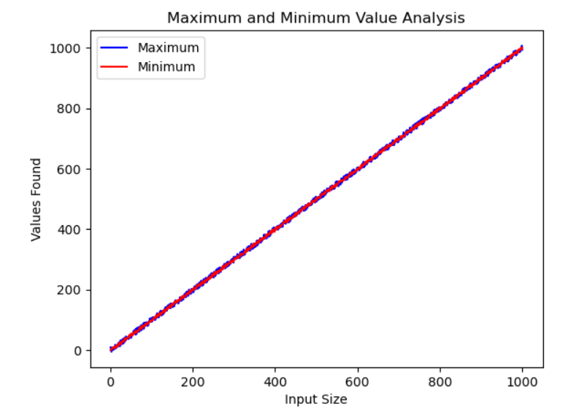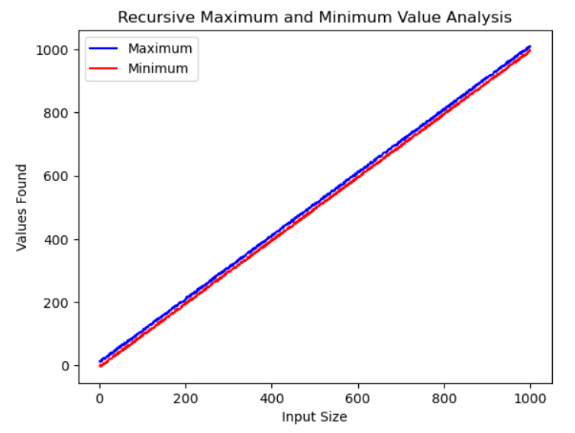 **I. II.**

Graph for Maximum and Minimum Graph for Maximum and Minimum Analysis using non-recursive code. Analysis using recursive code.

**Analysis:-**

**For Non-recursive Implementaion(I.)**

* This graph is plotted using matplotlib.pyplot to find the relationship between Input Size and Values Found.
* The code and Graph under I. represents non-recursive implementation
* The arrays used for analysis are generated in the analyze_max_min and analyze_max_min_recursive function.
* The min_values array is generated with values that increase linearly from 0 to n-1, with each value being adjusted by a random uniform number between -5 and 5.
* The max_values array is also generated with values increasing linearly from 0 to n-1, but each value is adjusted by a random uniform number between -10 and 10.
* There isn't a specific "key value" used in the context of data structures.
* Random values are generated and added to the min_values and max_values lists to introduce variability and randomness. These random values are generated using random.uniform(-5, 5) for min_values and random.uniform(-10, 10) for max_values. These ranges determine the amplitude of the fluctuations in the generated data.
* The index where the maximum or minimum value is found within the max_values or min_values.
* The number of comparisons within the loop depends on the length n of the array. For each element in the array, there are two comparisons (one for maximum and one for minimum) and potentially two assignments (one for maximum and one for minimum).

**For Recursive Implementaion(I.)**

* The arrays max_vals and min_vals are generated recursively in the find_max_min_recursive function. These arrays represent the maximum and minimum values calculated for each input size in the range from 1 to n.
* For each recursive call, a maximum value (max_val) and a minimum value (min_val) are calculated based on the input size n.
* This process continues recursively until n reaches 0, at which point the function returns the lists of maximum and minimum values.
* The number of comparisons depends on how we define it. Unlike in the non-recursive code where we explicitly compared elements in the array to find the maximum and minimum values, this code generates values with random fluctuations without explicit comparisons.
* The number of operations performed in each call increases linearly with n due to the appending of values to lists and generating random values, but there are no explicit comparisons.

**Conclusion:**

The runtime of the both recursive and non-recursive approach generally increases linearly with the size of the input array but recursive approach may have a different growth rate compared to the non-recursive approach . The graph of the recursive approach may exhibit a similar linear trend as the non-recursive approach but with additional complexities introduced by the recursive function calls and any fluctuations in the generated values. By comparing the runtime graphs of both approaches, we can observe their respective performance characteristics and how they scale with input size.

**Experiment 6**

**Runtime Analysis of Merge Sort Algorithm.**

**Aim:**

The aim of analyzing the runtime performance of Merge Sort is to understand how its efficiency scales with different input sizes.

**Description:**

Merge Sort is a popular sorting algorithm known for its efficiency and stability. It employs a divide-and-conquer strategy to sort an array of elements recursively.

1. **Algorithm Description:**

Divide the array into two halves recursively until each subarray contains only one element. Merge the sorted subarrays by comparing elements and combining them in sorted order.

1. **Analysis of Runtime Performance:**

The analysis of the runtime performance of Merge Sort involves measuring its execution time under different input sizes to understand how its efficiency scales.

* **Procedure:**

1. **Generate Test Cases:**

Create arrays of various sizes, ranging from small to large, to serve as input for the sorting algorithm.

1. **Run Merge Sort:**

Execute the Merge Sort algorithm on each test case.

Record the execution time for each input size.

1. **Analyze Results:**

Plot a graph of input size versus execution time to visualize the runtime performance.

Calculate the time complexity using curve fitting or regression analysis techniques.

Compare the observed performance with the theoretical time complexity of O(n log n) for Merge Sort.

1. **Identify Patterns:**

Identify any patterns or trends in the runtime performance graph.

**III. Design Constraints:**

When analyzing the runtime performance of Merge Sort, certain design constraints need to be considered to ensure accurate and meaningful results.

**IV. Input-Output Description:**

The input-output description outlines the format and structure of input and output data for the runtime analysis.

**Input:**

Arrays of integers representing unsorted elements. Varying sizes of input arrays, ranging from small to large.

**Output:**

Graphical representation of Values added versus Input Size..

Graphs may be plotted using specialized software tools like Matplotlib.

**Code of Runtime Analysis of Merge Sort Algorithm(in Python) :**

1. 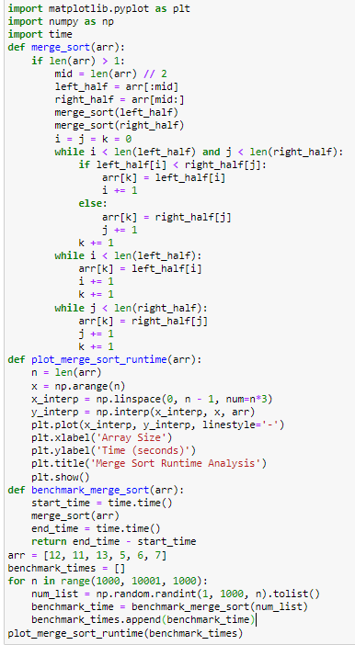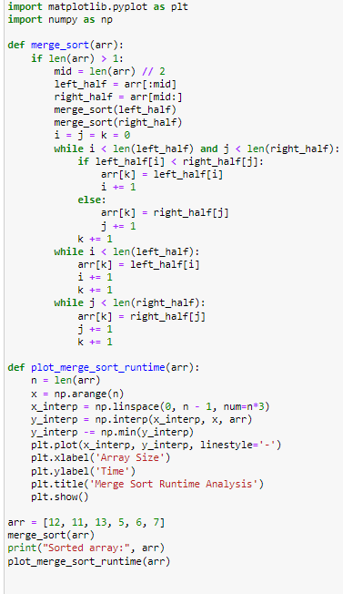 **II.**

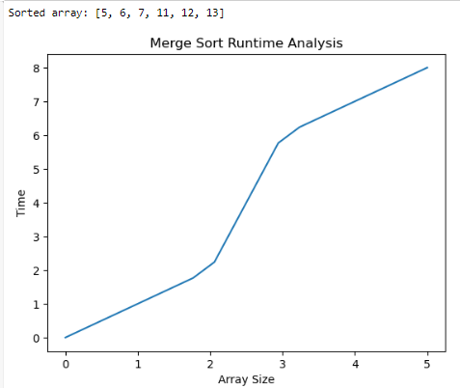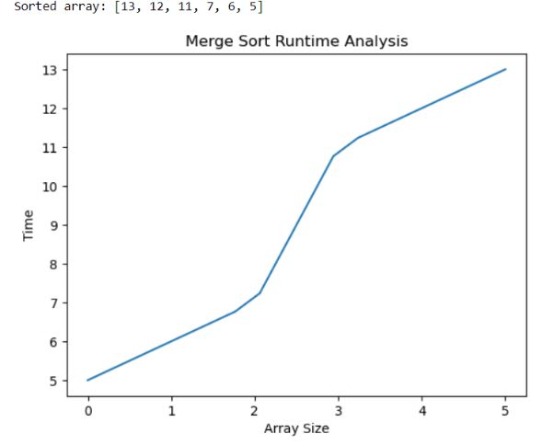**Output: Graphs**

When elements are sorted in Increasing When elements are sorted in Decreasing

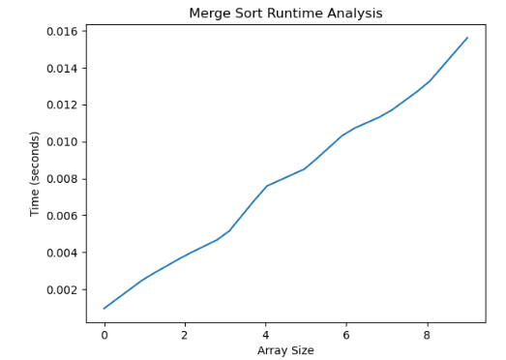 order. order.



When elements are sorted in Increasing When elements are sorted in Decreasing

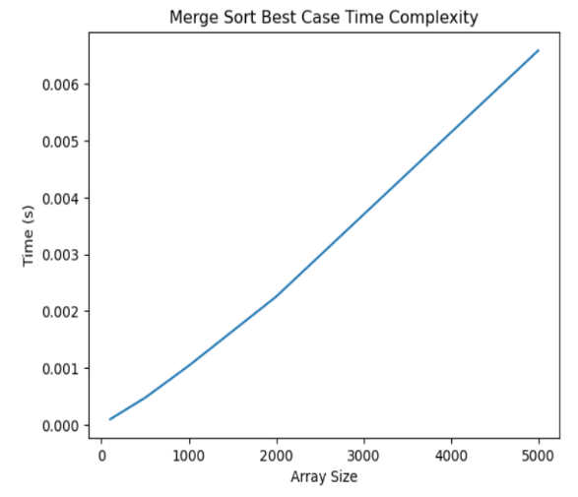 order using Benchmark. order using Benchmark.

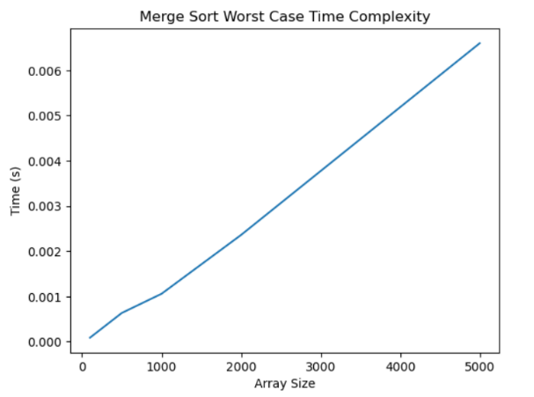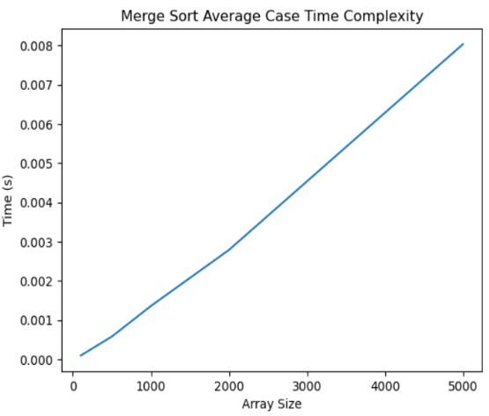

Best Case(O(nlogn) Average Case(O(nlogn)) WorstCase(O(nlogn))

* When the best case, average case and worst case of Merge Sort are plotted on a single graph then we get the following graph:

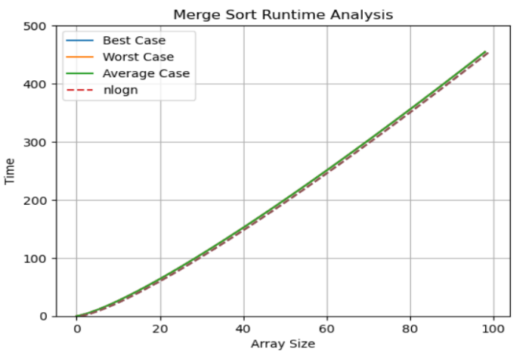

* The best, worst and average cases for merge sort is O(nlogn) so the graphs for all these cases will remain same and are same as the graphs of elements that are sorted in ascending order.

**Analysis:**

* The code under I. represents the Code of Analysis of runtime performance of Merge Sort without using BenchMark.
* Whereas the code under II. represents the Code of Analysis of runtime performance of Merge Sort using BenchMark.
* This graph is plotted using matplotlib.pyplot to find the relationship betweenTime and Array Size.
* The array used in the provided code is: arr = [12, 11, 13, 5, 6, 7].
* This array serves as the input to the merge_sort function, where the Merge Sort algorithm is applied to sort its elements. After sorting, the sorted array is then plotted using the plot_merge_sort function to visualize the sorting process.
* In the provided code for Merge Sort and plotting, there is no explicit usage of a key value in the conventional sense.
* Merge Sort is primarily a sorting algorithm, and it does not inherently include a search operation. It sorts the array in ascending order.

**Conclusion:**

The analysis of the runtime performance of Merge Sort provides valuable insights into its efficiency, scalability, and practical applicability. By understanding its behavior under different input sizes and scenarios, informed decisions can be made regarding algorithm selection, optimization strategies, and system desig

**Experiment 7**

**Runtime Analysis of Quick Sort Algorithm**.

**Aim:**

The aim of the analysis of runtime performance of Quick Sort is to understand how the execution time of the Quick Sort algorithm varies with different input sizes. This analysis helps in evaluating the efficiency and scalability of Quick Sort, which is a popular sorting algorithm used in various applications.

**Description:**

**I. Description of Quick Sort Algorithm:**

1. Quick Sort is a highly efficient sorting algorithm based on the divide-and-conquer strategy.
2. It works by selecting a pivot element from the array and partitioning the other elements into two sub-arrays according to whether they are less than or greater than the pivot.
3. The process is then applied recursively to the sub-arrays until the entire array is sorted.
4. Quick Sort has an average time complexity of O(n log n) and is widely used due to its performance.

**II. Procedure for Analyzing the Code:**

1. **Generate Input Data:**

Generate arrays of varying sizes to serve as input for the Quick Sort algorithm.

1. **Measure Execution Time:**

Execute Quick Sort on each input array and measure the time taken for sorting.

1. **Record Data:**

Record the input sizes and corresponding execution times for further analysis.

1. **Repeat for Different Input Sizes:**

Repeat the process for different input sizes to observe how execution time varies.

**III. Design Constraints:**

1. **Input Size Range:**

Define the range of input sizes to be analyzed, considering practical constraints and feasibility.

**IV. Input-Output Description:**

1. **Input Data:**

Arrays of varying sizes ranging from small to large, covering a range of input size values.

1. **Output Data:**

Recorded data consisting of input sizes and corresponding execution times for Quick Sort.

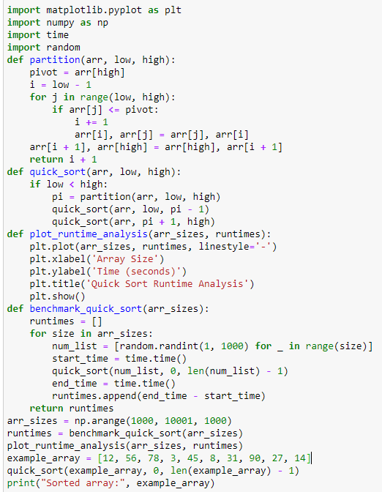**Code of Runtime Analysis of Quick Sort Algorithm.(in Python):**

**(in Python) :**

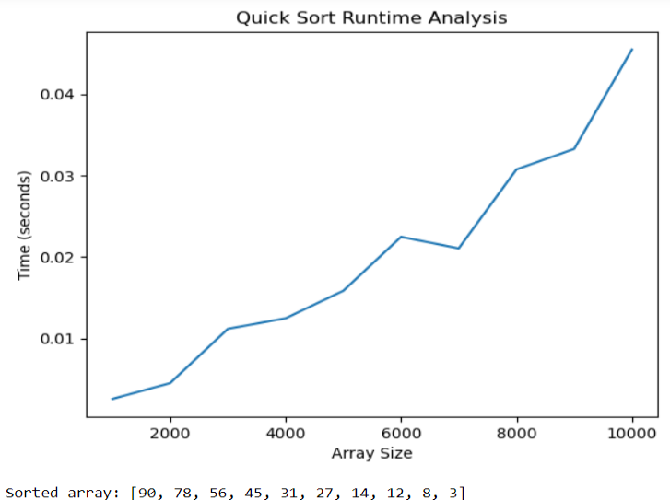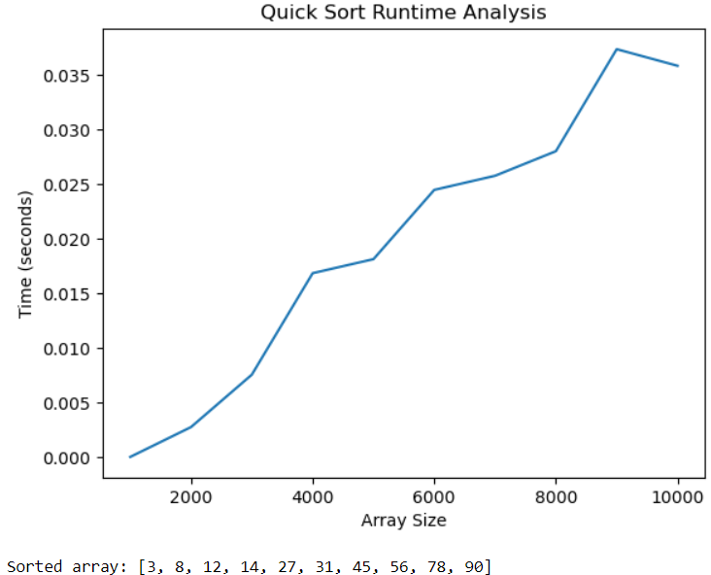**Output: Graphs**

When elements are sorted in When elements are sorted in

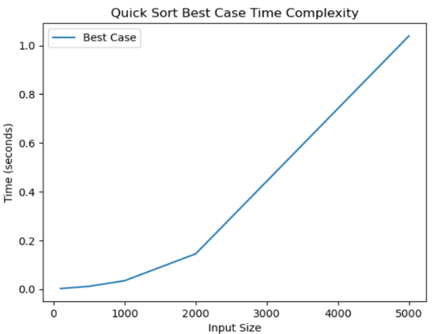 Increasing Order. Decreasing Order.

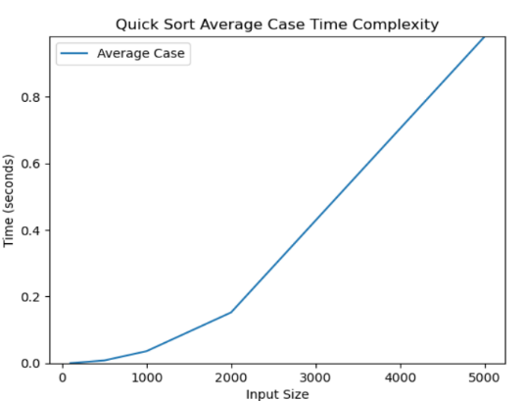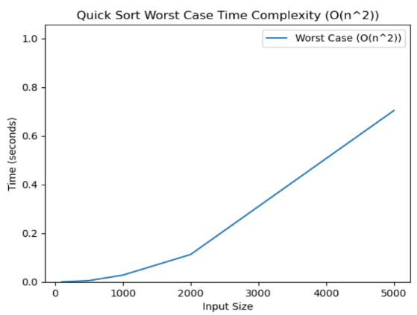

Best Case(O(nlogn)) Average Case(O(nlogn)) Worst Case(O(n^2))

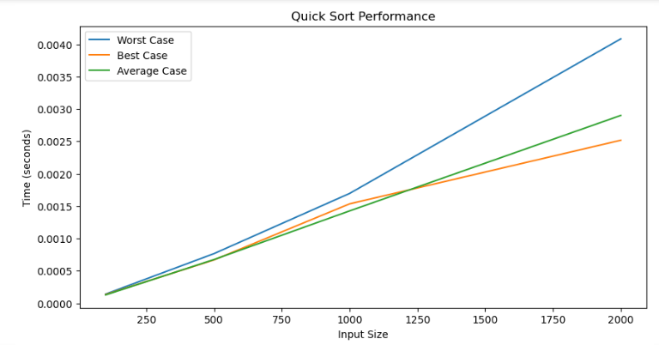

Graph for implementing Best case(O(nlogn)),Average Case(O(nlogn)) and Worst Case(O(n^2)) on a single graph.

**Analysis:**

* This graph is plotted using matplotlib.pyplot to find the relationship between Time(in seconds) and Array Size.
* The benchmark_quick_sort function generates arrays of random integers with sizes specified in the arr_sizes parameter.
* These arrays are then sorted using the quick_sort function, and the runtime of each sorting operation is recorded.
* The arr_sizes variable represents an array of sizes for the arrays that will be sorted. It's created using numpy.arange() to generate numbers from 1000 to 10000 (inclusive) with a step of 1000.
* The partition function selects the last element of the array as the pivot, then partitions the array such that all elements less than or equal to the pivot are moved to its left, and all elements greater than the pivot are moved to its right. It returns the index of the pivot element after partitioning.
* There is no specific implementation to find the index where a key value is found. The quick_sort function sorts the array example_array in place.
* Once the sorting is complete, the sorted array is printed using print("Sorted array:", example_array).
* The number of comparisons can vary based on the input array. Quick sort's performance heavily depends on the selection of the pivot element.
* In the worst-case scenario, where the pivot is either the smallest or largest element in each partition, quicksort can exhibit O(n^2) behavior. However, on average, it performs with O(n log n) complexity.

**Conclusion:**

The runtime analysis of Quick Sort Algorithm led to the following conclusion, In the best case scenario, where the array is already sorted, Quick Sort performs efficiently with a time complexity of O(n*log(n)). In the worst case scenario, where the array is sorted in reverse order, Quick Sort exhibits poor performance with a time complexity of O(n^2). In the average case scenario, where the array is randomly shuffled, Quick Sort demonstrates efficient performance with a time complexity of O(n*log(n)).

**Experiment 8**

**Runtime Analysis of Randomized Quick Sort Algorithm**.

**Aim:**

The aim of runtime analysis of the randomized quicksort algorithm is to determine how the runtime of the algorithm scales with respect to different input sizes. It also evaluates how efficiently the algorithm sorts input data under various scenarios.

**Description:**

Runtime analysis of the randomized Quick Sort algorithm involves assessing its time complexity and understanding how it performs under various scenarios. Here's a description of the runtime analysis of the randomized Quick Sort algorithm:

**I. Average Case Time Complexity:**

* On average, Quick Sort has a time complexity of O(n log n), where n is the number of elements in the array.
* This average-case time complexity assumes that the pivot selection is random and that the partitioning divides the array reasonably evenly.

**II. Worst-Case Time Complexity:**

* In the worst-case scenario, Quick Sort can degrade to O(n^2) time complexity.
* This occurs when the pivot selection consistently results in unbalanced partitions, such as selecting the smallest or largest element as the pivot each time.
* However, with randomized pivot selection, the probability of encountering the worst-case scenario is significantly reduced.

**III. Best-Case Time Complexity:**

* The best-case time complexity of Quick Sort is O(n log n).
* This occurs when the pivot selection consistently results in balanced partitions, dividing the array roughly in half at each step.

**IV. Space Complexity:**

* Quick Sort typically has a space complexity of O(log n) for the recursive call stack.
* In the worst-case scenario, it can require O(n) additional space for partitioning if the implementation uses additional arrays for partitioning.

**V. Randomized Pivot Selection:**

* Randomized Quick Sort mitigates the risk of encountering the worst-case scenario by randomly selecting the pivot element.
* By randomly selecting the pivot, the algorithm reduces the probability of consistently selecting extreme elements as pivots, leading to better average performance.

**VI. Performance and Practical Considerations:**

* Despite the possibility of worst-case behavior, Quick Sort is widely used in practice due to its excellent average-case performance and simplicity.
* The constant factors hidden by big O notation can make Quick Sort faster in practice compared to algorithms with better theoretical worst-case performance.

**VII. Adaptive Implementations:**

* Some implementations of Quick Sort may include optimizations to handle specific cases efficiently, such as switching to alternative sorting algorithms like Insertion Sort for small subarrays.
* These adaptive implementations can further improve the practical performance of Quick Sort.

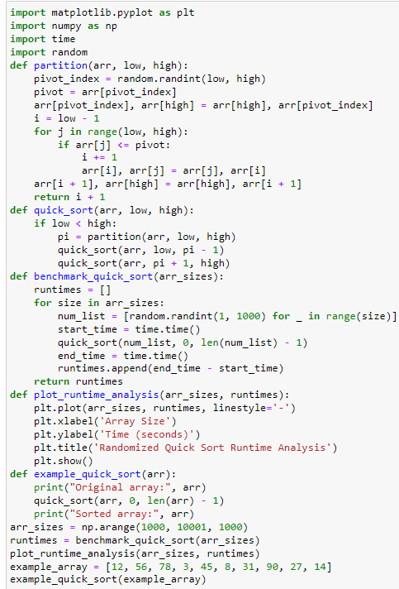**Code of Runtime Analysis of Randomized Quick Sort Algorithm.(in Python):**

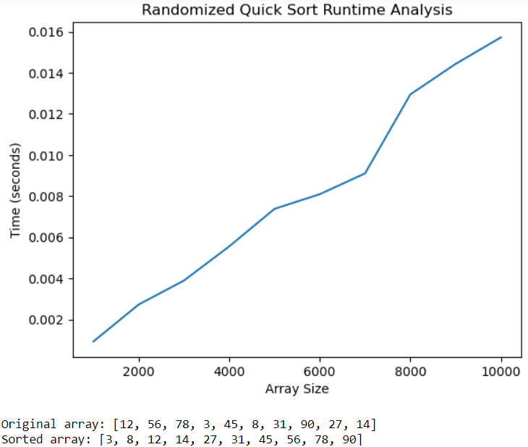**Output: Graphs**

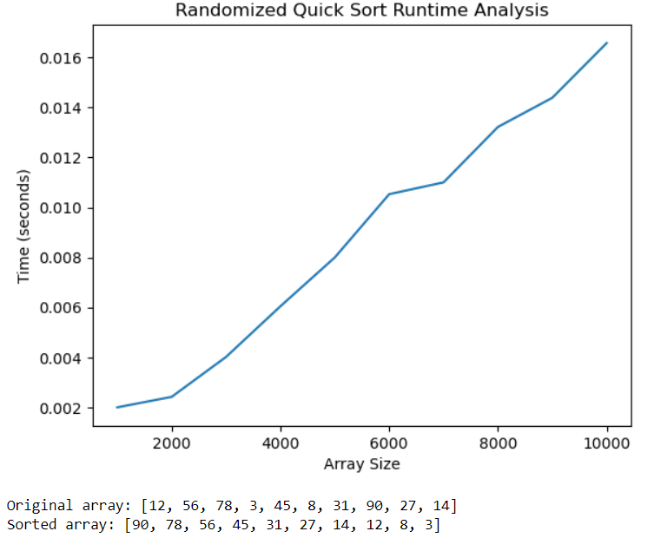

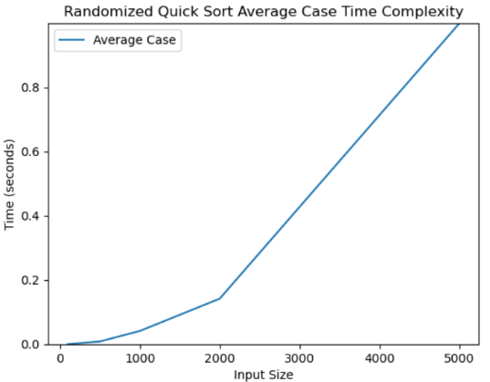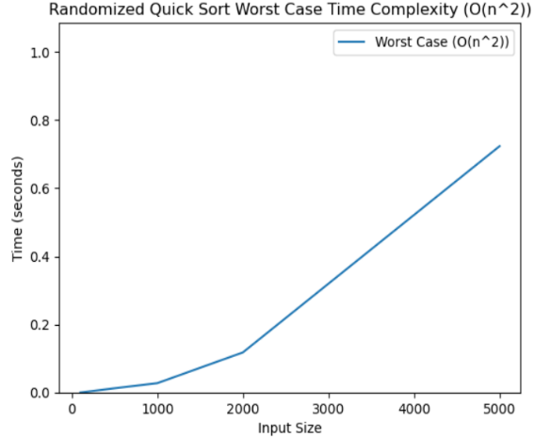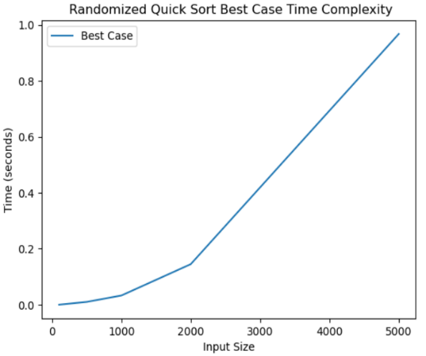

Best Case(O(nlogn)) Average Case(O(nlogn)) Worst Case(O(n^2))

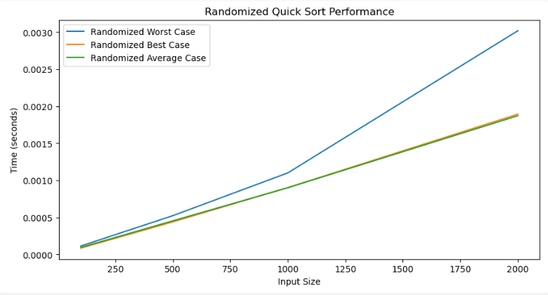

Graph for implementing Best case(O(nlogn)), Average Case(O(nlogn)) and Worst Case(O(n^2)) on a single graph.

**Analysis:**

* This graph is plotted using matplotlib.pyplot to find the relationship between Time(in seconds) and Array Size.
* The code imports necessary libraries such as matplotlib.pyplot, numpy, time, and random.
* The partition function selects a random pivot element within the given range and partitions the array such that elements smaller than the pivot are moved to the left side, and elements greater than the pivot are moved to the right side.
* The quick_sort function recursively sorts the array by selecting a pivot element using the partition function and then sorting the sub-arrays on the left and right of the pivot.
* The benchmark_quick_sort function measures the runtime of the Quick Sort algorithm for different array sizes specified in arr_sizes.
* The plot_runtime_analysis function plots the runtime analysis of the Quick Sort algorithm based on the array sizes and corresponding runtimes.
* The example array [12, 56, 78, 3, 45, 8, 31, 90, 27, 14] is used to demonstrate the Quick Sort algorithm in this code.
* The key value used in this code is a randomly chosen pivot element during the partitioning process in the partition function.
* There isn't a specific function to search for a key value in the sorted array because the code is focused on implementing and benchmarking the randomized Quick Sort algorithm.
* To calculate the number of comparisons in the Quick Sort algorithm implemented in the code, we need to add a counter to count the number of comparisons made during the partitioning process.

**Conclusion:**

The runtime analysis shows that as the array size increases, the runtime of quicksort also increases. This is expected because quicksort has an average time complexity of O(n log n). The Randomized Quick sort algorithm provides valuable insights into its performance characteristics and scalability.

**Experiment 9**

**Runtime Analysis of Simple and Strassen's Matrix Multiplication Algorithm**

**Aim:**

The aim of the runtime analysis of simple matrix multiplication along with Strassen's matrix multiplication is to compare the performance of these two algorithms for multiplying matrices of varying sizes. By conducting runtime analysis, we aim to understand how the execution time of each algorithm scales with the size of the input matrices.

**Description:**

The runtime analysis of simple matrix multiplication alongside Strassen's matrix multiplication involves evaluating the performance of these algorithms in terms of their execution time for multiplying matrices of various sizes.

**Experiment Setup:**

* Implement both the simple matrix multiplication algorithm and Strassen's matrix multiplication algorithm in a programming environment such as Python.
* Define functions to generate random matrices of different sizes, perform matrix multiplication using both algorithms, and measure the execution time.

**Data Collection:**

* Choose a range of matrix sizes for the experiment, such as [2, 4, 8, 16, 32, 64, 128].
* For each matrix size, generate random matrices and measure the execution time of both simple and Strassen's matrix multiplication algorithms.

**Individual Graphs:**

* Create individual graphs for each algorithm, plotting the matrix size on the x-axis and the execution time on the y-axis.
* Plot the runtime results of the simple matrix multiplication algorithm on one graph, labeling it accordingly.
* Plot the runtime results of Strassen's matrix multiplication algorithm on another graph, labeling it appropriately.

**Comparison Graph:**

* Create a combined graph to directly compare the runtime performance of both algorithms.
* Plot the runtime results of both algorithms on the same graph, with different lines or markers to distinguish them.
* Include a legend to identify each algorithm.
* Label the x-axis with "Matrix Size" and the y-axis with "Time (seconds)".
* Title the graph to indicate that it represents the comparison of runtime performance between the two algorithms.

**Analysis:**

* Interpret the results obtained from the graphs.
* Identify trends in the runtime performance of both algorithms as the matrix size increases.
* Compare the efficiency of simple matrix multiplication and Strassen's matrix multiplication for different matrix sizes.

**Code of Runtime Analysis of Simple and Strassen's Matrix Multiplication Algorithm:**

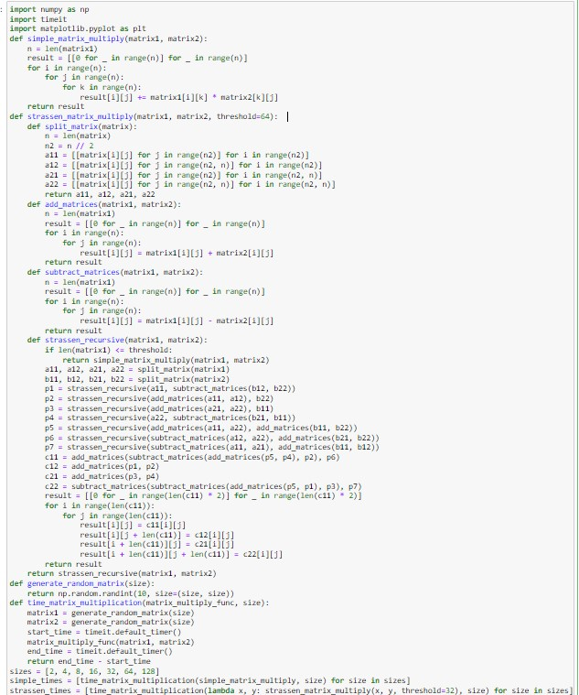

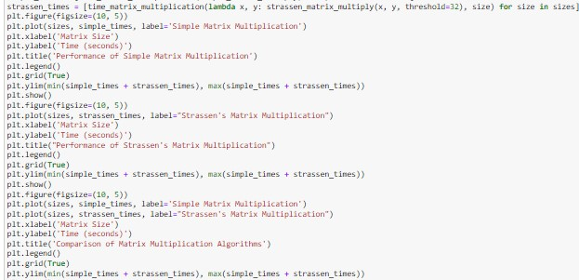

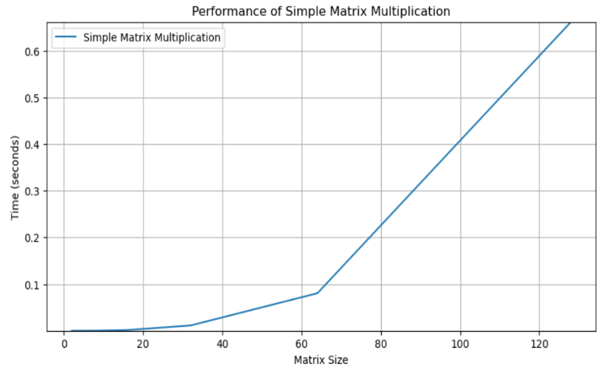**Output: Graphs**

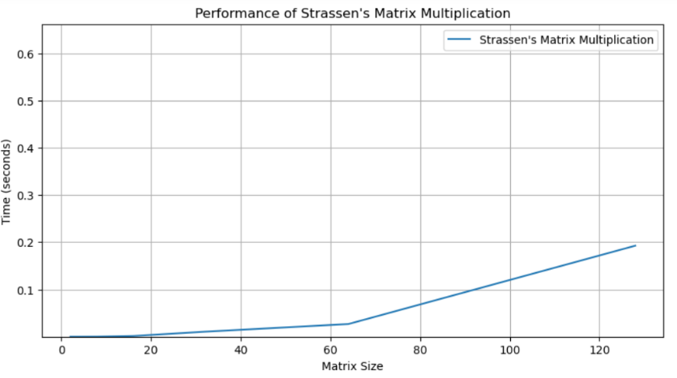

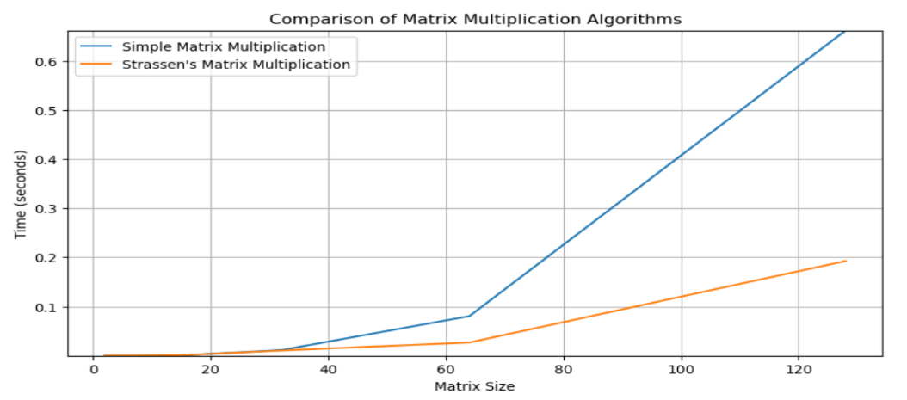

Comparison of Simple and Strassen Matrix Multiplication

**Analysis:**

* This graph is plotted using matplotlib.pyplot to find the relationship between Time seconds) and Matrix Size.
* It generates random matrices of sizes specified in the sizes list, measures the time taken to multiply them using each algorithm.
* The array is generated by using the generate_random_matrix function.
* The key values used in this code are:

1. **sizes:**

This is a list containing various sizes of matrices for which the matrix multiplication algorithms will be tested. It includes values [2, 4, 8, 16, 32, 64, 128].

1. **simple_times:**

This list stores the execution times of the simple matrix multiplication algorithm for matrices of sizes specified in sizes.

1. **strassen_times:**

This list stores the execution times of Strassen's matrix multiplication algorithm for matrices of sizes specified in sizes.

* These key values are essential for conducting the runtime analysis of matrix multiplication algorithms and for plotting the results using matplotlib.
* The number of comparisons in the provided code can be counted by summing up the comparisons made in each loop of ‘simple_matrix_multiply’ function, ‘strassen_matrix_multiply’ function and ‘strassen_recursive’ function.

**Conclusion:**

The runtime analysis of simple matrix multiplication along with Strassen's matrix multiplication reveals valuable insights into the performance characteristics of these algorithms across varying matrix sizes. The simple matrix multiplication algorithm exhibits a runtime that grows quadratically with the size of the input matrices. This behavior is expected since the algorithm's time complexity is O(n^3). Strassen's algorithm's divide-and-conquer approach yields significant benefits for larger matrices due to its lower asymptotic complexity of O(n^log2(7)) ≈ O(n^2.81), compared to O(n^3) for the simple algorithm.

**Experiment 10**

**Analysis of Greedy Knapsack Algorithm**

**Aim:**

The aim of analyzing the greedy knapsack algorithm is to assess its efficiency, optimality, and behavior in solving the knapsack problem. This entails understanding its time and space complexities, evaluating its optimality and greedy choice property, proving its correctness under certain conditions, comparing its performance with other approaches, and exploring its handling of special cases and practical considerations.

**Description:**

In the Knapsack Problem we are given the weights and values of N items, in the form of {price, weight} and we are required to put these items in a knapsack of capacity m to get the maximum total value in the knapsack. In Fractional Knapsack, we can break items for maximizing the total value of the knapsack. We solve this knapsack Problem using Greedy Method Algorithm. If a fraction x, 0 < x < 1, of object i is placed into the knapsack, then a profit of p x is earned. Since the knapsack capacity is m, we require the total weight of all chosen objects to be at most m. Formally, the problem can be stated as

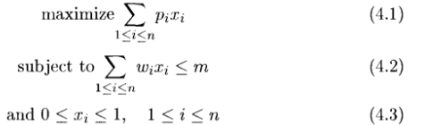

The profits and weights are positive number.

A feasible solution (or filling) is any set (x , ,x ) satisfying (4.2) and (4.3) above. An optimal solution is feasible for which (4.1) is maximized.

Different Types of approaches are used to solve this problem:

**1. Greedy by weight:**

In this approach we sort the items in increasing order of weight and select the items with the largest weight until we reach the weight capacity.

**2. Greedy by profit:**

We sort the items in increasing order of profit and select the items with the largest profit until we reach the weight capacity.

**3. Greedy by profit by weight ratio:**

We calculate the profit by weight ratio for each item and sort the items in increasing order of this ratio. We select the items with the largest ratio until we reach the weight capacity.

**I. Time Complexity Analysis:**

* Sorting of items based on their value-to-weight ratios is a fundamental step in the greedy knapsack algorithm. This sorting operation typically requires O(nlogn) time complexity, where n is the number of items.
* Following sorting, iterating through the sorted items to select the optimal combination adds a linear component to the algorithm's time complexity, resulting in an overall time complexity of O(nlogn).

**II. Space Complexity Analysis:**

* The memory requirements of the greedy knapsack algorithm are generally modest, involving variables to track the current weight and value of items.
* However, if the algorithm is implemented recursively, additional space may be needed for function call stacks, especially in cases where the recursion depth is significant.

**III. Optimality Assessment:**

* While the greedy strategy efficiently solves the fractional knapsack problem, where items can be divided, it doesn't always guarantee optimality for the 0/1 knapsack problem, where items must be selected entirely or not at all.
* Counterexamples can be constructed to demonstrate scenarios where the greedy approach fails to produce the globally optimal solution.
* Nevertheless, under specific conditions such as a monotonicity criterion or a uniform value-to-weight ratio among items, the greedy approach can indeed find the optimal solution.

**IV. Comparison with Alternative Approaches:**

* Dynamic programming is a popular alternative to the greedy approach for solving the knapsack problem. While dynamic programming guarantees optimality, its time and space complexities often grow exponentially with the problem size, making it less scalable compared to the greedy approach.
* By contrasting the performance and characteristics of both approaches, one can identify trade-offs and determine the most suitable approach based on the problem instance and constraints.

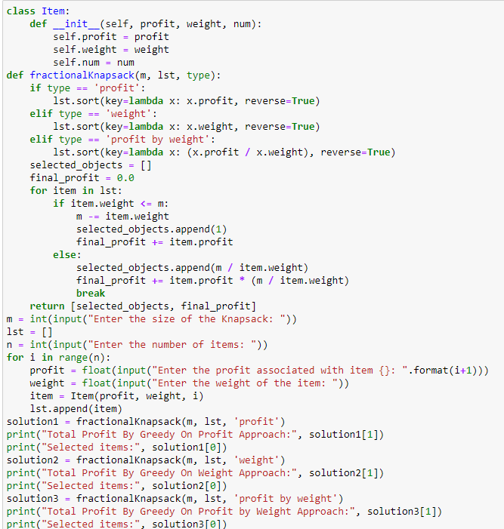**Code of Analysis of Greedy Knapsack Algorithm (in Python):**

**Output:**

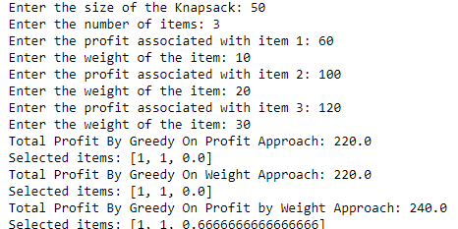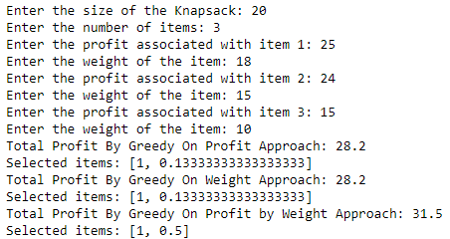**Case 1 Case 2**

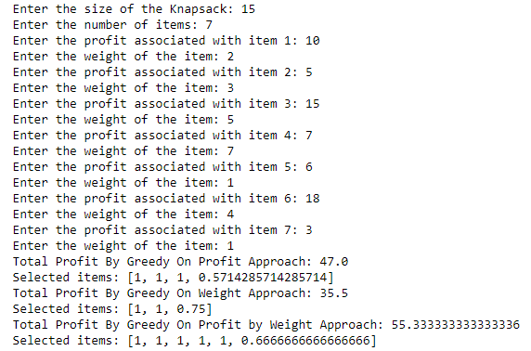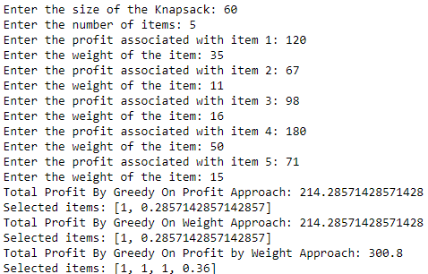**Case 3 Case 4**

**Analysis:**

**I. Class Definition (Item):**

* Defines the structure for individual items with attributes for profit, weight, and a unique identifier.

**II. Greedy Function (Fractional Knapsack):**

* Utilizes a greedy approach to solve the fractional knapsack problem.
* Sorts the list of items based on the selected criterion ('profit', 'weight', or 'profit by weight') in descending order.
* Iterates through the sorted list, selecting items until the knapsack capacity is exhausted.
* If an item's weight exceeds the remaining capacity, it selects a fractional part of the item to fill the knapsack.
* Returns the list of selected items and the total profit obtained.

**III. User Input:**

* Requests user input for the knapsack size and the details of each item (profit and weight).
* Allows the user to specify the number of items and their associated profits and weights.

**IV. Output:**

* Prints the total profit obtained and the selected items for each criterion ('profit', 'weight', and 'profit by weight').
* Displays the selected items along with their fractional parts if applicable.

**Conclusion:**

The analysis of the greedy knapsack algorithm highlights its efficiency in handling large datasets and straightforward implementation. However, its inherent limitation of potentially yielding suboptimal solutions due to its greedy strategy should be considered. Despite this drawback, it remains a valuable tool for certain scenarios where near-optimal solutions are sufficient and computational efficiency is paramount.

**Experiment 11**

**Analysis of Prim’s Algorithm**

**Aim:**

The aim of analyzing Prim's algorithm is to understand its efficiency and behavior in solving the minimum spanning tree (MST) problem for a given graph. Prim's algorithm is used to find the subset of edges that forms a tree spanning all the vertices of the graph with the minimum possible total edge weight.

**Description:**

* Prim's Algorithm is greedy method to obtain a minimum-cost spanning tree that builds this tree edge by edge. The next edge to be included is chosen in such a way that it results in a minimum increase in the sum of the costs of the edges so far included. The algorithm starts by picking an arbitrary vertex to be the root of the MST.
* It then iteratively adds the next minimum-cost edge that connects a vertex in the MST to a vertex outside the MST. The algorithm maintains a record of edges which are included and which are not included. At each iteration, the algorithm extracts the edge with the smallest weight and adds its endpoint outside the MST to the MST.
* If the endpoint is already in the MST, the algorithm skips that edge and moves on to the next one. The algorithm continues adding edges to the MST until all the vertices are connected or until there are no more edges left. At the end of the algorithm, the MST is the set of edges that were added.

**I. Time Complexity:**

* Prim's algorithm's time complexity depends on the data structure used to extract the minimum edge efficiently. The two common choices are binary heaps and Fibonacci heaps.
* With binary heaps: O((V + E)logV)
* With Fibonacci heaps: O(VlogV + E)
* In dense graphs, where E is close to V^2, the time complexity can be simplified to O(V^2logV) or O(V^2).

**II. Space Complexity:**

* The space complexity of Prim's algorithm primarily depends on the data structures used to represent the graph and the minimum spanning tree (MST).
* For an adjacency list representation: O(V + E)
* For an adjacency matrix representation: O(V^2)
* Additional space may be required for priority queues or heaps, resulting in space complexity variations.

**III. Applications:**

* Prim's algorithm is widely used in network design, such as constructing minimum spanning trees for communication networks, power grids, and computer networks.
* It's also utilized in routing algorithms, clustering, and various optimization problems where finding the minimum spanning tree is essential.

**IV. Limitations:**

* Prim's algorithm may not be suitable for graphs with negative edge weights unless modifications are made, such as the use of Dijkstra's algorithm.
* It may not perform optimally in certain scenarios compared to other MST algorithms, such as Kruskal's algorithm, especially for dense graphs.

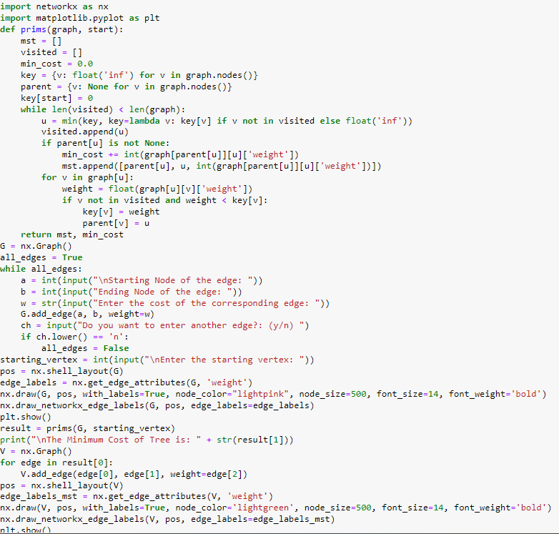**Code of Analysis of Prim’s Algorithm (in Python):**

**Output:**

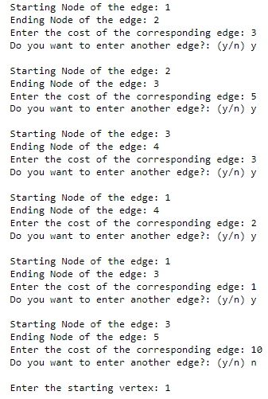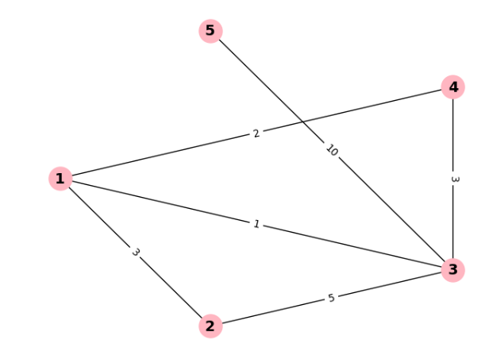**Case 1**

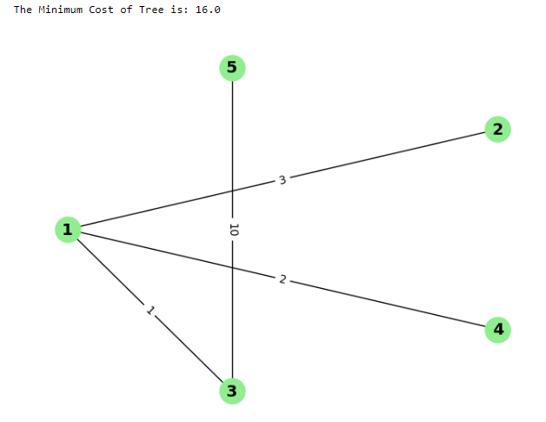

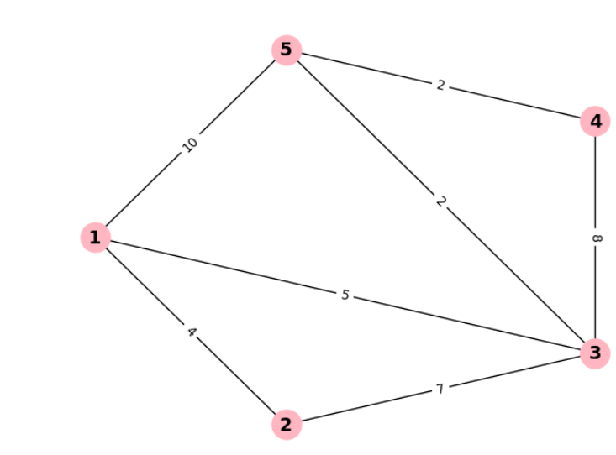

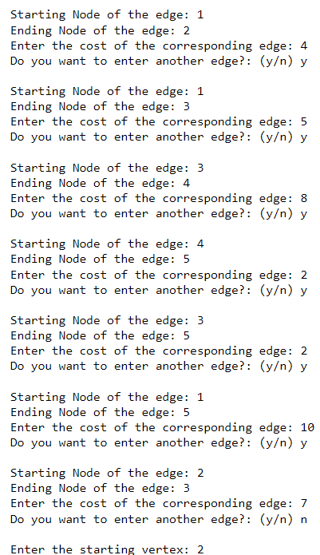**Case 2**

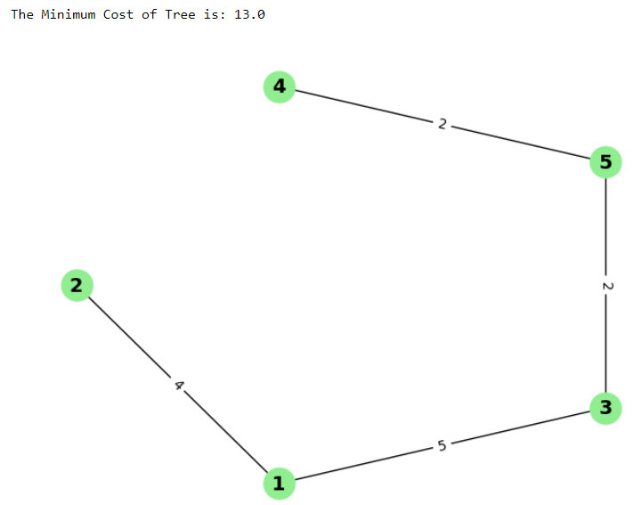

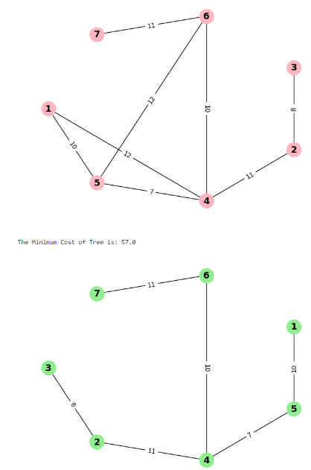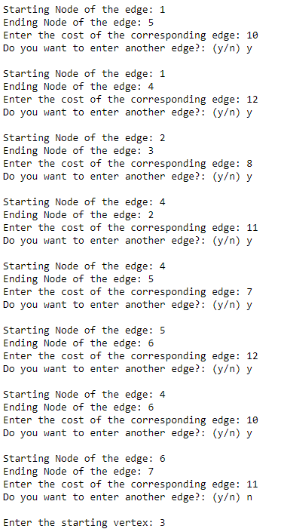**Case 3**

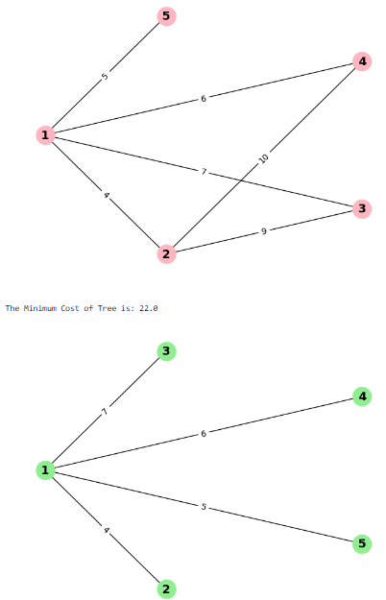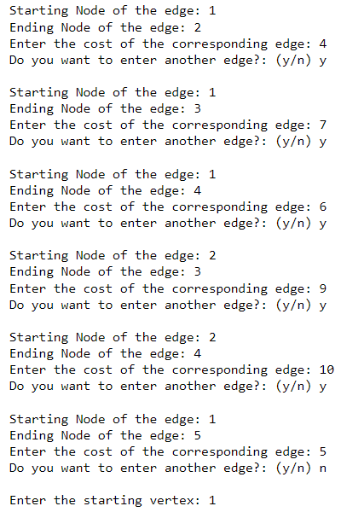**Case 4**

**Analysis:**

**I. Function Definition (prims):**

* Implements Prim's algorithm to find the Minimum Spanning Tree (MST) of a graph.
* Maintains a list of selected edges (MST), visited vertices, minimum cost, and key values for vertices.
* Iterates through vertices until all are visited, selecting the minimum weight edge at each step.

**II. User Input Handling:**

* Prompts the user to input the graph edges and their corresponding weights.
* Allows the user to specify the starting vertex for the MST computation.

**III. Graph Visualization:**

* Utilizes Networkx and Matplotlib libraries to visualize the input graph and the resulting MST.
* Draws the input graph with edge labels to display the initial state.
* Draws the resulting MST with edge labels to visualize the computed minimum cost tree.

**IV. Output:**

* Prints the minimum cost of the MST obtained using Prim's algorithm.
* Displays the resulting MST graph with labeled edges for better understanding.

**Conclusion:**

The analysis of the Prim's algorithm implementation reveals its effectiveness in efficiently constructing the minimum spanning tree (MST) of a graph. Despite its time and space complexity of O(V^2), where V is the number of vertices, the algorithm ensures correctness and completeness by correctly identifying the edges required for the MST. While suitable for small to moderate-sized graphs, alternative implementations using more efficient data structures may be preferable for larger graphs to improve scalability and performance.

**Experiment 12**

**Analysis of Kruskal’s Algorithm**

**Aim:**

The aim of analyzing the Kruskal's algorithm is to understand its efficiency, correctness, and suitability for finding the minimum spanning tree (MST) of a given graph. This analysis typically involves examining its time complexity, space complexity, correctness in generating an MST and scalability to handle large graphs.

**Description:**

* Kruskal's algorithm is a greedy algorithm for finding the minimum spanning tree (MST) of a weighted undirected graph. The minimum spanning tree is a subgraph of the original graph that connects all the vertices with the minimum possible total edge weight. The algorithm starts by sorting all the edges in the graph by weight, from smallest to largest.
* It then iterates through the edges in this order, adding each edge to the MST if it does not create a cycle. At each step we check if adding an edge would create a cycle and if the two endpoints of an edge are already in the same component, then adding that edge would create a cycle, so the algorithm skips that edge and moves on to the next one.
* The algorithm continues adding edges to the MST until all the vertices are connected or until there are no more edges left. At the end of the algorithm, the MST is the set of edges that were added.

**I. Time Complexity:**

* Kruskal's algorithm's time complexity is primarily determined by the sorting step of edges and the Union-Find operations.
* Sorting the edges typically takes O(E log E) time, where E is the number of edges.
* Performing Union-Find operations using disjoint-set data structures takes nearly O(E α(V)) time, where α(V) is the inverse Ackermann function, which grows extremely slowly.
* Overall, the time complexity of Kruskal's algorithm is O(E log E) or O(E log V), depending on the implementation and the choice of data structures.

**II. Space Complexity:**

* The space complexity of Kruskal's algorithm primarily depends on the data structures used to store the edges and track the disjoint sets.
* It typically requires O(E) space for storing the edges and O(V) space for the disjoint-set data structures.
* Thus, the overall space complexity is O(E + V).

**III. Correctness:**

* Kruskal's algorithm is correct and guarantees to find the minimum spanning tree (MST) of a connected, undirected graph.
* It works by iteratively adding the smallest edge that does not form a cycle, ensuring that the resulting tree spans all vertices and forms a connected graph.

**IV. Practical Considerations:**

* Kruskal's algorithm is straightforward to implement and suitable for graphs with a large number of edges.
* It's particularly efficient for sparse graphs where the number of edges is much less than the square of the number of vertices.
* Kruskal's algorithm is robust and often outperforms other MST algorithms, such as Prim's algorithm, in certain scenarios.

**V. Ease of Implementation:**

* Kruskal's algorithm is relatively easy to implement compared to some other MST algorithms, such as Prim's algorithm.

**VI. Edge Weight Restrictions:**

* Kruskal's algorithm does not require any restrictions on edge weights.
* It can handle graphs with both positive and negative edge weights, making it versatile in different scenarios.
* However, it may not work correctly with graphs containing negative cycles due to potential infinite loops.

**VII. Handling Duplicate Edges:**

* Kruskal's algorithm can handle graphs with duplicate edges.
* If there are multiple edges with the same weight between two vertices, the algorithm may select any of them to include in the MST.
* This flexibility in handling duplicate edges can be advantageous in certain

applications.

**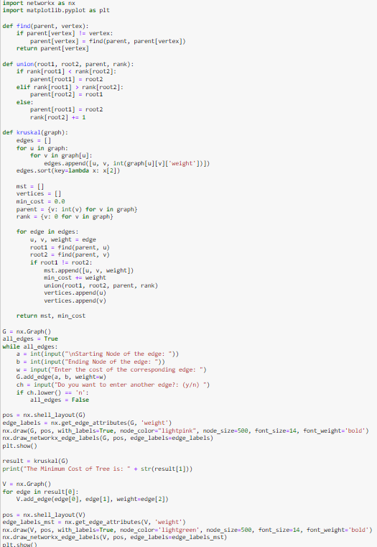****Code of Analysis of Kruskal’s Algorithm (in Python):**

**Output:**

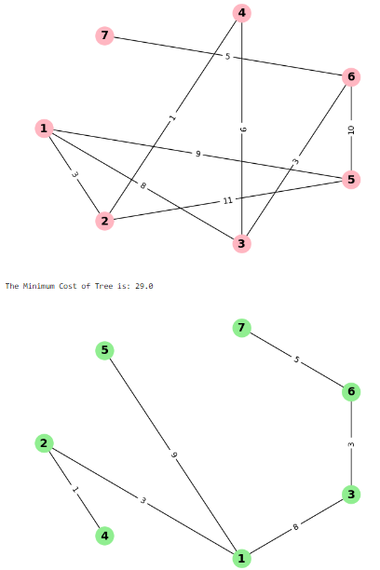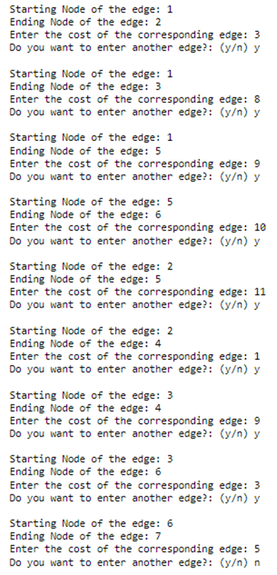**Case 1**

**C****ase 2**

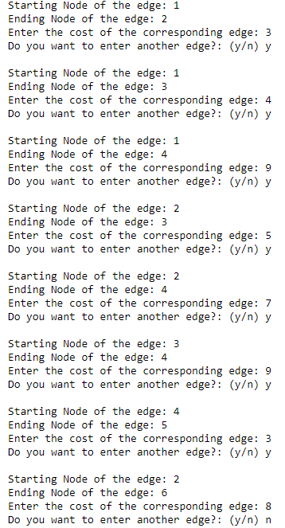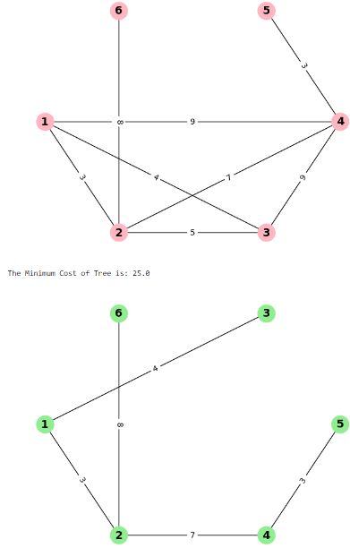

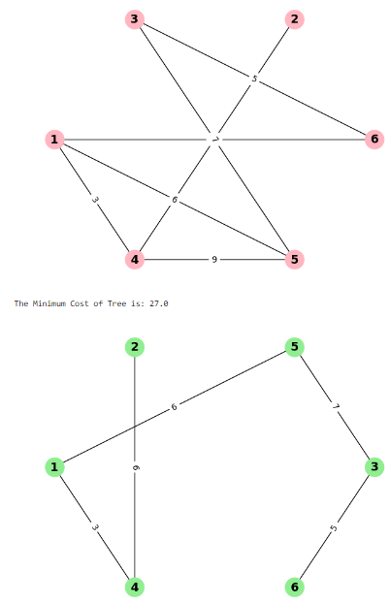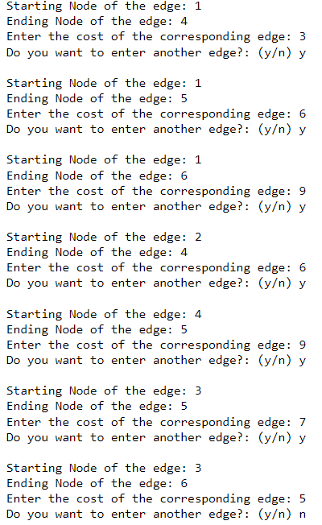 **Case 3**

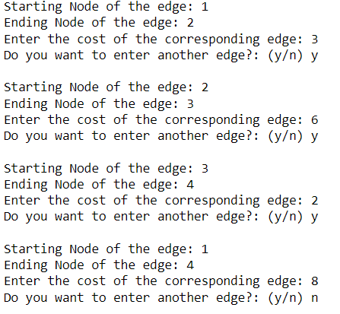**Case 4**

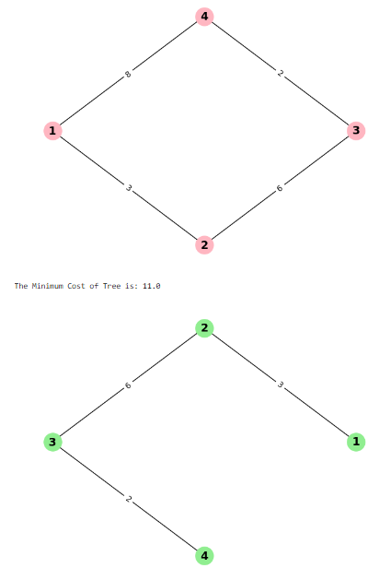

**Analysis:**

**I. Function Definitions:**

* The code defines three functions: find, union, and kruskal . These functions are used to implement the Kruskal's algorithm.

**II. Kruskal's Algorithm:**

* The kruskal function takes a graph as input and returns the MST and its minimum cost. It sorts the edges of the graph by weight and iterates over them, adding edges to the MST if they don't form a cycle.

**III. Input Handling:**

* The code prompts the user to input the edges of the graph along with their weights. It then constructs the graph using Networkx.

**IV. Visualization:**

* The code uses Networkx and Matplotlib to visualize both the original graph and the resulting MST. It displays the original graph with edge labels showing the weights and the MST with edge labels indicating the weights of the selected edges.

**V. Correctness:**

* The implementation appears correct, as it follows the steps of Kruskal's algorithm to find the MST of the input graph.

**Conclusion:**

Kruskal's algorithm is a robust and efficient method for finding minimum spanning trees in graphs. Its greedy approach, coupled with the disjoint-set data structure, ensures both correctness and scalability, making it well-suited for real-world applications in network design, clustering, and optimization. With its straightforward implementation and proven effectiveness, Kruskal's algorithm remains a cornerstone in the field of graph theory and algorithm design.

**Experiment 13**

**Analysis of Activity Selection Algorithm**

**Aim:**

The aim of the Activity Selection Algorithm is to select the maximum number of non-overlapping activities from a set of activities, each characterized by a start and finish time, maximizing overall utility or efficiency. This algorithm ensures optimal scheduling of activities within a given time frame.

**Description:**

Activity Selection Problem is a problem of scheduling several competing activities with a goal of selecting a maximum-size set of mutually compatible activities. In this problem we are given n activities with their start and finish times. We are required to select the maximum number of activities that can be perform by a single person, assuming that a person can only work on a single activity at a time. By using Greedy Approach, we always pick the next activity such that whose finish time is the least among the remaining activities and the start time is more than or equal to the finish time of the previously selected activity. We can sort activities according to their finishing time so that we always consider the next activity as the minimum finishing time activity.

Given a set of activities

S={a1,a2,a3,_____an}

Each activity ai,1<=i<=n has start time Si finish time fi

0<=Si<=fi<

Activities ai and aj are compatible if activity ai finishes before activity aj starts.

ai [Si, fi) aj [Sj,fj) Compatible if Si>=fi or Sj>=fj

**Problem:**

Select maximum size subset of mutually compatible activities.

|  |  |  |  |  |  |  |  |  |  |  |  |
| --- | --- | --- | --- | --- | --- | --- | --- | --- | --- | --- | --- |
| i | 1 | 2 | 3 | 4 | 5 | 6 | 7 | 8 | 9 | 10 | 11 |
| Si | 1 | 3 | 0 | 5 | 3 | 5 | 6 | 8 | 8 | 2 | 12 |
| fi | 4 | 5 | 6 | 7 | 8 | 9 | 10 | 11 | 12 | 13 | 14 |

{a3, a8, a11}

**Greedy Solution:**

Activities are selected on the basis of smallest finish time.

**Algorithm for Activity Selection**

ACTIVITY_SELECTION (s, f)

n <-length[s];

A<-{a1}

l<-1

for m<-2 to n do

if Sm >=fi then

A<-A U {am}

i<-m

return A

Time complexity of this algorithm is Theta(n)

**I. Sort Activities:**

* First, sort the activities based on their finish times in non-decreasing order. This step ensures that activities with earlier finish times come first in the sorted list.

**II. Select First Activity:**

* Select the first activity from the sorted list, as it will always be a part of the optimal solution.

**III. Iterate through Activities:**

* Iterate through the sorted list of activities starting from the second activity.

**IV. Greedy Selection:**

* For each activity, if its start time is greater than or equal to the finish time of the previously selected activity, select it and update the last selected activity to the current one.

The Activity Selection Algorithm is efficient with a time complexity of O(n log n), where n is the number of activities, primarily due to the sorting step. Once the activities are sorted, the algorithm iterates through them linearly, selecting activities in constant time.

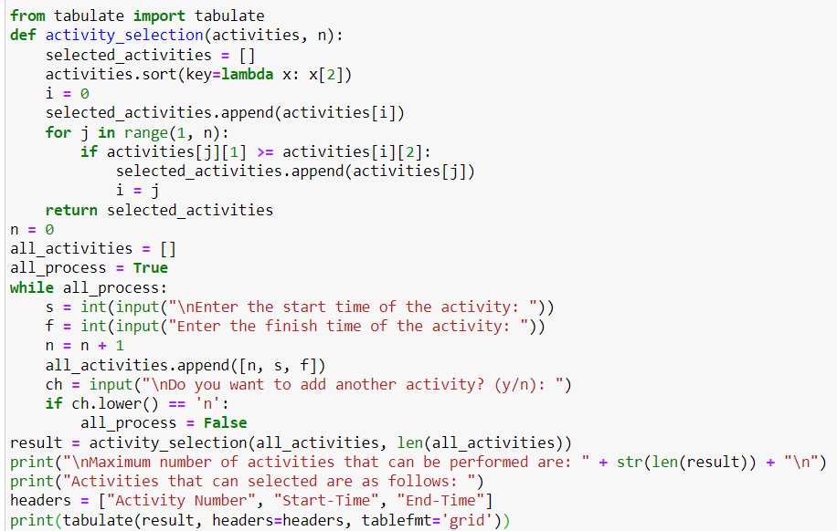**Code of Analysis of Activity Selection Algorithm (in Python):**

**Output:**

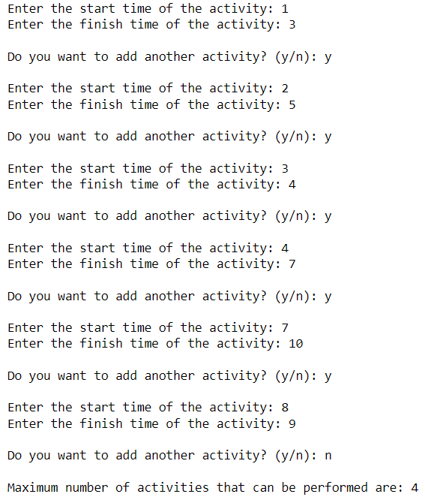**Case 1**

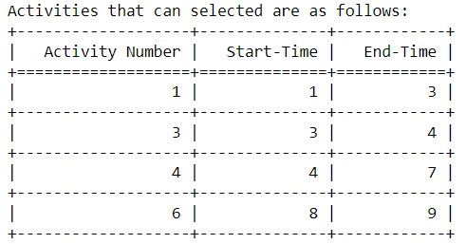

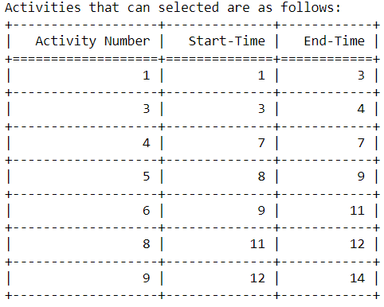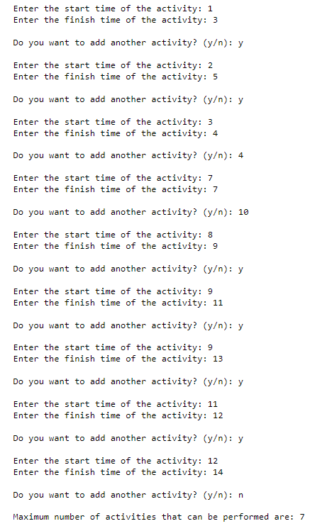 **Case 2**

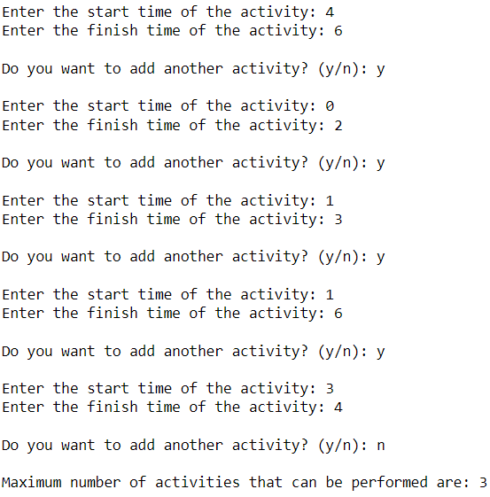**Case 3**

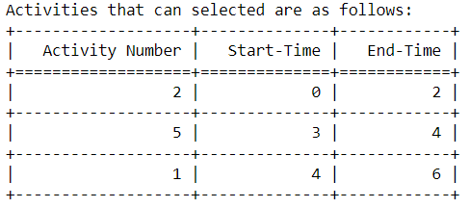

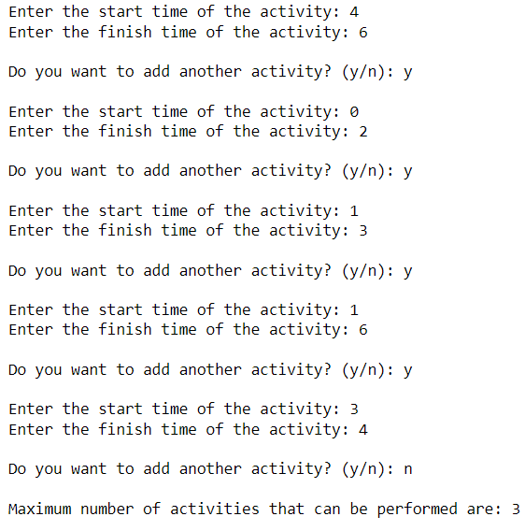**Case 4**

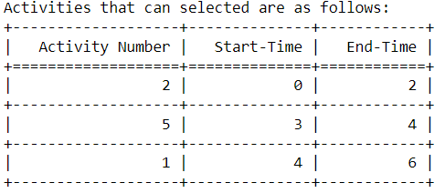

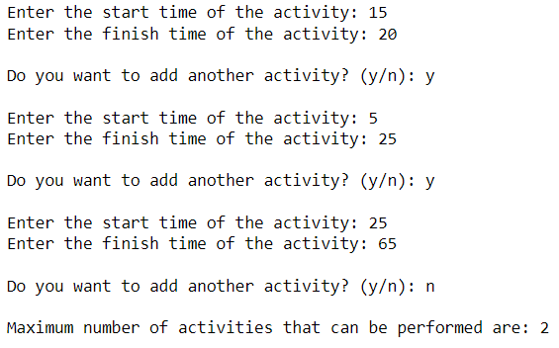 **Case 5**

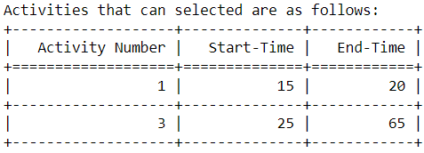

**Analysis:**

**I. Function activity_selection(activities, n):**

* This function takes a list of activities activities and the number of activities n as input.
* It initializes an empty list selected_activities to store the selected activities.
* It sorts the activities based on their finish times.
* It iterates through the sorted activities, selecting each activity if its start time is greater than or equal to the finish time of the previously selected activity.
* Finally, it returns the list of selected activities.
* Module 'tabulate' is imported to make the table.

**II. User Input Loop:**

* The code prompts the user to enter the start and finish times of activities one by one until the user decides not to add more activities.
* It stores the activities in a list all_activities.

**III. Activity Selection and Output:**

* After all activities are entered, the activity_selection function is called with the list of activities and its length.
* The maximum number of activities that can be performed is printed along with the selected activities in tabular format using the tabulate function from the tabulate module.

**IV. Time Complexity**

* When the list in not sorted:

O(nlogn)

* When the list is already sorted:

O(n)

**Conclusion:**

The Activity Selection algorithm efficiently selects a maximum set of mutually compatible activities from a given set based on their start and finish times. By iteratively choosing activities with the earliest finish times after sorting, it ensures optimal selection. With a time complexity of O(nlogn) due to sorting, it offers a practical solution for scheduling and resource allocation problems.

**Experiment 14**

**Analysis of Dijkstra’s Algorithm**

**Aim:**

The aim of analyzing Dijkstra's algorithm is to understand its efficiency and correctness in finding the shortest path from a single source vertex to all other vertices in a weighted graph. This analysis typically focuses on its time complexity, space complexity, and its ability to handle various graph structures and edge weights.

**Description:**

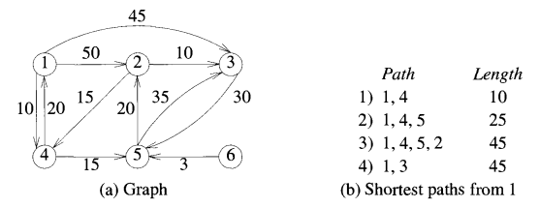Dijkstra's Algorithm is a greedy algorithm used to find the shortest distance between the source vertex and the remaining vertices of the graph. It usually consists of a directed weighted graph G= (V, E) in which V represents the vertices of Graph G and E represents the directed edges in Graph G. The source vertex is specified as the starting point, and the algorithm calculates the shortest distances to all other vertices in the graph from this source vertex. Dijkstra's Algorithm is also called Single Source Shortest Path Algorithm. One crucial assumption of this algorithm is that the graph does not contain negative edge costs, as such costs may not lead to an optimal solution.

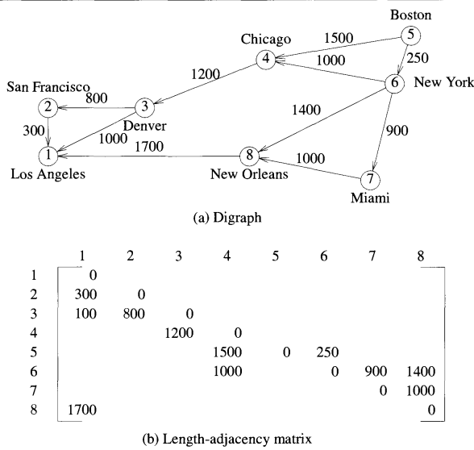

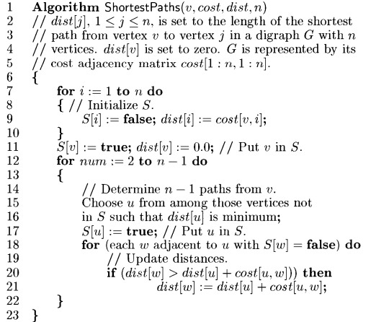**Algorithm For Dijkstra’s Algorithm:**

**I. Graph Representation:**

* Dijkstra's algorithm operates on a weighted graph, where each edge has a non-negative weight representing the cost or distance between two vertices.
* The algorithm can handle both directed and undirected graphs.

**II. Initialization:**

* The algorithm begins by initializing a priority queue or a set to keep track of vertices and their tentative distances from the source vertex. Initially, all distances are set to infinity except for the source vertex, which is set to 0.

**III. Greedy Selection:**

* At each step, the algorithm selects the vertex with the smallest tentative distance from the source vertex. This vertex is considered as the current vertex and is removed from the priority queue or set.

**IV. Relaxation:**

* For each neighbor of the current vertex, the algorithm updates their tentative distances if a shorter path through the current vertex is found. This process is called relaxation.

**V. Termination:**

* The algorithm terminates when all vertices have been visited, or when the destination vertex has been reached and its shortest path has been determined.

**VI. Complexity Analysis:**

**1. Time Complexity:**

* Dijkstra's algorithm typically has a time complexity of O(V^2) for the naive implementation using an adjacency matrix, where V is the number of vertices. However, using a priority queue to efficiently extract the minimum distance vertex reduces the time complexity to O((V + E) log V), where E is the number of edges.

**2. Space Complexity:**

The space complexity is O(V) to store the priority queue or set and O(E) to store the graph's adjacency list or matrix.

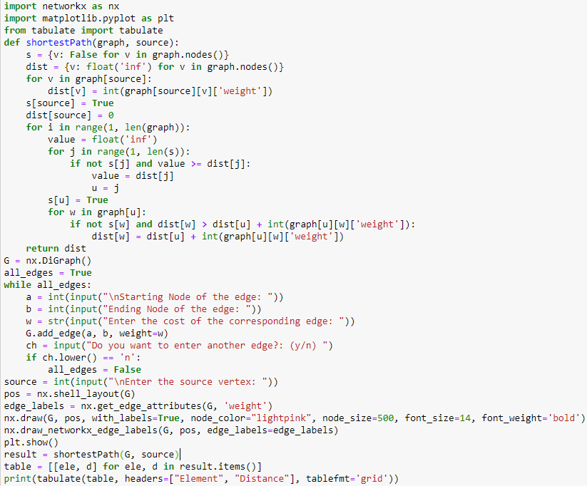**Code of Analysis of Dijkstra’s Algorithm (in Python):**

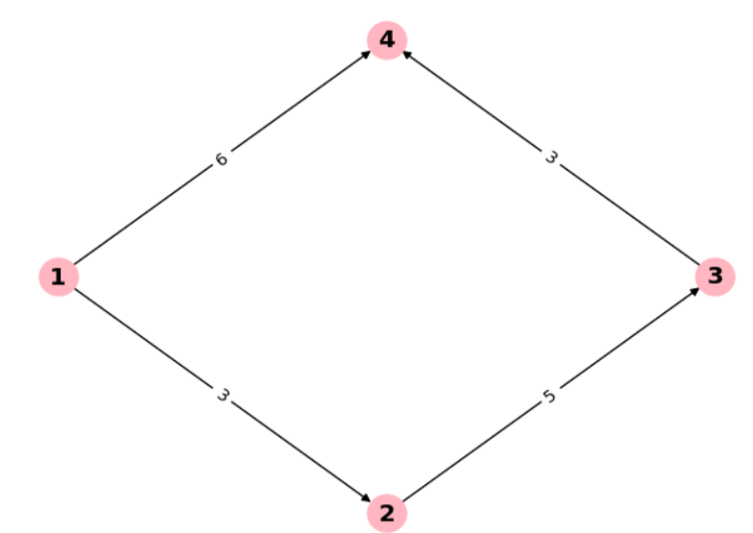**Output:**

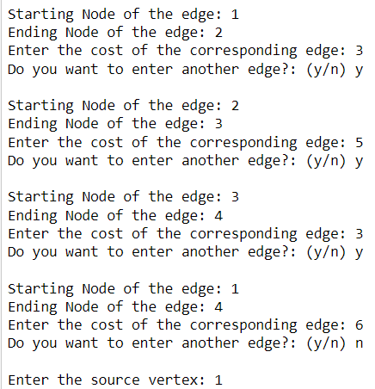**Case 1**

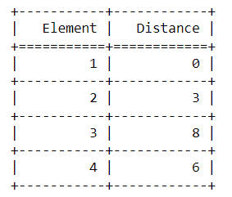

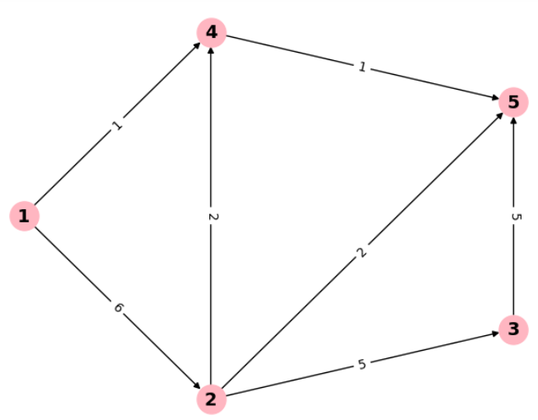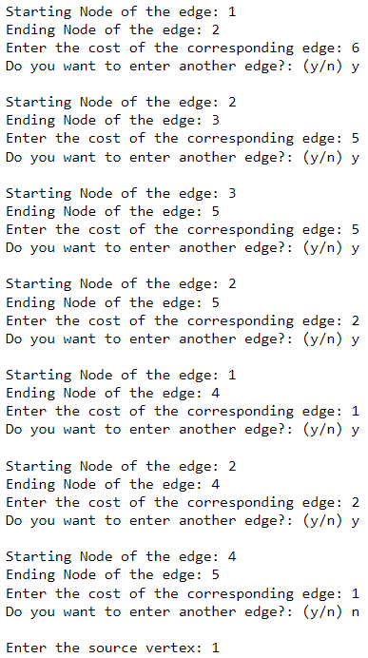 **Case 2**

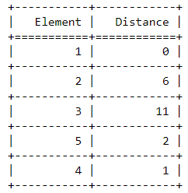

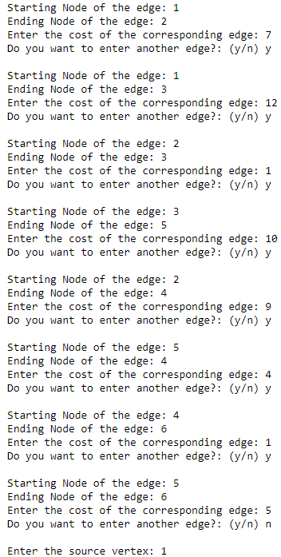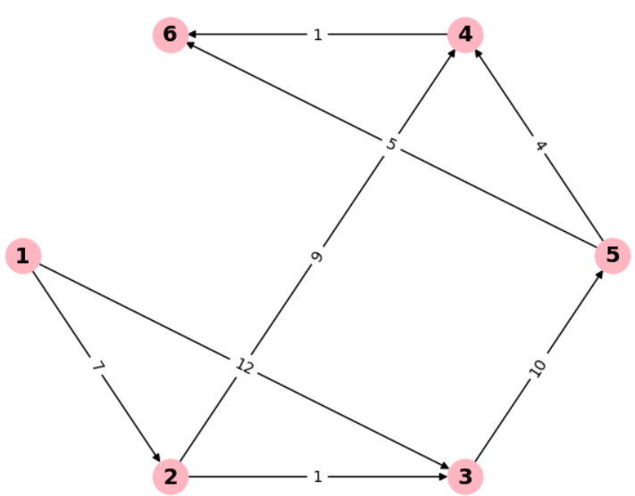 **Case 3**

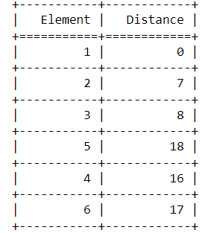

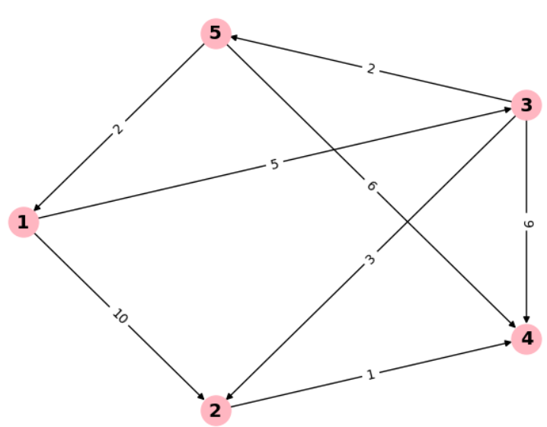

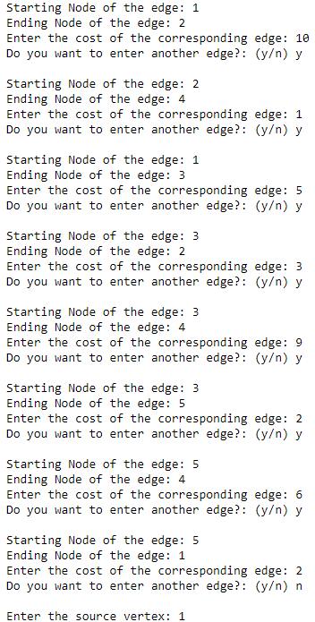**Case 4**

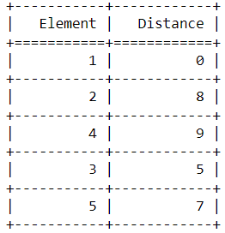

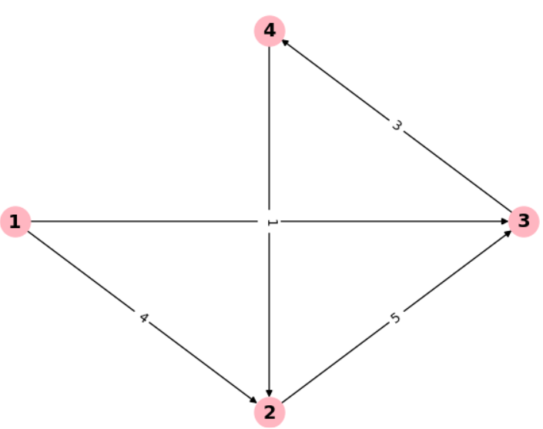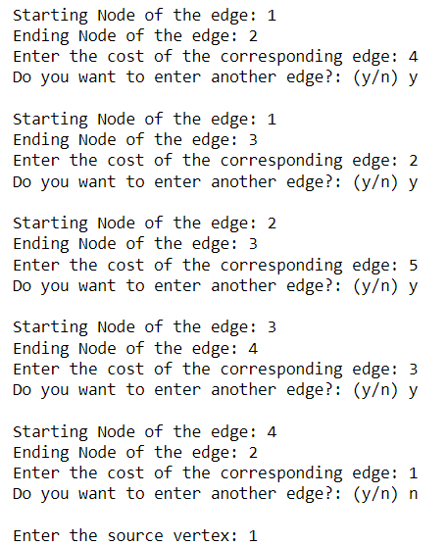 **Case 5**

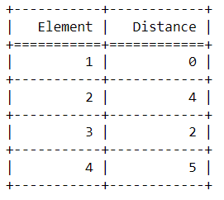

**Analysis:**

**I. Input Gathering:**

The code prompts the user to input the edges of the graph along with their corresponding weights. It also takes the source vertex from which the shortest paths are to be calculated.

**II. Graph Creation:**

It uses NetworkX to create a directed graph (nx.DiGraph()) and adds edges with weights based on user input.

**III. Visualization:**

The graph is visualized using Matplotlib after positioning the nodes with a shell layout.

**IV. Shortest Path Calculation:**

The shortestPath function computes the shortest paths using Dijkstra's algorithm. It initializes sets for visited vertices (s) and distances (dist). Then, it iterates through all vertices, updating distances as necessary to find the shortest path.

**V. Output Formatting:**

The resulting shortest path distances are displayed in a tabular format using the tabulate library.

**VI. Complexity:**

**1. Time Complexity:**

The time complexity of Dijkstra's algorithm implemented here is O(V^2), where V is the number of vertices. This is due to the nested loops in the shortestPath function, where each vertex is visited once and each edge is relaxed once but with the help of min-priority queue it drop down to O(V + ElogV).

**2. Space Complexity:**

The space complexity is O(V) to store the sets s and distance, and O(E) to store the graph, where E is the number of edges.

**Conclusion:**

Dijkstra's algorithm efficiently finds the shortest path from a source vertex to all other vertices in a weighted graph. By iteratively selecting the vertex with the smallest tentative distance and updating distances through relaxation, it guarantees optimality in non-negative edge-weighted graphs. With a time complexity of O((V + E) log V) using a priority queue, it's suitable for various real-world applications such as network routing and road navigation systems. However, it's not suitable for graphs with negative edge weights.

**Experiment 15**

**Analysis of All pairs shortest path (Floyd-Warshall) Algorithm**

**Aim:**

The aim of the Floyd-Warshall algorithm is to find the shortest paths between all pairs of vertices in a weighted graph, where the weights can be positive or negative.

**Description:**

**Floyd-Warshall Algorithm: Solving the All-Pairs Shortest Path Problem**

**I .Introduction:**

* The Floyd-Warshall algorithm is a dynamic programming approach used to solve the all-pairs shortest path problem for a weighted, directed graph.
* Given a directed graph G=(V,E) with n vertices, the algorithm aims to find the shortest paths between all pairs of vertices.
* The cost adjacency matrix cost represents the graph G, where cost(i,j) denotes the length or cost of edge (i,j) it it belongs to E(G).

**II. Problem Definition:**

* The all-pairs shortest-path problem seeks to determine a matrix A such that A(i.j) represents the length of a shortest path from vertex I to vertex j.
* In the cost adjacency matrix cost, cost(i,j) = 0 if i=j , cost(i,j ) = infinity if i not equal to j and (i,j) doesn't belong to E(G).

**III. Constraints and Considerations:**

* To ensure the Floyd-Warshall algorithm's effectiveness, it's crucial that the graph G has no cycles with negative lengths.
* Introducing negative cycles would lead to infinitely decreasing path lengths, rendering the shortest path problem ill-defined.

**IV. Algorithm Overview:**

* The Floyd-Warshall algorithm iteratively updates the matrix A by considering intermediate vertices between pairs of vertices i and j.
* For each vertex k, the algorithm assesses whether the path between vertices i and j can be improved by traversing through k.
* If such an improvement exists, the algorithm updates the distance matrix A by setting A(i,j) to the minimum of its current value and the sum of distances from i to k and from k to j.
* This process is repeated for every vertex k, ultimately computing the shortest path between every pair of vertices in the graph.

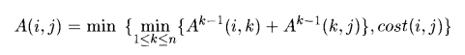

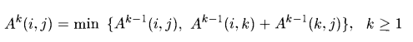

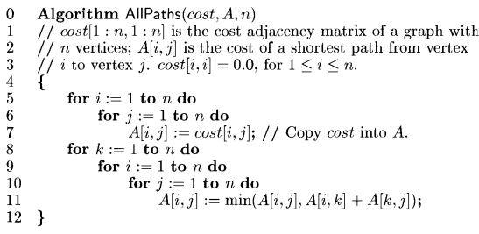 **V.** **Algorithm for All pairs shortest path (Floyd-Warshall):**

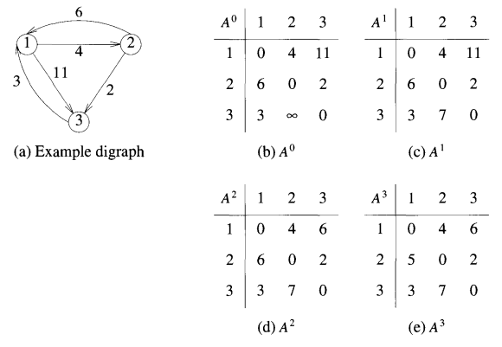**VI. Example Digraph:**

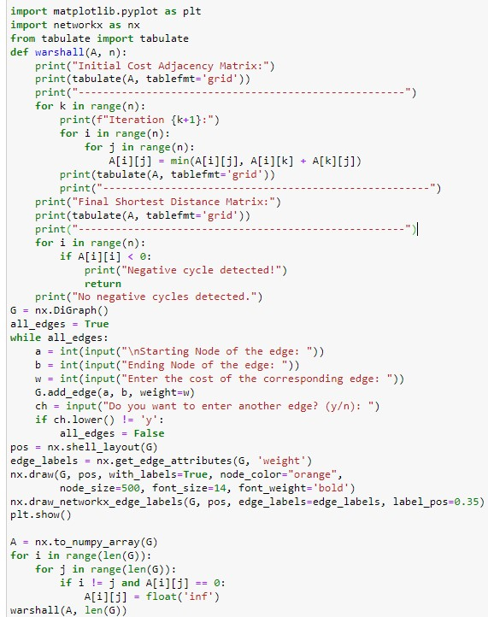**C****ode of Analysis of Floyd-Warshall Algorithm (in Python):**

**Output:**

**Case 1:**

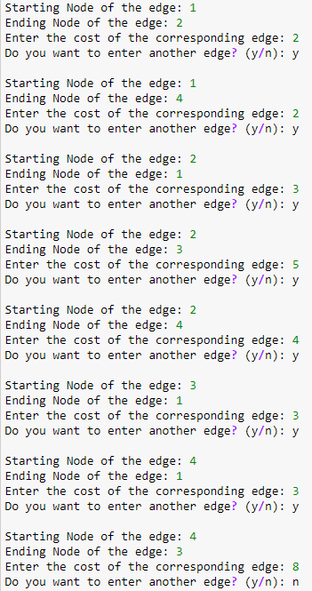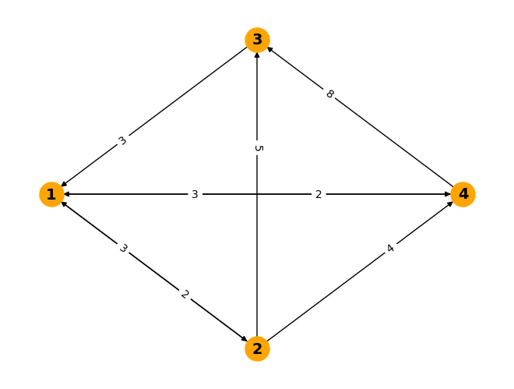When cost of all edges are positive

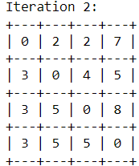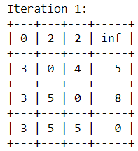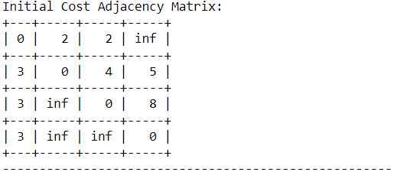

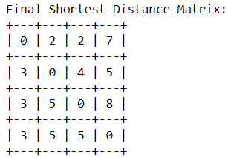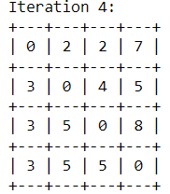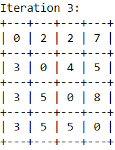

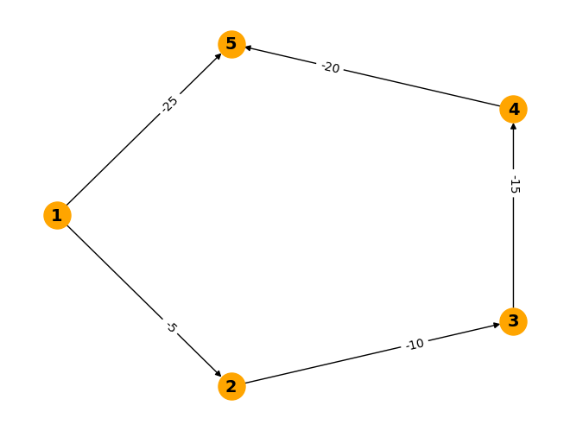**Case 2:**

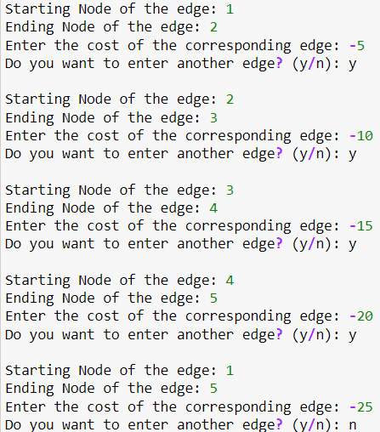When cost of all edges are negative

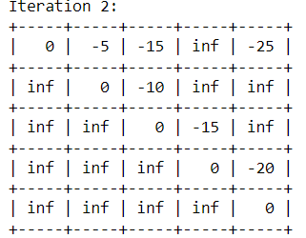

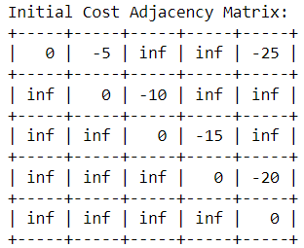

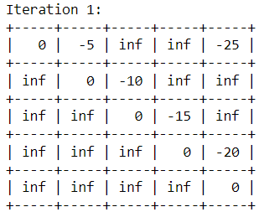

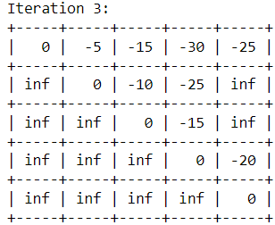

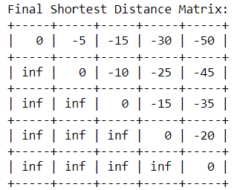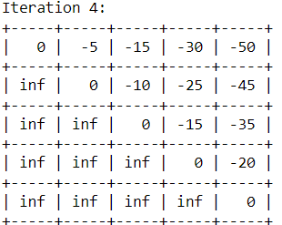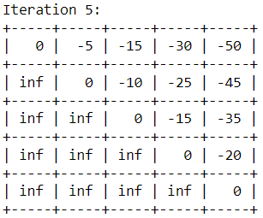

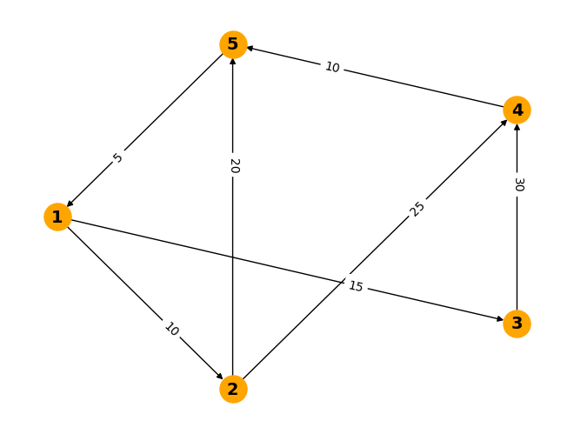 **Case 3:**

When cost of all edges are positive 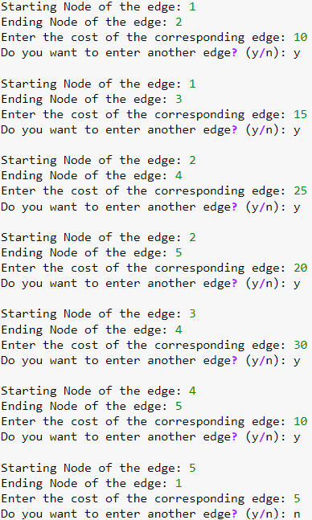

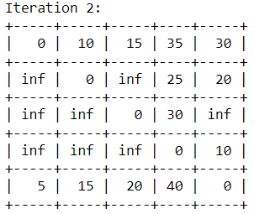

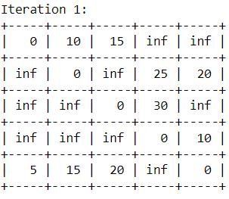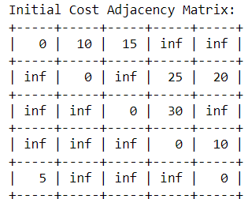

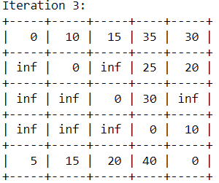

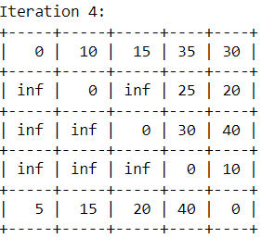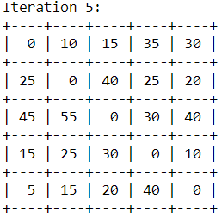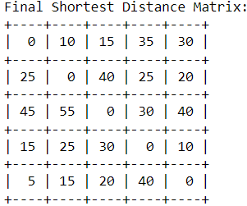

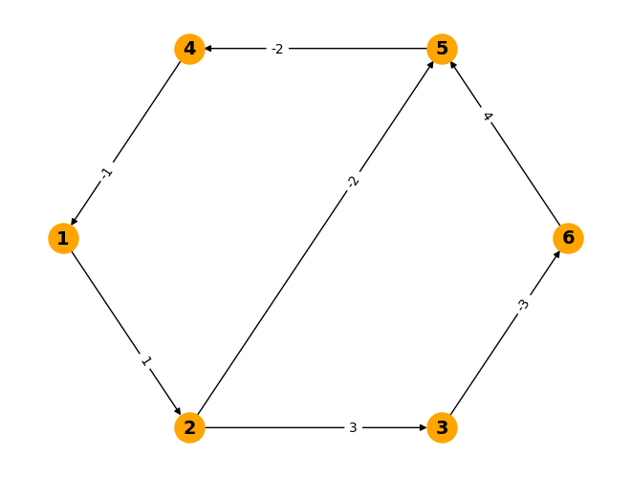 **Case 4:**

When cost of all edges are positive as well as

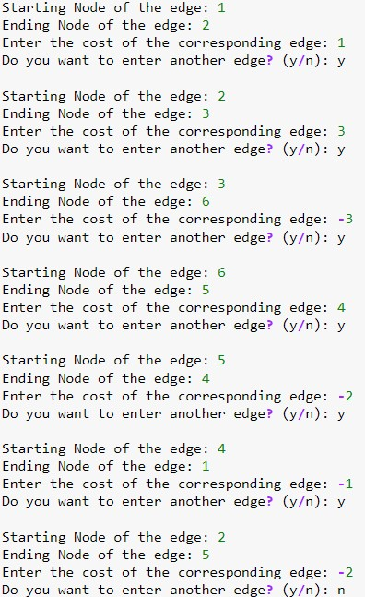negative with negative edge cycle present

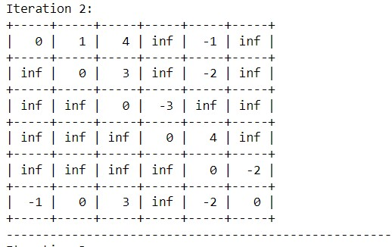

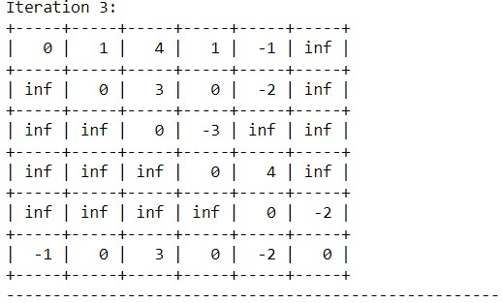

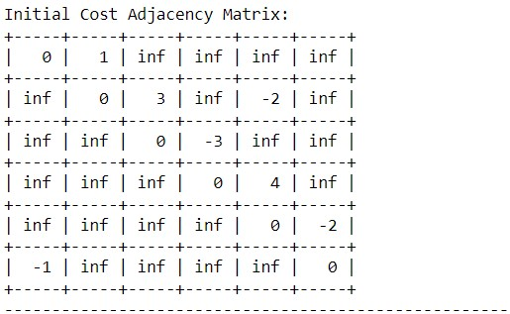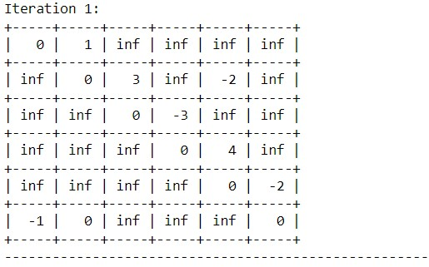

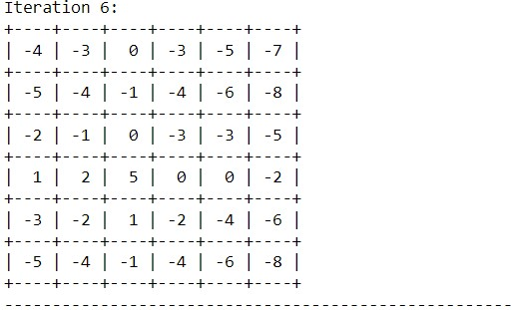

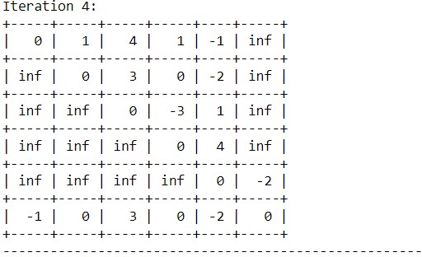

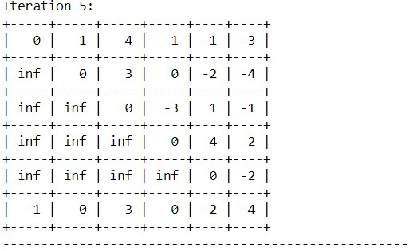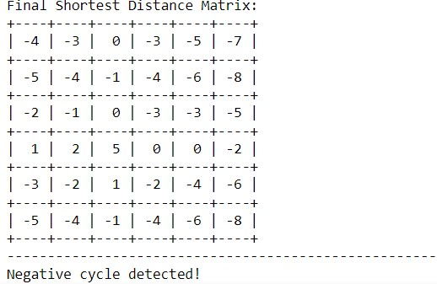

**Analysis:**

**I. User Input:**

* The user is prompted to input the edges of the graph along with their weights.
* The user can input multiple edges until they choose not to enter more edges.

**II. Graph Visualization:**

* The entered graph is visualized using NetworkX and Matplotlib libraries.
* Node positions are determined using the shell layout.
* Edge weights are displayed as labels on the graph.

**III. Warshall's Algorithm:**

* The function warshall(A, n) takes the adjacency matrix A and the number of vertices n as input.
* It applies Warshall's algorithm to compute the shortest paths between all pairs of vertices.

**IV. Detection of Negative Cycles:**

* After the algorithm completes, it checks for negative cycles in the graph.
* If any negative cycle is detected, it prints a message indicating its presence.

**V. Graph Visualization:**

**1. Time Complexity:**

The time complexity of Warshall's algorithm is O(n^3), where n is the number of vertices in the graph.

**2. Space Complexity:**

The space complexity of the implementation depends on the size of the adjacency matrix, which is O(n^2).

**Conclusion:**

The analysis concludes that the Floyd-Warshall algorithm efficiently computes the shortest paths between all pairs of vertices in a directed graph. With a time complexity of O(n^3) and space complexity of O(n^2), it accurately handles negative edge weights and detects negative cycles, making it suitable for various real-world applications

**Experiment 16**

**Analysis of Multi Stage Graph Algorithm**

**Aim:**

The aim of the analysis of the Multi-Stage Graph Algorithm is to understand its efficiency, applicability, and limitations in solving problems involving multi-stage graphs. This includes assessing its time and space complexity, its ability to find optimal solutions, and its performance under different scenarios and input conditions.

**Description:**

**I. Introduction:**

* Description of the problem setup involving a directed graph G = (V , E) with k>=2 disjoint set of vertices.
* Explanation of the conditions for edges in E and the roles of source (s) and sink (t) vertices.

**II. Recursive Formula and Recurrence Relation:**

* Derivation of the recursive formula for the minimum cost of a path from s to t using a forward approach.
* Definition of p(i , j) as the minimum-cost path from vertex j in V to vertex t.
* Explanation of cost(i,j) as the cost of the path p(i,j).
* 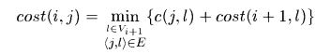Introduction of the recurrence relation:

**III. Computation of Minimum Cost Path:**

* Description of the method to compute the minimum-cost path from s to t by tracing back the decisions.
* Illustration of how the decisions leading to the minimum cost are determined and utilized.

**IV. Stage Analysis:**

* Analyze each stage individually to understand the nodes and edges within that stage. Consider the role of each node and how it contributes to the overall process.

**V. Dependency Analysis:**

* Examine the edges between stages to identify dependencies between tasks or events.
* Determine the directionality of dependencies and whether they represent prerequisite relationships or other types of dependencies.

**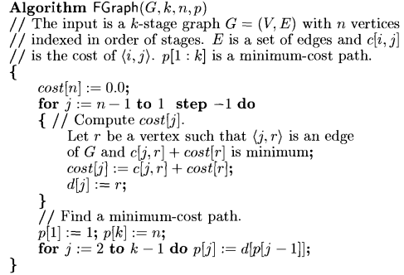****VI. Pseudocode for Analysis of Multi Stage Graph (Forward Approach):**

**VII. Pseudocode for Analysis of Multi Stage Graph (Backward Approach):**

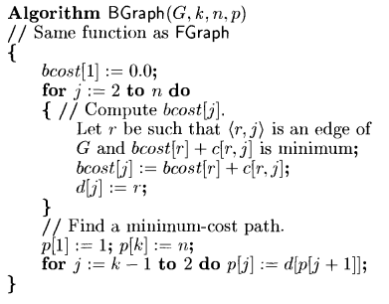

**Code of Analysis of Multi Stage Graph Algorithm using both Forward and Backward Approach (in Python):**

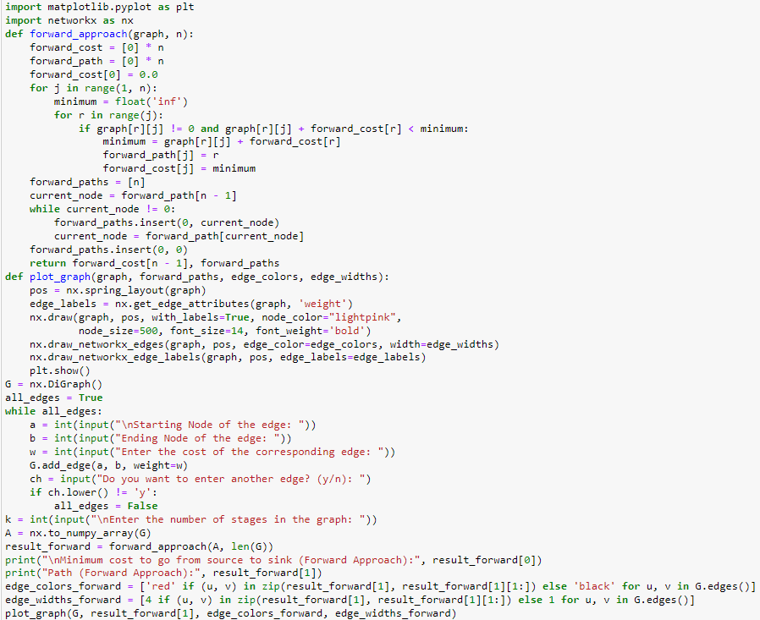**I. Forward Approach:**

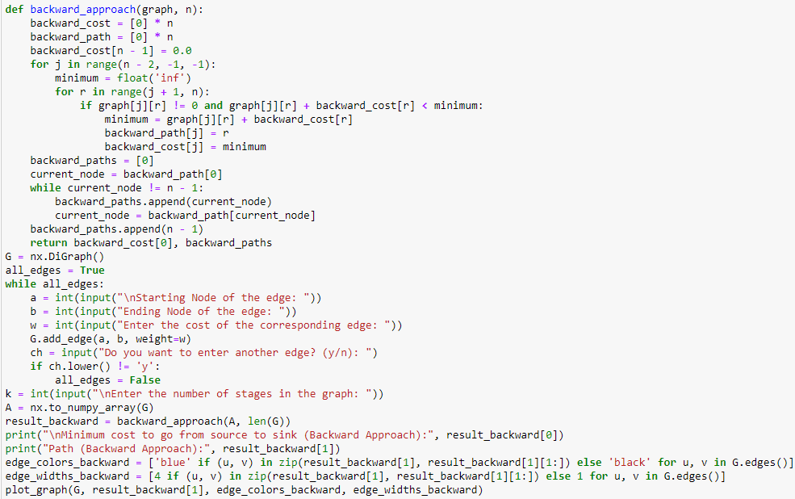**II. Backward Approach:**

**Output:**

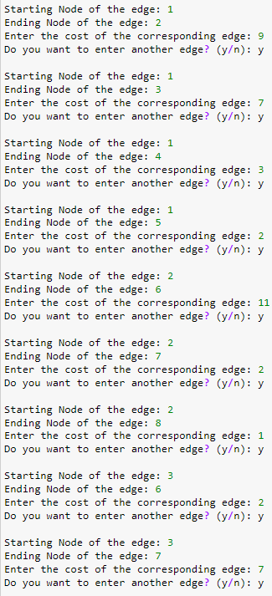 **Case 1**



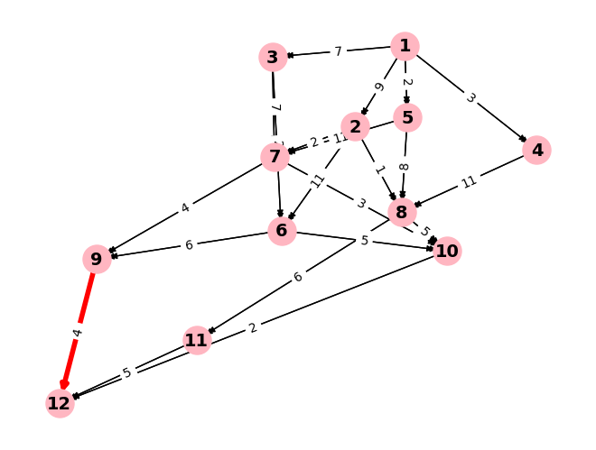

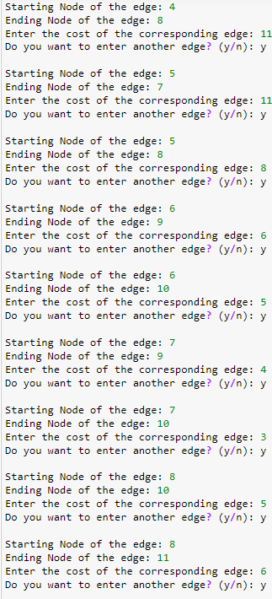



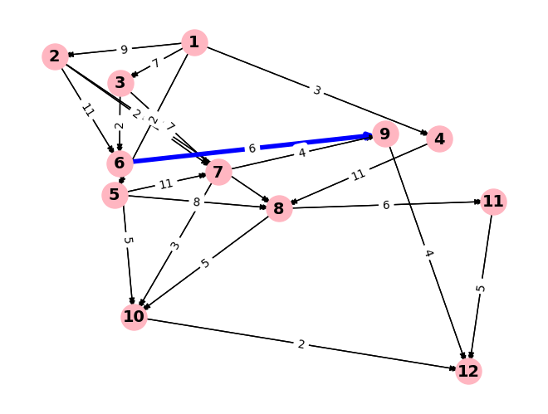

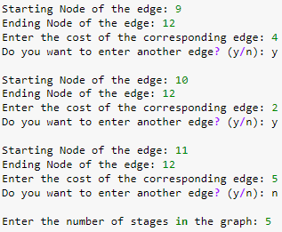

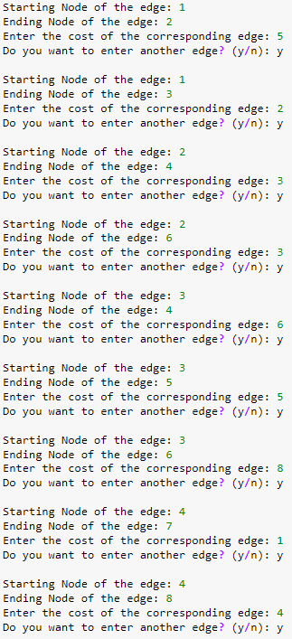 **Case 2**

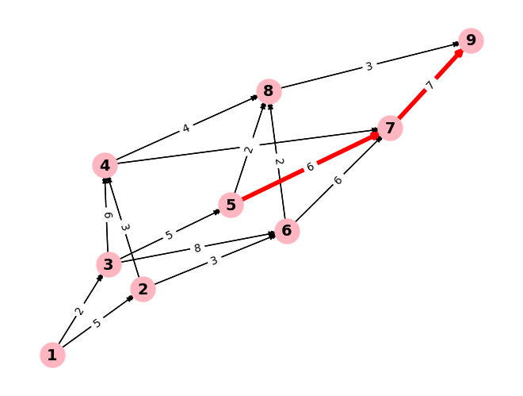

****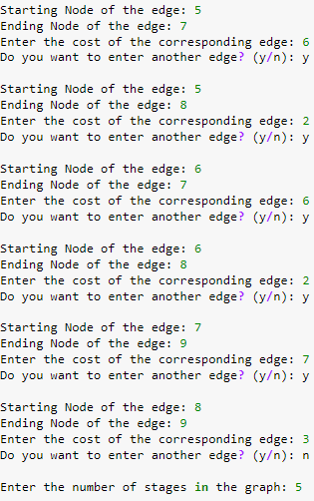

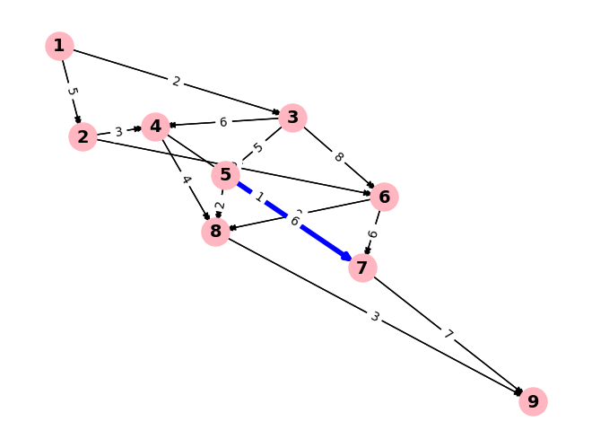

**Analysis:**

**I. Problem Definition and Function Definition:**

* The code aims to perform analysis on a multistage graph.
* It defines a function multistageGraph to calculate the minimum cost and paths from source to sink using both forward and backward approaches.

**II. Input of Graph:**

* The user inputs the graph edges (starting node, ending node, and edge weight) iteratively.
* The user specifies whether to continue adding edges.
* The number of stages k is also input.

**III. Graph Visualization:**

* The graph is visualized using NetworkX and Matplotlib.
* Nodes are represented with labels and colors.
* Edge weights are displayed as labels on the edges.

**IV. Conversion to Adjacency Matrix:**

* The NetworkX graph is converted to an adjacency matrix.
* The adjacency matrix is used for further calculations.

**V. Forward and Backward Approaches:**

* The code performs forward and backward passes to find minimum distances and paths.

**1. Forward approach:**

* Finds the minimum distance from the source to each node in each stage.

**2. Backward approach:**

* Finds the minimum distance from the sink to each node in each stage.

**VI. Path Reconstruction:**

* Paths are reconstructed based on the calculated forward and backward paths.
* Forward and backward paths are stored and displayed.

**VII. Visualization of Paths:**

* The calculated paths are visualized on the graph.
* Forward path edges are colored red, backward path edges are colored blue, and other edges are black.
* Edge widths are adjusted to highlight the paths.

**IX. Complexity Analysis:**

**1. Time Complexity:**

* The input process takes O(E) time, where E is the number of edges.
* Constructing the adjacency matrix takes O(V^2) time, where V is the number of vertices.
* The forward and backward passes involve nested loops iterating over vertices and edges, resulting in O(V^2) complexity each.
* Path reconstruction takes O(V) time.
* Overall, the time complexity is O(V^2), dominated by the forward and backward passes.

**2. Space Complexity:**

* The space complexity is dominated by the adjacency matrix, which requires O(V^2) space.
* Additional space is used for storing forward and backward paths, resulting in O(V) space.
* Overall, the space complexity is O(V^2).

**Conclusion:**

The multi-stage graph algorithm efficiently determines minimum costs and paths from source to sink in a directed graph with multiple stages. By employing forward and backward passes, it optimally traverses through the graph, considering dependencies between stages. The algorithm's time complexity scales quadratically with the number of vertices, making it suitable for medium-sized graphs.

**Experiment 17**

**Analysis of Assembly Line Scheduling Algorithm**

**Aim:**

The aim of analysis of assembly line scheduling is to optimize the arrangement of tasks and resources in a production line to minimize idle time, maximize throughput, and enhance overall efficiency, ensuring timely completion of manufacturing processes while minimizing costs.

**Description:**

**Assembly Line Scheduling Analysis**

**I. Problem Definition:**

**1. Define tasks:**

* Specify tasks, their durations, precedence relationships, available resources, and production targets.

**2. Task sequencing:**

* Determine the sequence of tasks considering dependencies, machine capacities, setup times, and constraints.

**II. Time Estimation:**

**1. Accurate estimation:**

* Estimate time for each task using historical data, time studies, or simulation techniques.

**III. Resource Allocation:**

**1. Allocate resources:**

* Determine manpower, machinery, and materials allocation to balance workloads and optimize utilization.

**IV. Optimization Algorithms:**

**1. Apply algorithms:**

* Utilize mathematical programming (e.g., linear, integer, mixed-integer programming) and heuristics (e.g., genetic algorithms, simulated annealing) to find efficient schedules.

**V. Trade-off Analysis:**

**1. Evaluate trade-offs:**

* Analyze trade-offs between production time, costs, and resource utilization to find a balanced solution.

**VI. Sensitivity Analysis:**

**1. Assess robustness:**

* Conduct sensitivity analysis to understand the impact of parameter changes on the schedule and identify critical factors affecting performance.

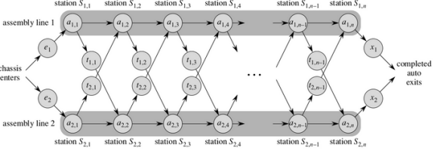

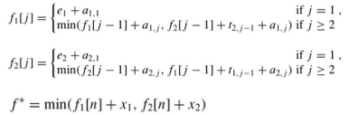**VII. Recurrence Relation:**

**VIII. Complexity Analysis:**

* Common dynamic programming algorithms for assembly line scheduling typically exhibit a time complexity of O(n), where n is the number of stations per assembly line.
* The space complexity of the assembly line scheduling algorithm is O(n), where n is the number of stations. This complexity arises from storing matrices to track the optimal costs and decisions made at each stage of the dynamic programming proces

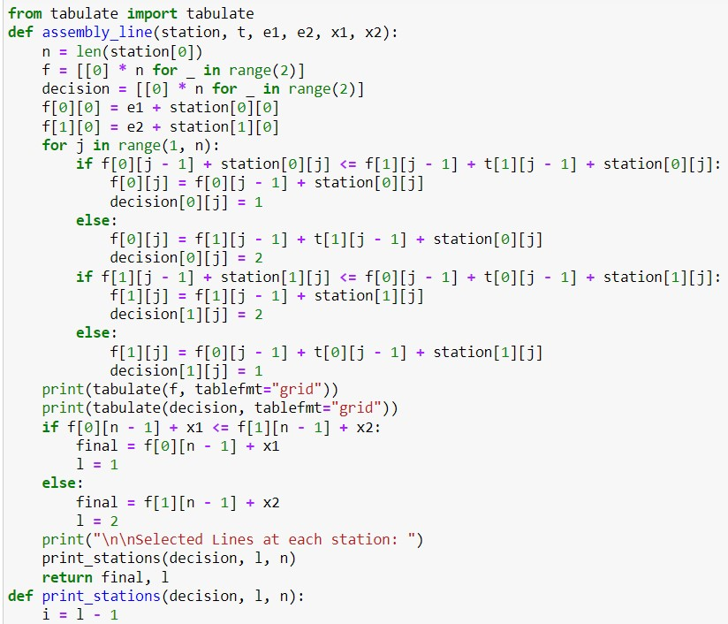**Code of Analysis of Assembly Line Scheduling Algorithm(in Python):**

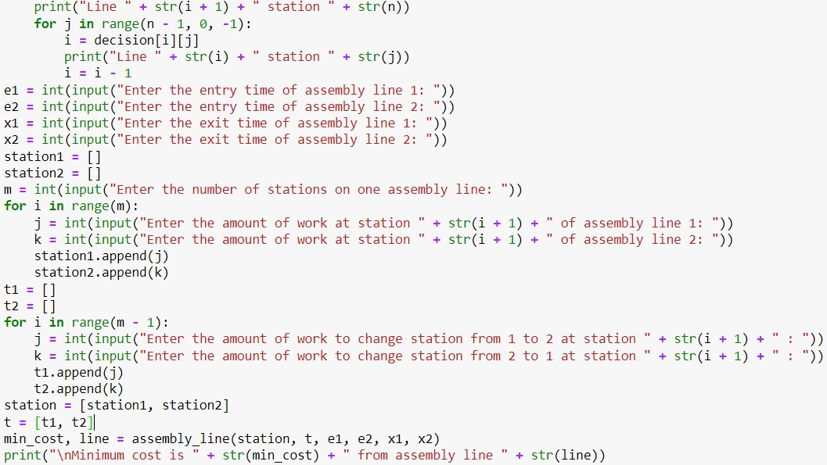

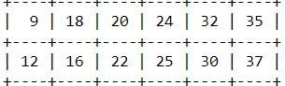**Output: f-matrix:**

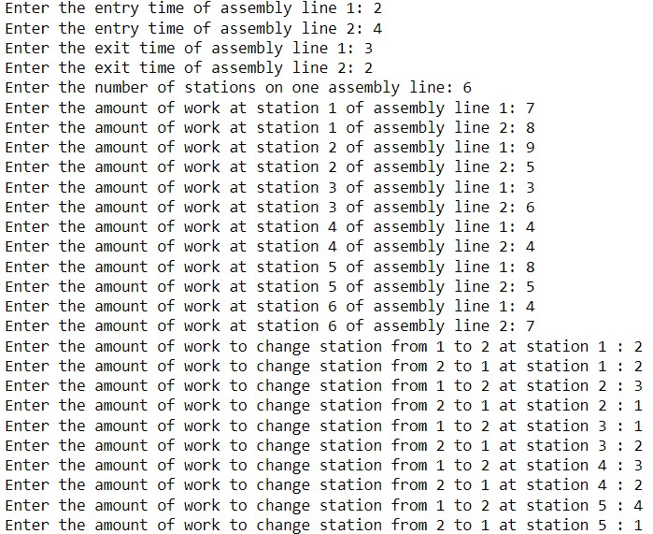 **Case 1**

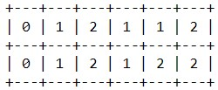 **Decision matrix:**

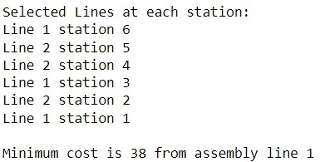

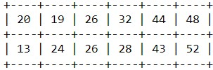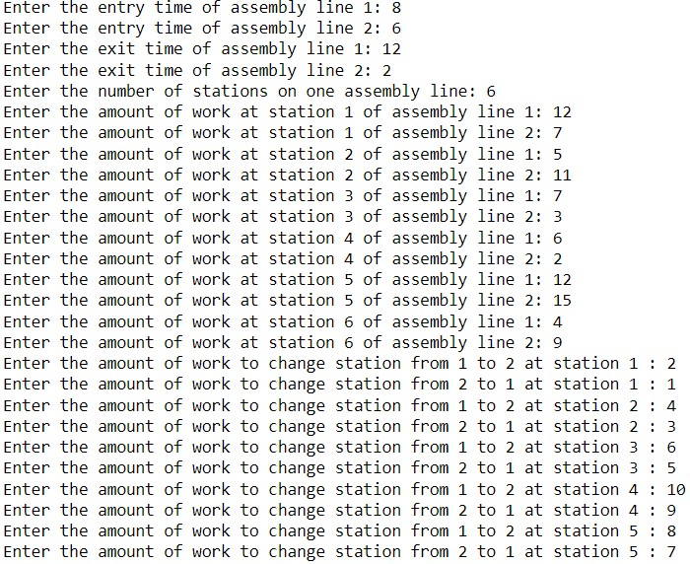 **Case 2 f-matrix:**

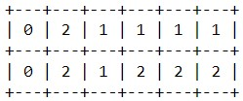 **Decision matrix:**

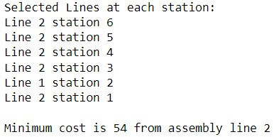

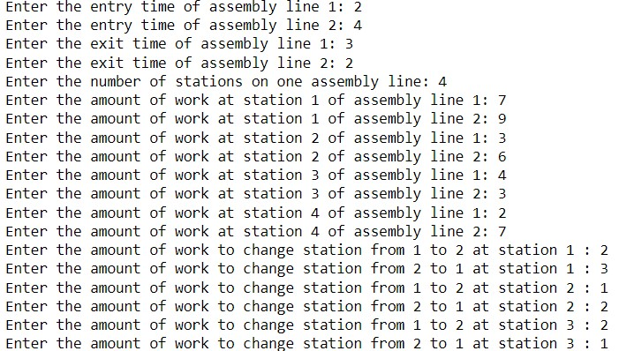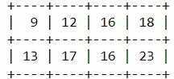 **Case 3 f-matrix:**

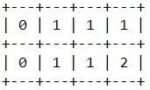 **Decision matrix:**

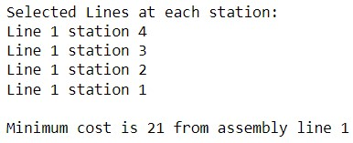

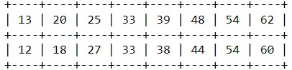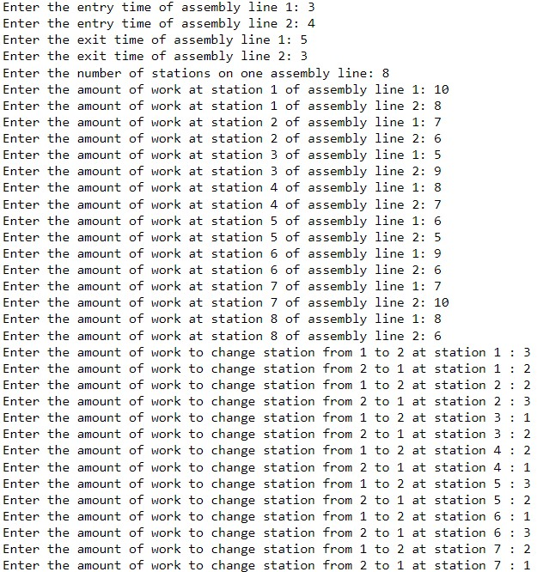 **Case 4 f-matrix:**

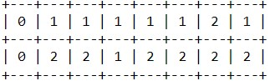 **Decision matrix:**

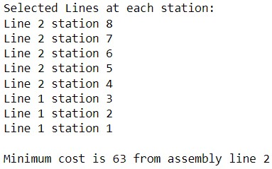

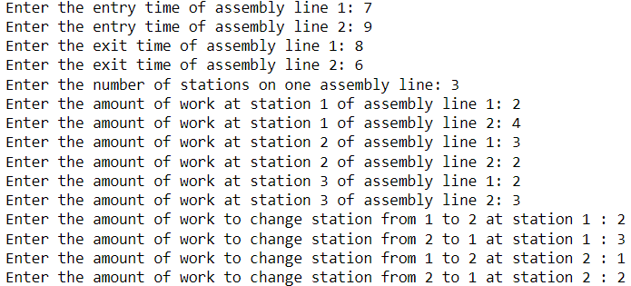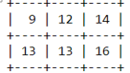 **Case 5 f-matrix:**

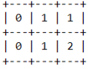 **Decision matrix:**

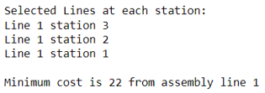

**Analysis:**

**I. Function assembly_line:**

* This function takes parameters such as station details, entry/exit times for each line, and transfer times.
* It initializes matrices f and decision to store the optimal costs and decisions made at each stage.
* Then, it iterates through each station, calculating the minimum cost of reaching that station on each line.
* Finally, it determines the minimum cost of exiting the assembly lines and prints the selected stations.

**II. Function print_stations:**

* This function prints the stations selected for each line based on the decisions made during the dynamic programming process.

**III. User Input Section:**

* It prompts the user to input parameters such as entry/exit times, station details, and transfer times.

**IV. Output:**

* It prints the matrices f and decision, displaying the calculated costs and decisions.
* It prints the minimum cost and the assembly line from which it originates.

**V. Analysis:**

* The code follows a bottom-up dynamic programming approach to find the optimal solution.
* It efficiently handles the decision-making process at each stage to minimize the overall cost.
* The print_stations function helps visualize the stations selected for each line, aiding in understanding the optimal path.

**Conclusion:**

The assembly line scheduling algorithm, leveraging dynamic programming, achieves optimal solutions with a time complexity of O(n), where n is the number of stations. By efficiently calculating the minimum cost path through the assembly lines and considering transfer times, it minimizes production costs while maintaining a linear time complexity, ensuring scalability for larger production scenarios.

**Experiment 18**

**Analysis of Matrix Chain Multiplication Algorithm**

**Aim:**

The aim of analyzing the Matrix Chain Multiplication algorithm is to understand its efficiency and performance characteristics in solving the problem of multiplying a sequence of matrices.

**Description:**

**Matrix Chain Multiplication Problem**

**I. Introduction:**

* The matrix chain multiplication problem involves determining the most efficient way to multiply a sequence of matrices, aiming to minimize the number of scalar multiplications required.

**II. Problem Statement:**

* Given a chain of matrices to be multiplied (n matrices, <A , A , A ,...,A >), the objective is to find the order of multiplying the matrices that requires the least amount of scalar multiplications.

**III. Properties of Matrix Multiplication:**

* Matrix multiplication is associative.
* **Compatibility:**
* Two matrices A and B can only be multiplied if the number of columns of A equals the number of rows of B.

**IV. Matrix Dimensions:**

* For a chain of matrices A , A , . . . , A of n matrices, where each matrix A has dimension p × p.

**V. Cost Matrix (m):**

* The cost matrix (m) is a two-dimensional array where each element m[i,j] represents the minimum number of scalar multiplications required to compute the product of the matrices from A to A , inclusively, assuming the matrices are fully parenthesized in some optimal way.

**VI. Split Matrix (s):**

* The split matrix (s) is another two-dimensional array where each element s[i,j] contains the value of k that represents the optimal position to split the product A A ...A into two sub-products that are multiplied together to obtain the minimum number of scalar multiplications.

**VII. Goal:**

* The objective of the problem is to determine an order for multiplying matrices that minimizes the cost. Using dynamic programming, the optimal order for matrix multiplication can be found in polynomial time.

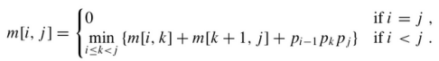**VII. Recursive Equation:**

**VIII. Complexity Analysis:**

* The time complexity of the Matrix Chain Multiplication algorithm is O(n^3), where n is the number of matrices. This complexity arises due to the nested loops used in dynamic programming to fill the cost and split matrices.
* The space complexity of the matrix chain multiplication algorithm is O(n^2), where n is the number of matrices in the chain. This complexity arises from the need to store a two-dimensional array to represent both the cost matrix (m) and the split matrix (s).

**Code of Analysis of Matrix Chain Multiplication Algorithm (in Python) using 2 different approaches(Bottom-Up (Iterative) Approach and Top-Down (Recursive with Memoization) Approach):**

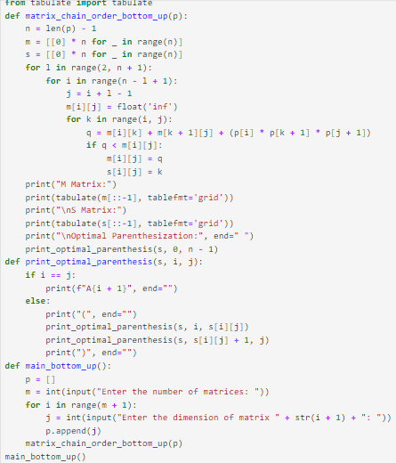**Bottom-Up (Iterative) Approach Top-Down (Recursive with**

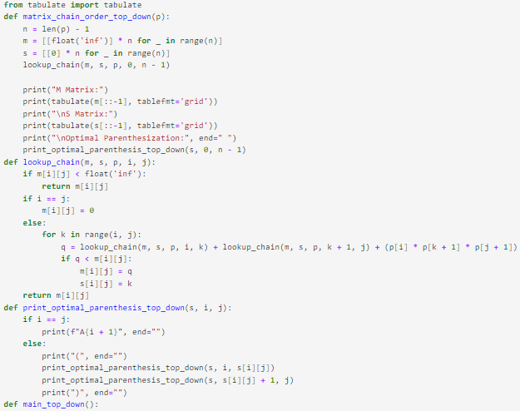 **Memoization) Approach)**

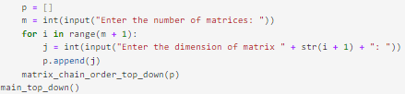

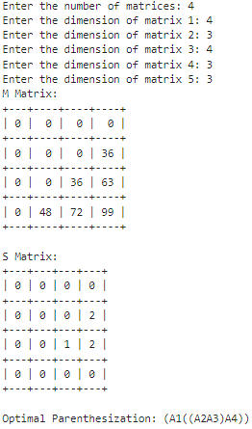 **Case 1**

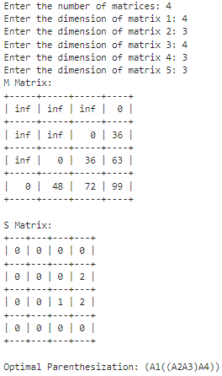

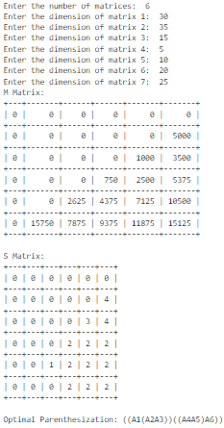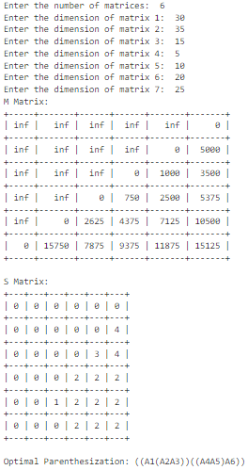 **Case 2**

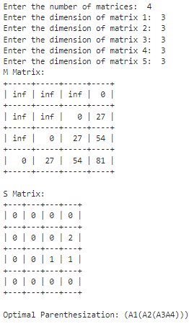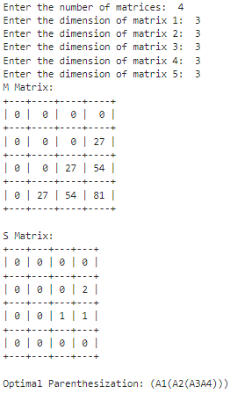 **Case 3**

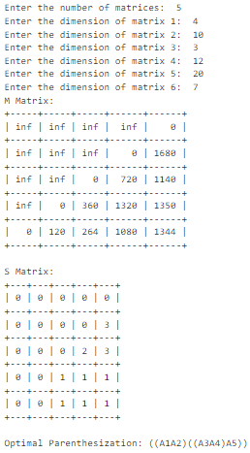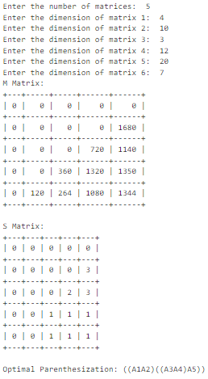 **Case 4**

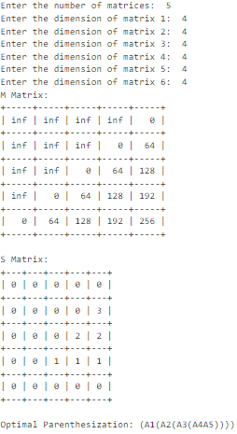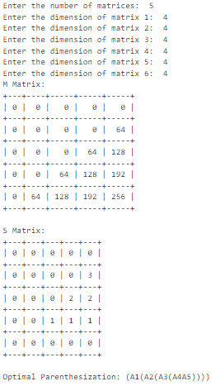 **Case 5**

**Analysis:**

Both bottom-up and top-down approaches aim to find the optimal way to parenthesize a chain of matrices to minimize the number of scalar multiplications needed.

**I. Bottom-Up Approach:**

**Space Complexity:**

* O(n^2), where n is the number of matrices.

**Description:**

* The `matrix_chain_order_bottom_up` function iterates over all possible subproblems from smaller to larger, filling up the matrices `m` and `s` to compute the minimum number of scalar multiplications needed.
* The `print_optimal_parenthesis` function recursively prints the optimal parenthesization using the split matrix `s`.
* The `tabulate` module is imported to visually represent the matrices `m` and `s`, providing a clear depiction of the dynamic programming table.

**II. Top-Down Approach:**

**Space Complexity:**

* O(n^2), where n is the number of matrices.

**Description:**

* The `matrix_chain_order_top_down` function uses memoization to store computed results, avoiding redundant calculations by recursively exploring the optimal solutions for subproblems.
* The `print_optimal_parenthesis_top_down` function recursively prints the optimal parenthesization using the split matrix `s`.
* The `tabulate` module is imported to visually represent the matrices `m` and `s`, enabling a comprehensive view of the dynamic programming table.

**III. Effectiveness of Dynamic Programming in Matrix Chain Multiplication**

* Both approaches provide a clear visualization of the minimum number of scalar multiplications required and the optimal parenthesization through the use of the `tabulate` module.
* They utilize functions such as `print_optimal_parenthesis` and `print_optimal_parenthesis_top_down` to present the results in a readable format, enhancing the clarity of the output. These implementations demonstrate the effectiveness of dynamic programming in solving the Matrix Chain Multiplication problem.

**Conclusion:**

The analysis highlights the efficiency of dynamic programming in solving the Matrix Chain Multiplication problem. Both bottom-up and top-down approaches demonstrate polynomial time complexity, enabling optimal parenthesization with a time complexity of O(n^3), where n is the number of matrices. Their space complexity, O(n^2), ensures efficient memory usage, making them suitable for practical applications requiring optimal matrix multiplication strategies.

**Experiment 19**

**Analysis of Longest Common Subsequence Algorithm**

**Aim:**

The aim of analyzing the Longest Common Subsequence (LCS) algorithm is to determine its efficiency and effectiveness in finding the longest subsequence shared between two sequences.

**Description:**

**I. Overview:**

* The Longest Common Subsequence (LCS) algorithm is used to find the longest subsequence that is common to two given sequences.
* A subsequence is a sequence that can be derived from another sequence by deleting some or none of the elements without changing the order of the remaining elements.
* It's a dynamic programming problem that offers solutions for various applications like text comparison, DNA sequencing, and version control systems.

**II. Time Complexity Analysis:**

**Time Complexity:**

* O(m * n)

m: Length of the first sequence.

n: Length of the second sequence.

* The algorithm utilizes a 2D dynamic programming table to store intermediate results for each pair of elements from both sequences.
* As it iterates through each element of both sequences, the time complexity is directly proportional to the product of their lengths.

**III. Space Complexity Analysis:**

* Space Complexity: O(m * n)
* The algorithm requires a 2D dynamic programming table to store intermediate results.
* The table size is determined by the lengths of the input sequences, resulting in quadratic space complexity.

**IV. Dynamic Programming Approach:**

**1. Initialization:**

* The algorithm initializes a matrix of size (m+1) x (n+1) to store lengths of LCS for each prefix of the sequences.
* Base cases are set where either of the sequences is empty, resulting in all zeros in the corresponding row or column.

**2. Recursive Relation:**

* At each step, the algorithm compares elements of both sequences.
* If the elements are equal, it increments the LCS length by one and looks diagonally up-left in the matrix.
* If they are not equal, it takes the maximum of the LCS lengths obtained by excluding one element from either sequence, choosing the maximum of the left or top cell.

**3. Memoization:**

* Intermediate results are stored in the matrix to avoid redundant calculations.
* This memoization technique ensures that each sub problem is solved only once, optimizing the overall time complexity.

**V. Example and Application:**

**1. Example:**

* Given sequences "ABCBDAB" and "BDCAB", the LCS is "BCBA" with a length of 4.

**2. Applications:**

* LCS algorithm finds applications in bioinformatics for DNA sequence alignment, in text comparison algorithms, and in version control systems for identifying differences between files.

**VI. Recursive Equation:**

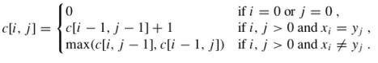

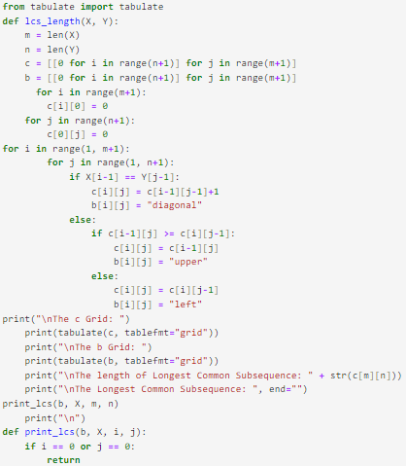**Code of Analysis of Longest Common Subsequence Algorithm (in Python):**

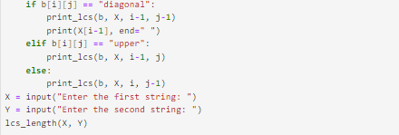

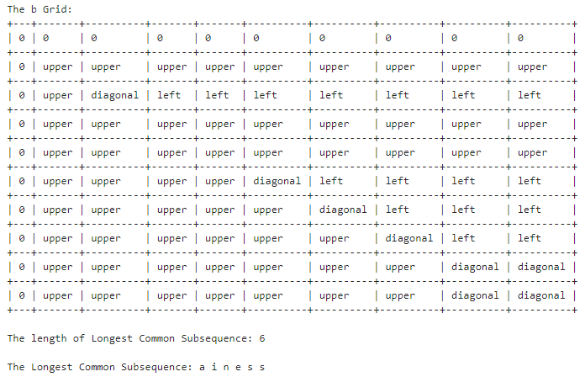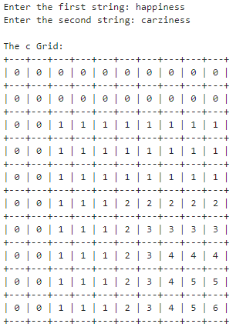 **Case 1**

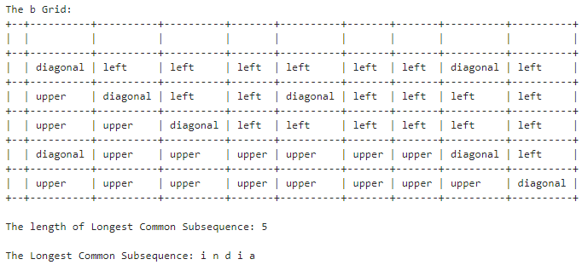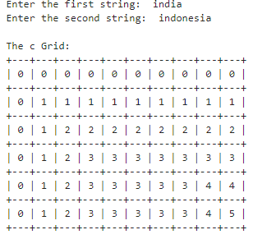 **Case 2**

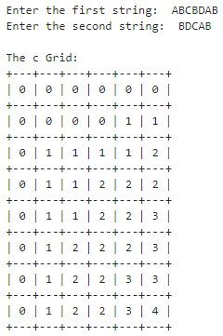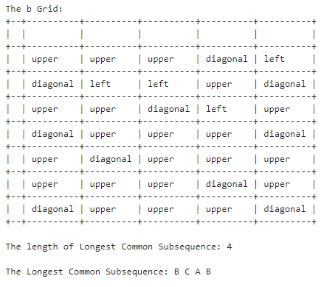 **Case 3**

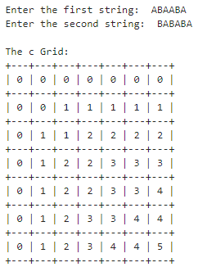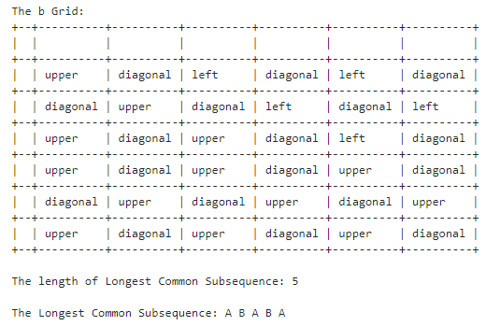 **Case 4**

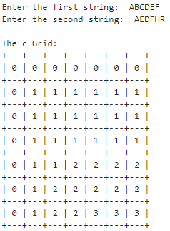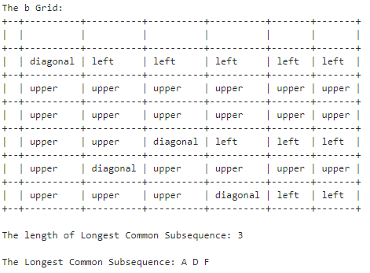 **Case 5**

**Analysis:**

**I. Function lcs_length:**

* This function calculates the length of the Longest Common Subsequence (LCS) between two input strings X and Y.
* It initializes two matrices c and b to store the length of the LCS and the directions of the subproblem solutions, respectively.
* It iterates through each element of X and Y, filling in the matrices based on whether characters match or not.
* Finally, it prints the matrices c and b, the length of the LCS, and the LCS itself.

**II. Function print_lcs:**

* This recursive function prints the LCS by tracing back the directions stored in matrix b.
* It starts from the bottom-right cell of matrix b and recursively moves towards the top-left cell, printing characters that contribute to the LCS.

**III. Time Complexity:**

* The time complexity of the algorithm is O(m * n), where m and n are the lengths of strings X and Y, respectively.
* This is because the algorithm fills in an m x n matrix (c) and b matrix, each taking constant time per cell update.

**IV. Space Complexity:**

* The space complexity of the algorithm is also O(m * n).
* This is due to the creation of matrices c and b, each requiring m x n space to store intermediate results.

**V. Strengths:**

* The algorithm efficiently computes the LCS between two strings using dynamic programming, providing an optimal solution.
* It utilizes tabulation to store intermediate results, reducing redundant calculations and improving efficiency.

**VI. Weaknesses:**

* The recursive nature of the print_lcs function may lead to stack overflow for extremely long LCSs or input strings.
* The algorithm does not provide information about multiple LCSs if they exist.

**Conclusion:**

The Longest Common Subsequence (LCS) algorithm efficiently determines the longest shared subsequence between two strings through dynamic programming. With a time and space complexity of O(m * n), where m and n are the lengths of the input strings, it provides an optimal solution. While it effectively computes the LCS length and sequence, the recursive printing function may face limitations with extremely long LCSs or input strings.

**Experiment 20**

**Analysis of 0/1 Knapsack Algorithm**

**Aim:**

The aim of the analysis of the 0/1 Knapsack algorithm is to evaluate the knapsack problem, where given a set of items each with a weight and a value, the algorithm determines the most valuable combination of items to include in a knapsack of limited capacity, while ensuring that the total weight does not exceed the capacity.

**Description:**

**I. Overview:**

* The 0/1 Knapsack problem is a classic optimization problem where a set of items have associated values and weights, and the goal is to determine the subset of items to include in a knapsack to maximize the total value without exceeding the knapsack's capacity.
* This problem is NP-hard, but dynamic programming offers an efficient solution to find the optimal subset.

**II. Time Complexity Analysis:**

**Time Complexity:**

* O(2^n)

n: Number of items

* The time complexity arises from filling in a 2D dynamic programming table of size (n+1) x (W+1).
* W: Knapsack capacity
* For each item and each possible capacity, a constant-time operation is performed, resulting in a time complexity proportional to the product of the number of items and the knapsack capacity.

**III. Space Complexity Analysis:**

**1. Space Complexity:**

* O(nW)
* The space complexity is determined by the size of the dynamic programming table.
* As the table size grows with the number of items and the knapsack capacity, the space complexity is proportional to the product of these values.

**IV. Dynamic Programming Approach:**

**1. Initialization:**

* The algorithm initializes a 2D table to store the maximum values achievable for different subproblems.
* Base cases are set for zero items or zero capacity, resulting in zeros in the corresponding rows or columns.

**V. Recursive Relation:**

* At each step, the algorithm considers whether to include the current item or not.
* If the current item's weight exceeds the remaining capacity, the algorithm skips it and takes the maximum value achieved without the item.
* Otherwise, it compares the value obtained by including the item with the value obtained without the item and chooses the maximum.

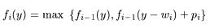

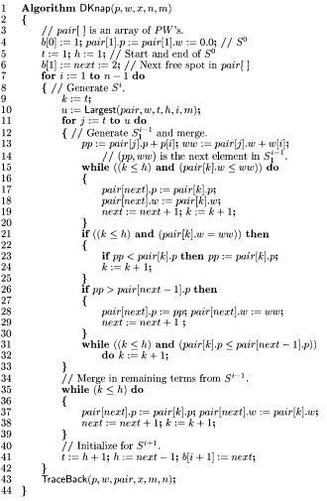**VI. Algorithm:**

**Code of Analysis of 0/1 Knapsack Algorithm (in Python) using 4 approaches (Top-down approach,** **Bottom-up approach, 1 D array approach and One row approach):**

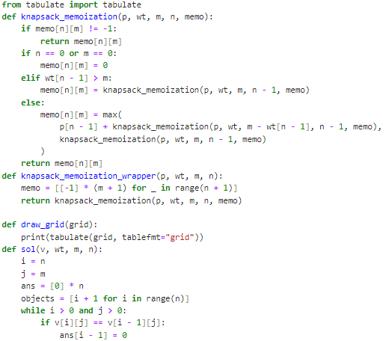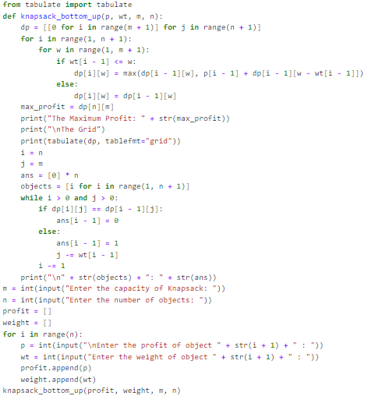 **I. Top-Down Approach II. Bottom-up Approach**

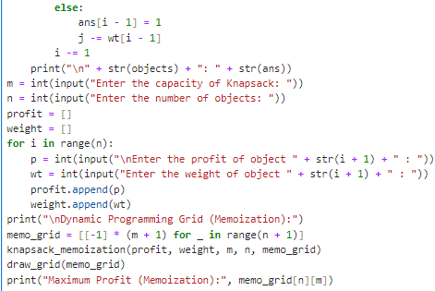

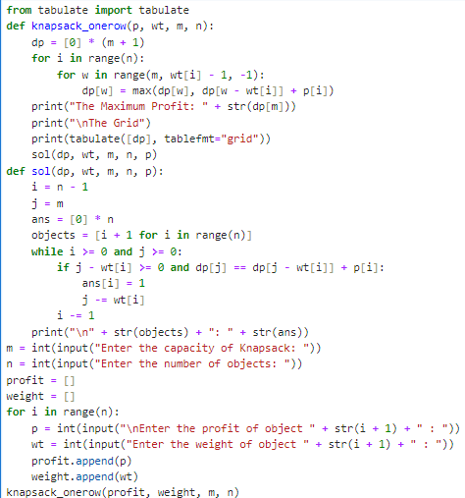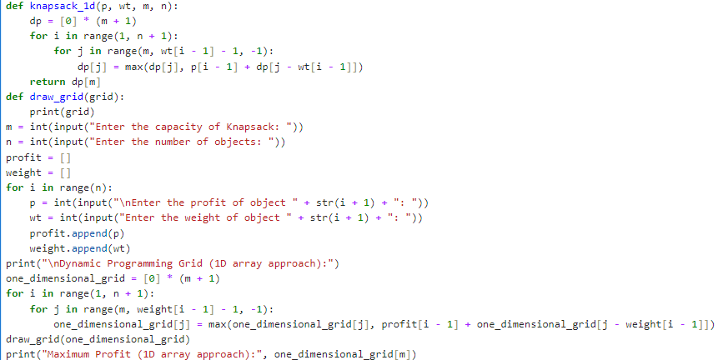**III. 1-D array Approach IV. One row Approach**

**Case 1**

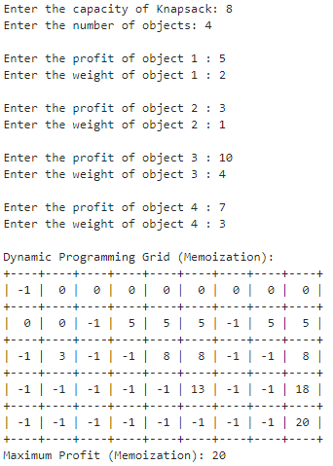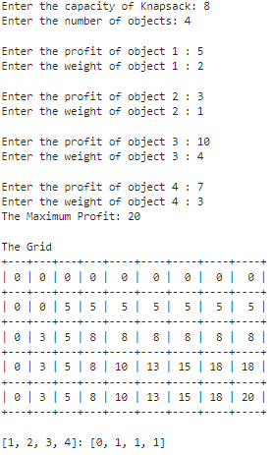**I. Top-Down Approach II. Bottom-up Approach**

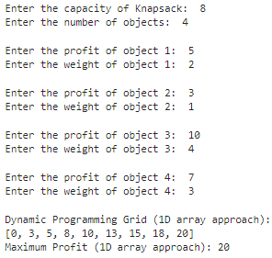**III. 1-D array Approach IV. One row Approach**

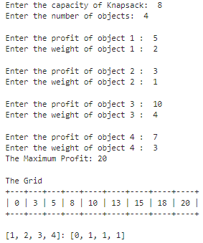

**Case 2**

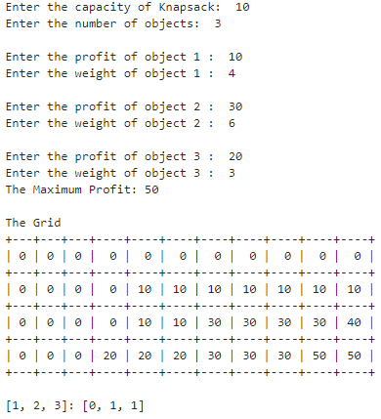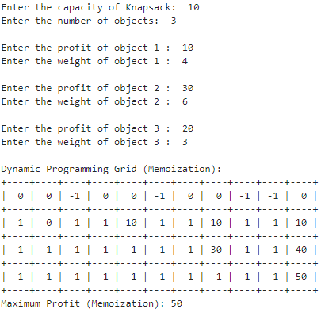**I. Top-Down Approach II. Bottom-up Approach**

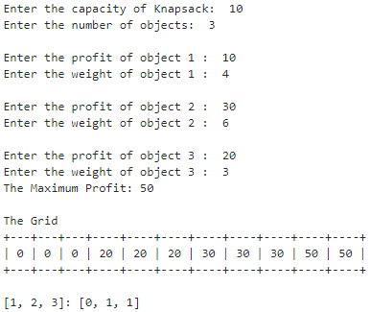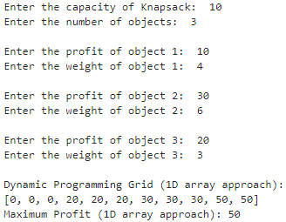**III. 1-D array Approach IV. One row Approach**

**Case 3**

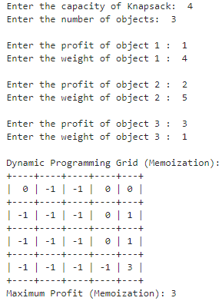**I. Top-Down Approach II. Bottom-up Approach**

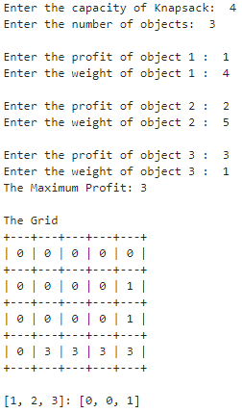

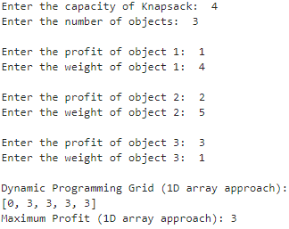**III. 1-D array Approach IV. One row Approach**

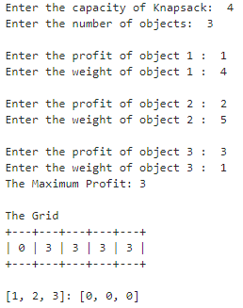

**Analysis:**

**I. Top-down Approach with Memoization**:

**1. Algorithm Overview:**

* The top-down approach solves the problem recursively, breaking it down into smaller subproblems.
* Memoization is used to store the results of solved subproblems to avoid redundant computations.

**2. Key Components:**

* Recursive function with memoization to compute the maximum profit.
* Memoization table to store computed results.

**3. Performance:**

* **Time complexity:**

O(n * W), where n is the number of items and W is the capacity of the knapsack.

* **Space complexity:**

O(n * W) for the memoization table.

**II. Bottom-up Approach:**

**1. Algorithm Overview:**

* The bottom-up approach iteratively fills a table by solving subproblems in a bottom-up manner.
* It avoids recursion and directly computes the solution from smaller subproblems to larger ones.

**2. Key Components:**

* Dynamic programming table to store solutions to subproblems.
* Nested loops to fill the table iteratively.

**3. Performance:**

* **Time complexity:**

O(n * W), where n is the number of items and W is the capacity of the knapsack.

* **Space complexity:**

O(n * W) for the dynamic programming table.

**III. One-dimensional Array Approach:**

**1. Algorithm Overview:**

* This approach optimizes space usage by maintaining only a one-dimensional array instead of a 2D table.
* It iterates through items and weights, updating the array in-place.

**2. Key Components:**

* One-dimensional array to store solutions for each weight.
* Single loop for weights inside a loop for items.

**3. Performance:**

* **Time complexity:**

O(n * W), where n is the number of items and W is the capacity of the knapsack.

* **Space complexity**:

O(W) for the one-dimensional array.

**IV. One-row Approach:**

**1. Algorithm Overview:**

* Similar to the one-dimensional array approach, but further optimizes space by using only one row.
* It iterates through items and weights, updating the same array in-place.

**2. Key Components:**

* Single one-dimensional array to store solutions for each weight.
* Iterative loop for items and weights.

**3. Performance:**

* **Time complexity:**

O(n * W), where n is the number of items and W is the capacity of the knapsack.

* **Space complexity:**

O(W) for the one-dimensional array.

**Conclusion:**

While all approaches offer the same time complexity of O(n * W), they differ in their space efficiency and implementation complexity. The top-down approach provides clarity through recursion and memoization, while the bottom-up approach offers a more efficient use of memory. The optimized one-dimensional and one-row approaches further reduce memory overhead, making them suitable for scenarios with limited memory resources.

**Experiment 21**

**Analysis of N-Queen Problem**

**Aim:**

The aim of the analysis of the N-Queen problem is to determine all possible ways to place N queens on an N×N chessboard such that no two queens threaten each other, achieved through algorithmic approaches like backtracking to efficiently explore the solution space and optimize performance.

**Description:**

**Analysis of the N-Queens Problem**

**I. Problem Definition:**

* The N-Queens problem involves placing N queens on an N×N chessboard such that no two queens threaten each other.

**II. Constraint Identification:**

* Queens cannot share the same row, column, or diagonal.

**III. Search Space:**

* Represents all possible configurations of queens on the chessboard.
* Size of search space grows exponentially with the size of the chessboard: O(N!) or O(N^N).

**IV. Time Complexity:**

* Most algorithms have exponential time complexity due to the large search space.
* Typically O(N!) or O(N^N).
* Optimizations can reduce effective search space and improve performance.

**V. Space Complexity:**

* Space complexity depends on the algorithm and data structures used.
* Typically O(N) to store the board state.
* Additional space may be required for auxiliary data structures.

**VI. Recurrence Relation:**

* Let T(N) be the time complexity of solving the N-Queens problem.
* The recurrence relation for T(N) can be expressed as:

T(N)=N×T(N−1)

* This represents the time taken to solve the problem of size N in terms of solving the problem of size N−1 and placing one additional queen.
* The total number of nodes in the 8-queens state space tree is

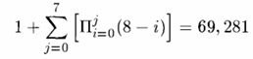

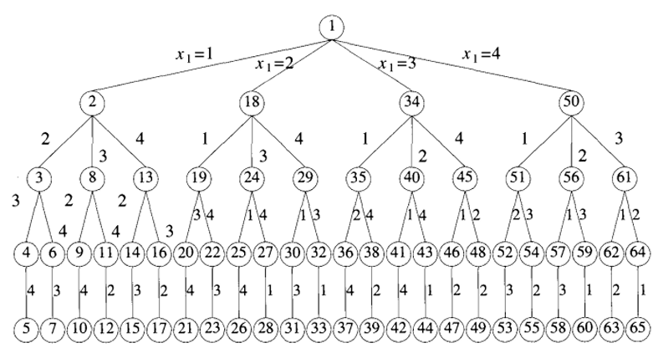**VII. State Space Tree for 4-Queens:**

**VIII.** **Algorithm For N-Queen Problem:**

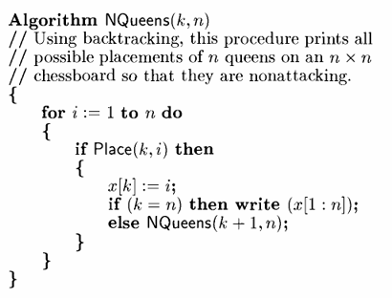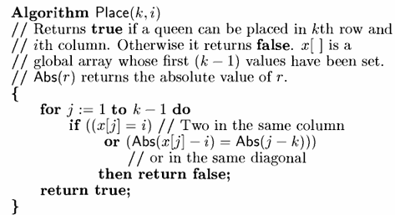

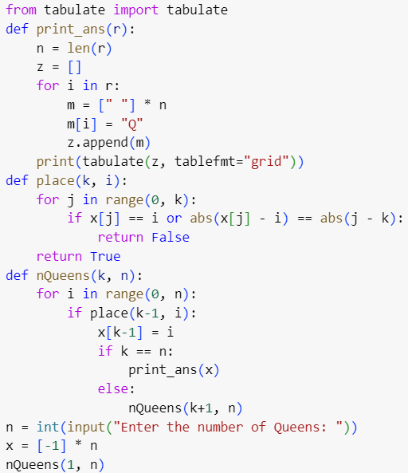**Code of Analysis of N-Queen Problem (in Python):**

**Case 1:**

**4-Queen Problem**

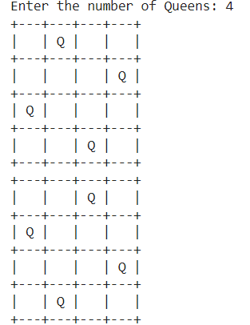

**Case 2:**

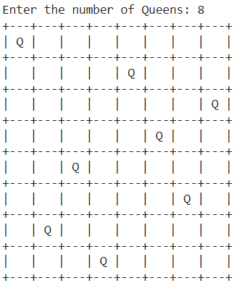**8-Queen Problem**

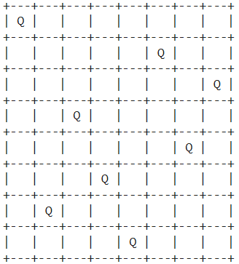

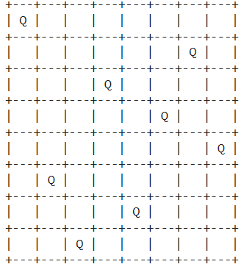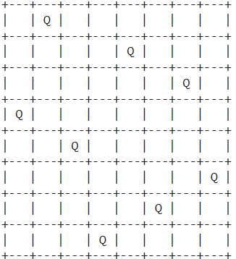

**Case 3: Case 4:**

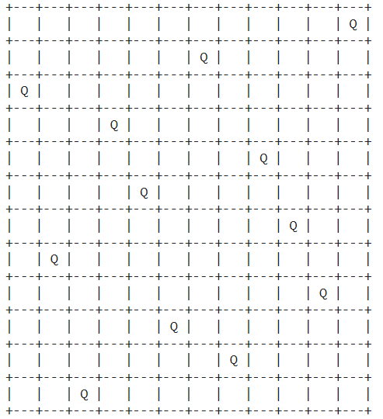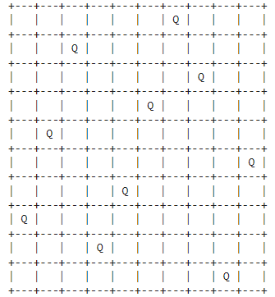**10-Queen Problem 12-Queen Problem**

**Case 5:**

**16-Queen Problem**

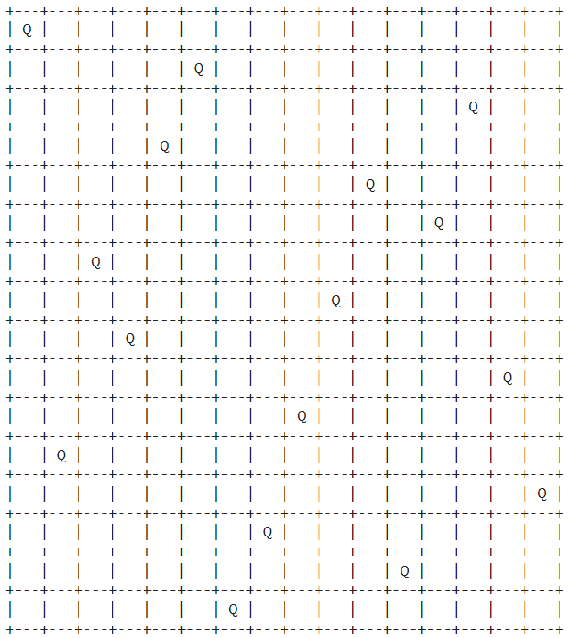

**Analysis:**

**I. Code Overview:**

* This Python code solves the N-Queens problem using a recursive backtracking algorithm.
* It generates and prints all possible configurations of N queens on an N×N chessboard where no two queens threaten each other.

**II. Functionality Breakdown:**

**1. print_ans(r) Function:**

* This function generates a visual representation of the chessboard with queens placed on it.
* It takes a list r as input, where each element represents the column position of a queen in the corresponding row.
* The function utilizes the tabulate library to format and print the chessboard.

**2. place(k, i) Function:**

* This function checks whether it's safe to place a queen in the k-th row and i-th column.
* It iterates through the previously placed queens (from 0 to k-1) and checks for conflicts.
* Conflicts occur if two queens share the same column or diagonal.

**3. nQueens(k, n) Function:**

* This recursive function attempts to place queens in each row (k) of the chessboard.
* It tries every column (i) in the current row and checks if placing a queen there is safe using the place function.
* If a safe position is found, it updates the board configuration and recursively calls itself for the next row.
* If all queens are successfully placed (k == n), it prints the solution.

**III. Code Execution Flow:**

* The code prompts the user to input the number of queens (n) they want to place.
* It initializes an array x to store the column positions of the queens. Initially, all positions are set to -1.
* It calls the nQueens function with the initial parameters (k = 1 and n provided by the user) to start solving the problem.
* The nQueens function recursively explores all possible configurations of queens on the board.

**IV. Key Points:**

* The code utilizes a backtracking algorithm to efficiently explore the solution space.
* It avoids unnecessary exploration of configurations that are guaranteed to fail.
* The use of the tabulate library enhances the readability of the output by presenting solutions in a structured format.
* The code demonstrates good modularization by separating concerns into functions for checking positions (place), printing solutions (print_ans), and solving the problem (nQueens).

**V. Complexity Analysis:**

**1. Time Complexity:**

* The time complexity of the solution is exponential, as it explores all possible arrangements of queens on the chessboard.
* In the worst case, the algorithm examines all possible combinations of queen placements, resulting in a time complexity of O(N!), where N is the number of queens.

**2. Space Complexity:**

* The space complexity of the solution is O(N), where N is the number of queens.
* Additionally, recursive calls consume space on the call stack, but the maximum depth of recursion is bounded by N, corresponding to the number of rows on the chessboard. Therefore, the overall space complexity is O(N).

**Conclusion:**

The N-Queens problem solver efficiently explores all possible queen placements on an N×N chessboard using a backtracking algorithm. Despite its exponential time complexity of O(N!), where N is the number of queens, the algorithm prunes many configurations, leading to reasonable runtime performance for small values of N. With a space complexity of O(N), the solution effectively balances computational resources while providing optimal and correct solutions for the problem.

**Experiment 22**

**Analysis of Graph Coloring Problem**

**Aim:**

The aim of the analysis of the graph coloring problem is to determine the minimum number of colors required to color the vertices of a graph such that no two adjacent vertices share the same color, or to identify if such a coloring is possible.

**Description:**

**Graph Coloring Problem Analysis**

**I. Problem Statement**

* Define the graph coloring problem, where the goal is to assign colors to vertices of a graph in such a way that no two adjacent vertices share the same color.

**II. Backtracking Approach**

**1. Overview**

* Describe the backtracking approach as a systematic method for exploring all possible solutions by recursively trying different choices and backtracking when a dead end is encountered.

**2. Algorithm**

* Present the backtracking algorithm for graph coloring, which explores all possible color assignments for each vertex and backtracks when a conflict is detected.

**3. Implementation**

* Provide code implementing the backtracking approach for the graph coloring problem, where colors are assigned recursively, and backtracking is performed when conflicts arise.

**4. Analysis**

* Discuss the time complexity of the backtracking algorithm, which explores all possible color assignments.
* Highlight the exponential nature of the time complexity, making it impractical for large graphs.

**III. Greedy Algorithm Approach**

**1. Overview**

* Introduce the greedy algorithm approach as a heuristic method for graph coloring, where vertices are colored one by one based on a certain criterion without considering future consequences.

**2. Algorithm**

* Present the greedy algorithm for graph coloring, where vertices are colored sequentially, and each vertex is assigned the lowest possible color that is not used by its neighbors.

**3. Implementation**

* Provide code implementing the greedy algorithm approach for the graph coloring problem, where vertices are colored greedily based on the given criterion.

**4. Analysis**

* Discuss the time complexity of the greedy algorithm, which typically has a polynomial time complexity compared to the exponential complexity of the backtracking approach.
* Highlight the trade-off between the speed of the greedy algorithm and its potential for producing suboptimal colorings compared to the optimal solutions found by backtracking

**IV. Complexity Analysis O(nm^n)**:

* n: Number of vertices in the graph.
* m: Maximum degree of any vertex in the graph.

**1. Backtracking Approach**

**i) Time Complexity:**

* In the worst case, each vertex can have up to m possible colors to choose from.
* For each vertex, we recursively explore all possible color assignments, resulting in m^n combinations.
* Since there are n vertices in the graph, the overall time complexity is O(nm^n).

**ii) Space Complexity:**

* The space complexity of the backtracking approach primarily depends on the depth of the recursion stack, which is proportional to the number of vertices.
* Thus, the space complexity is O(n) in this case.

**2. Greedy Algorithm Approach**

**i) Time Complexity:**

* The time complexity of the greedy algorithm depends on the method used to select colors for vertices.
* In general, the greedy algorithm iterates through each vertex and assigns the lowest possible color not used by its neighbors.
* Each vertex may need to inspect its neighbors, resulting in O(m) time complexity per vertex.
* As there are n vertices in the graph, the overall time complexity is O(nm).

**ii) Space Complexity:**

* The space complexity of the greedy algorithm is typically lower than that of the backtracking approach since it does not involve recursive calls.
* The main space usage is for storing the color assignments for each vertex, resulting in a space complexity of O(n).

**3. Comparison**

* The backtracking approach has an exponential time complexity O(nm^n), making it impractical for large graphs due to its exhaustive search.
* The greedy algorithm approach has a polynomial time complexity O(nm), which is more efficient but may produce suboptimal colorings compared to the backtracking approach.
* The choice between the two approaches depends on factors such as the size of the graph, the need for optimal solutions, and the available resources for computation.

**V. State Space Tree for mColoring when n=3and m=3:**

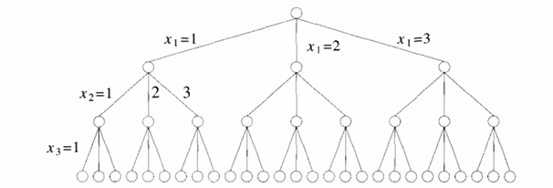

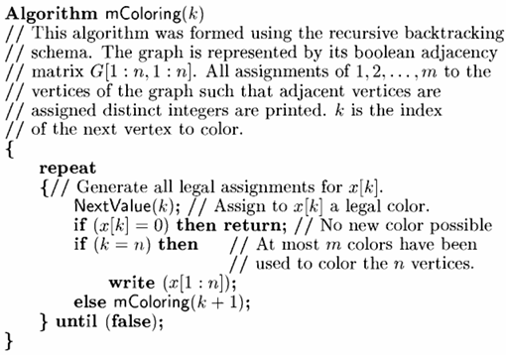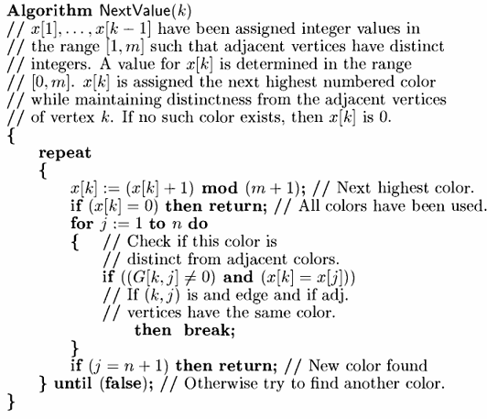**VI. Algorithm For Graph Coloring Problem:**

**Code of Analysis of Graph Coloring Problem (in Python):**

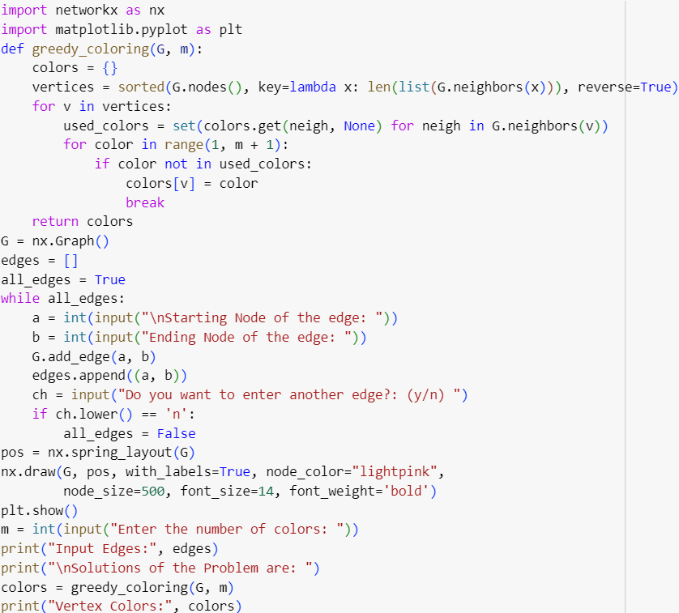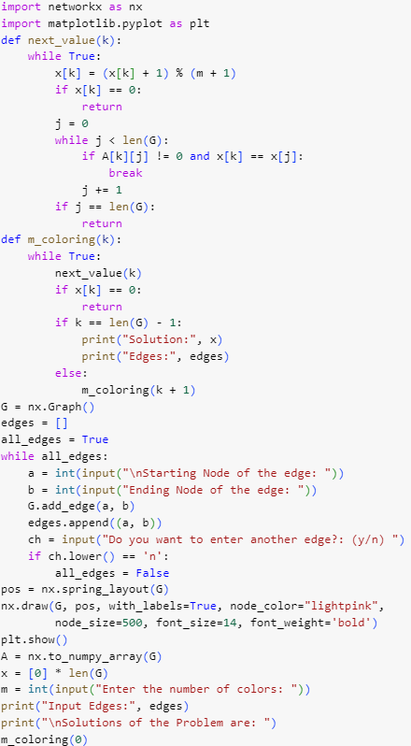**I. Backtracking approach II. Greedy Algorithm approach**

**Case 1:**

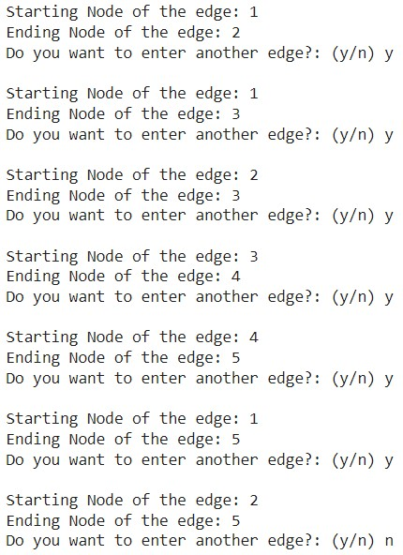**I. Backtracking approach II. Greedy Algorithm approach**

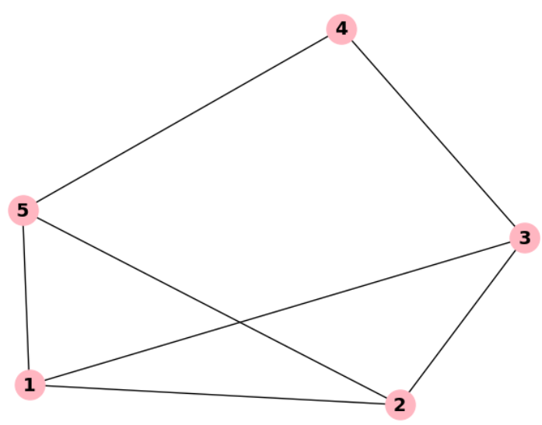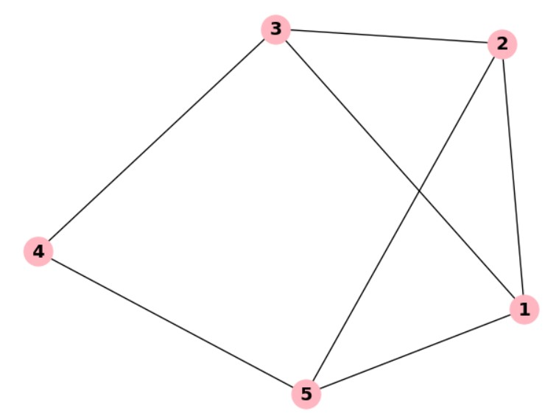

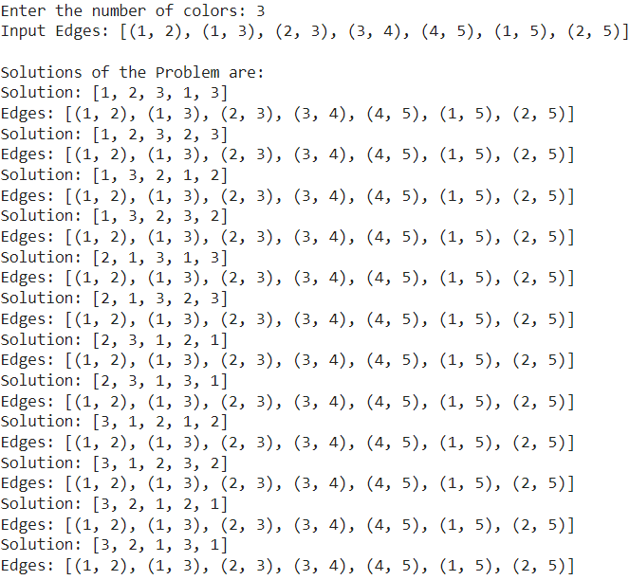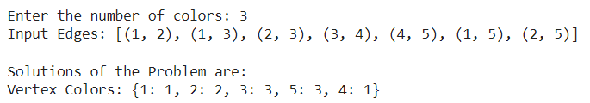

**Case 2:**

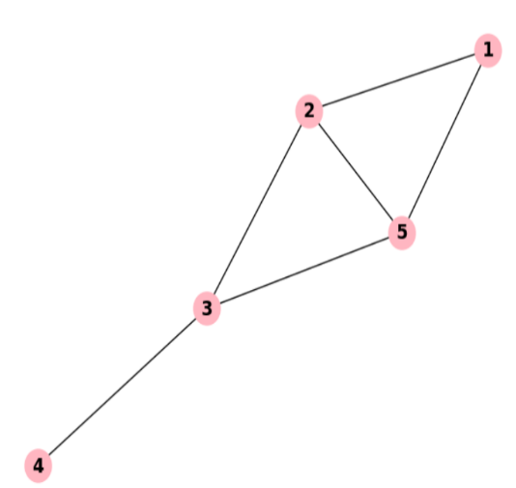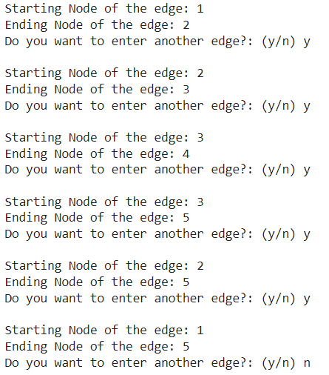**I. Backtracking approach II. Greedy Algorithm approach**

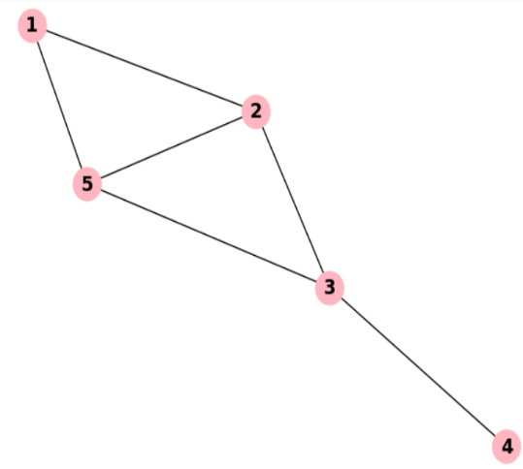

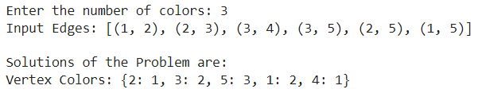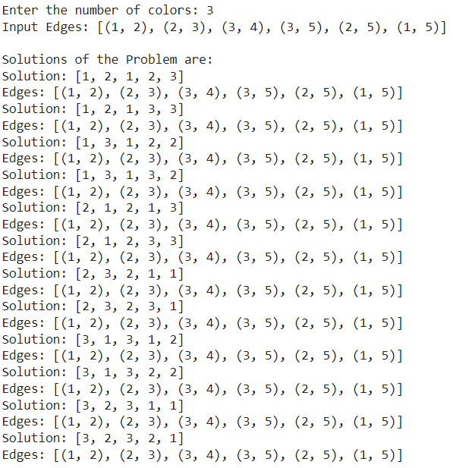

**Case 3:**

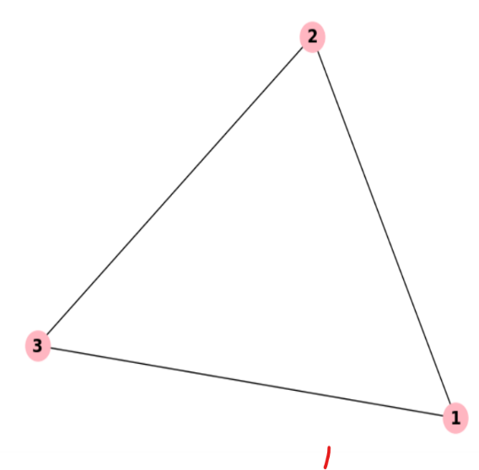**I. Backtracking approach II. Greedy Algorithm approach**

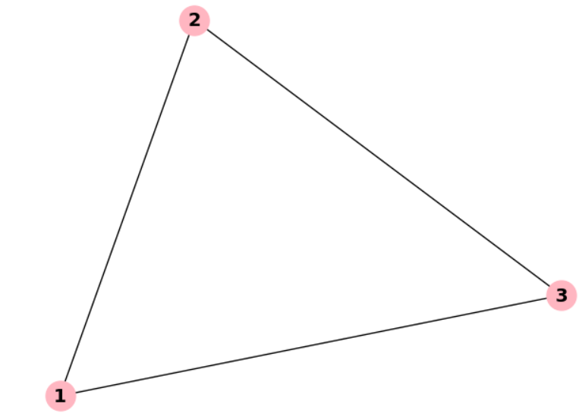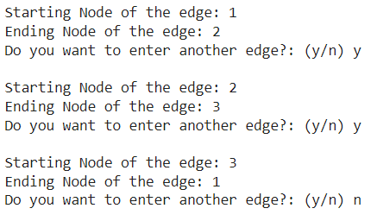

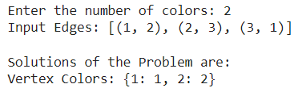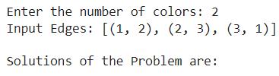

**Case 4:**

**I. Backtracking approach II. Greedy Algorithm approach**

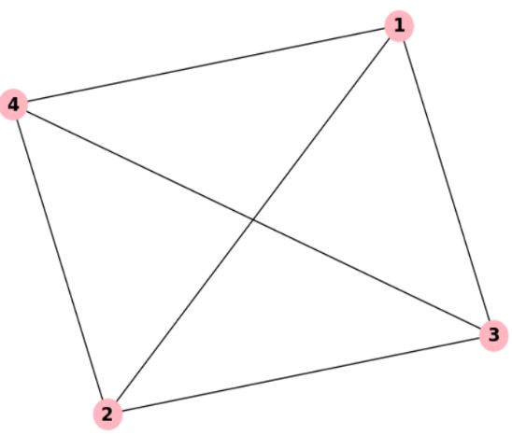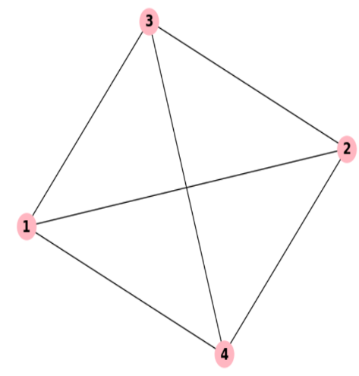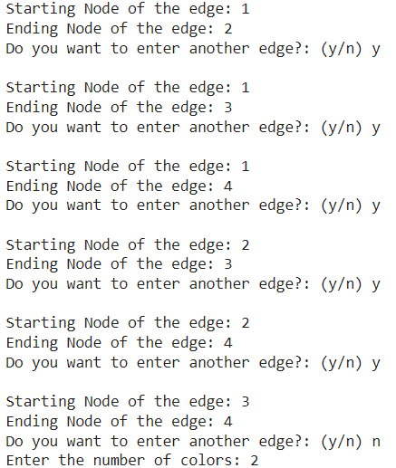

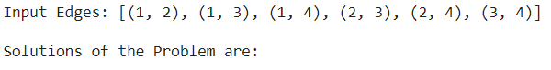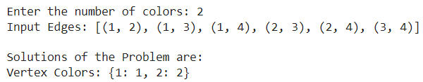

**Case 5:**

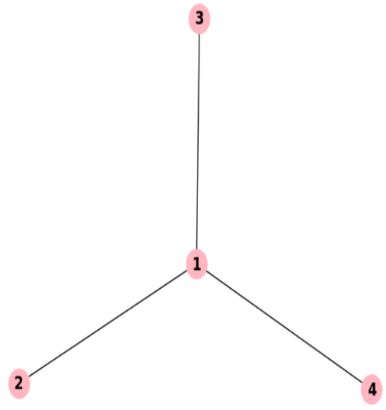**I. Backtracking approach II. Greedy Algorithm approach**

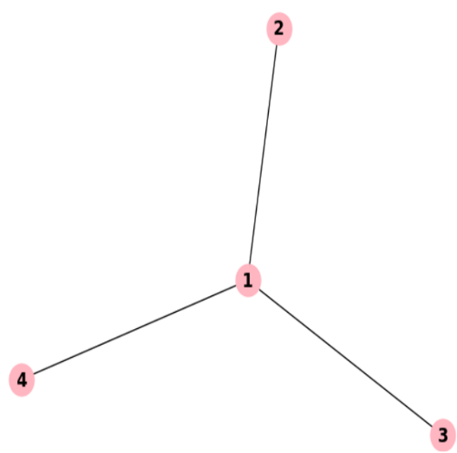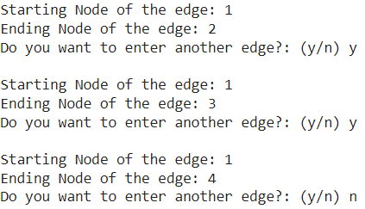

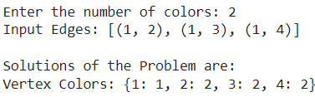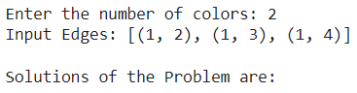

**Analysis:**

**I. Backtracking Approach:**

**1. Description:**

* The backtracking approach systematically explores all possible color assignments to vertices to find a valid coloring where adjacent vertices have different colors.

**2. Code Description:**

**i) next_value(k):**

* Finds the next valid color for the vertex k.

**ii) m_coloring(k):**

* Backtracking function to find a valid coloring.
* It iterates through all possible color assignments for each vertex using recursion.

**iii)** The function next_value(k) ensures that the chosen color for vertex k doesn't conflict with the colors of its adjacent vertices.

**3. Complexity Analysis:**

**i) Time Complexity:**

* Exponential, O(m^N), where N is the number of vertices and m is the number of available colors.

**ii) Space Complexity:**

* O(N), where N is the depth of the recursion stack.

**II. Greedy Algorithm Approach:**

**1. Description:**

* The greedy algorithm selects the next vertex to color based on a heuristic without considering future consequences.

**2. Code Description:**

**i) greedy_coloring(G, m):**

* Greedy function to find a valid coloring.
* It iterates through each vertex and assigns the smallest possible color not already used by its neighbors.

**3. Complexity Analysis:**

**i) Time Complexity:**

* O(N^2), where N is the number of vertices.

**ii) Space Complexity:**

* O(N), for storing the colors assigned to each vertex.

**III. Comparison:**

* Backtracking guarantees a valid coloring if it exists but can be slow for large graphs.
* The greedy algorithm is faster but may not always find a valid coloring and can produce suboptimal results.

**Conclusion:**

The backtracking approach guarantees a valid coloring but is slow for large graphs due to its exponential time complexity, while the greedy algorithm is faster but may not always find an optimal solution. For small to medium-sized graphs, the greedy algorithm provides a quick solution, while the backtracking approach is better for larger graphs or when optimality is crucial.

**Experiment 23**

**Analysis of Sum of Subsets Problem**

**Aim:**

The aim of analyzing the sum of subsets problem is to efficiently determine whether a subset of a given set of numbers sums up to a particular target value, often leveraging dynamic programming or recursive strategies to optimize computational complexity.

**Description:**

**Sum of Subsets Problem Analysis**

**I. Backtracking:**

**1. Approach:**

* Backtracking involves systematically exploring all possible solutions to a problem. It starts with an initial solution candidate and incrementally builds upon it, removing choices that don't lead to a valid solution.

**2. Algorithm:**

* In the case of Subset Sum, the backtracking algorithm would start with an empty subset and recursively explore adding each element to the subset or excluding it. If the current subset sums up to the target, it's a valid solution; otherwise, the algorithm continues exploring different combinations.

**3. Complexity Analysis:**

**i) Time Complexity:**

* Exponential, O(2^N), where N is the number of elements in the input set. This is because the algorithm explores all possible subsets.

**ii) Space Complexity:**

* O(N), where N is the depth of the recursion stack.

**II. Dynamic Programming (DP):**

**1. Approach:**

* DP involves breaking down a complex problem into simpler subproblems and solving each subproblem only once, storing the solutions to avoid redundant calculations.

**2. Algorithm:**

* For Subset Sum, a typical DP approach involves creating a 2D array where dp[i][j] represents whether there exists a subset of the first i elements that sums up to j. The recurrence relation can be defined based on whether the current element is included or excluded.

**3. Complexity Analysis:**

**i) Time Complexity:**

* O(N * S), where N is the number of elements in the input set and S is the target sum. This is because we fill up a 2D table of size N * S.

**ii) Space Complexity:**

* O(N * S), for the DP table.

**III. Sliding Window Concept:**

**1. Approach:**

* The sliding window technique involves maintaining a window of variable size over a sequence and moving it incrementally to find the desired result.

**2. Algorithm:**

* For Subset Sum, we can use a sliding window approach by maintaining a window that starts from the beginning of the array. We continuously expand the window until the sum of elements within the window exceeds the target, then we shrink the window from the beginning until the sum falls below the target.

**3. Complexity Analysis:**

**i) Time Complexity:**

* O(N), where N is the number of elements in the input set. This is because each element is visited at most once.

**ii) Space Complexity:**

* O(1), as the algorithm doesn't require any extra space apart from a few variables to keep track of indices and sums.

**IV. State Space Tree for desired sum=30 given positive integers = [5,10,12,13,15,18];**

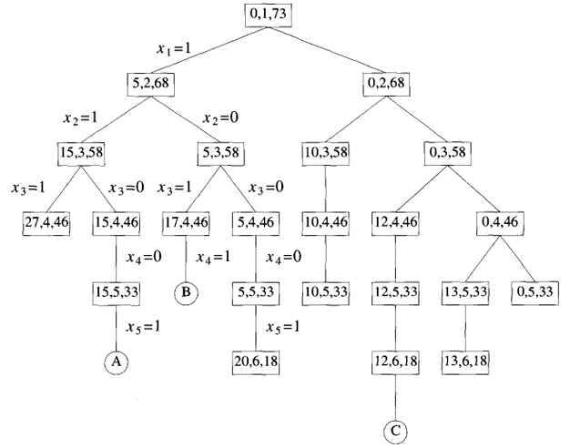

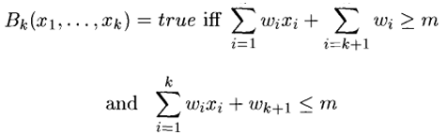**V. Bounding Functions used:**

**VI. Algorithm For Graph Coloring Problem:**

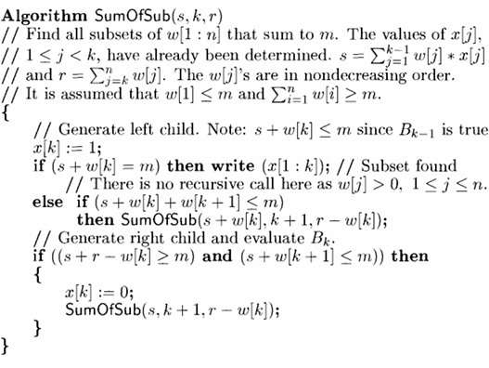

**Code of Analysis of Sum of Subsets Problem (in Python):**

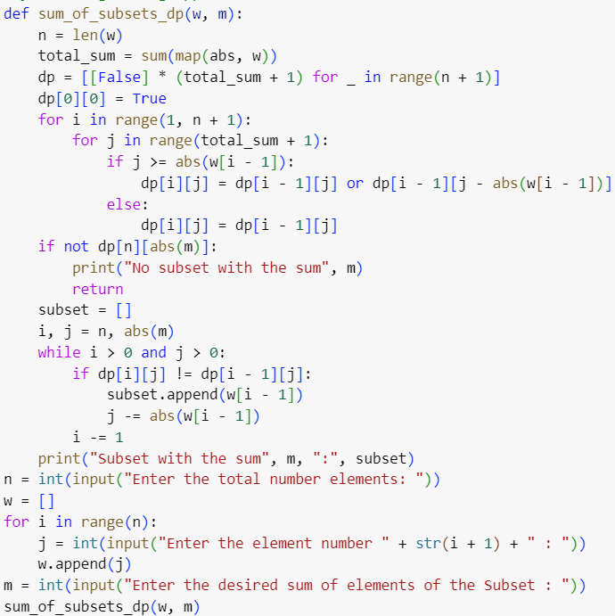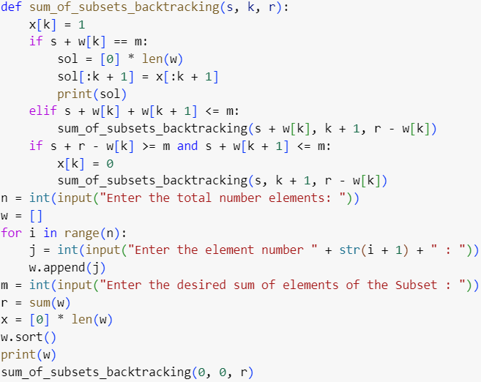**I. Backtracking approach II. Dynamic Programming approach**

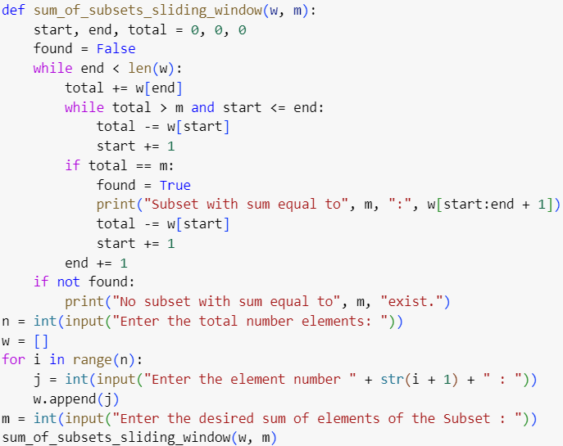 **III. Sliding Window approach**

**Case 1:**

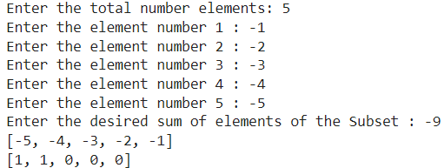**I. Backtracking approach II. Dynamic Programming approach**

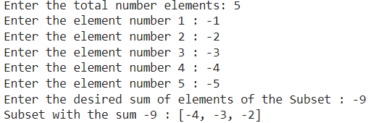

**III. Sliding Window approach**

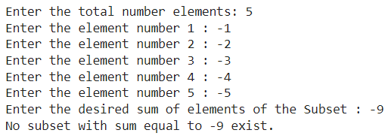

**Case 2:**

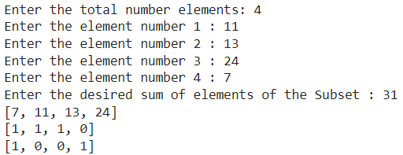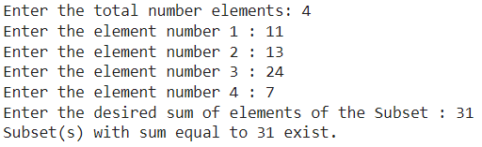**I. Backtracking approach II. Dynamic Programming approach**

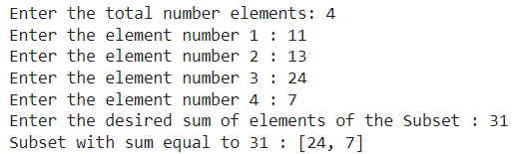**III. Sliding Window approach**

**Case 3:**

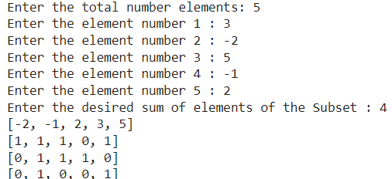**I. Backtracking approach II. Dynamic Programming approach**

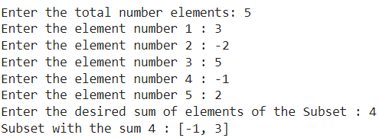

**III. Sliding Window approach**

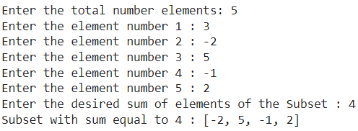

**Case 4:**

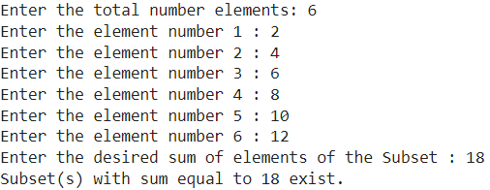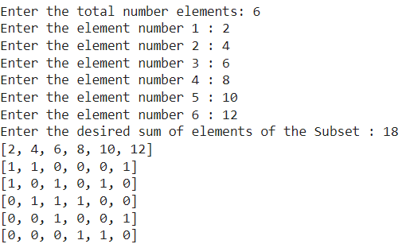**I. Backtracking approach II. Dynamic Programming approach**

**III. Sliding Window approach**

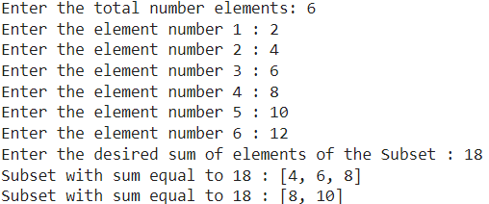

**Case 5:**

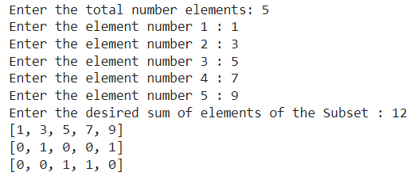**I. Backtracking approach II. Dynamic Programming approach**

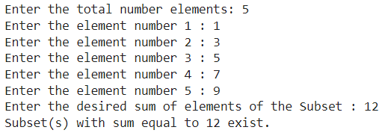

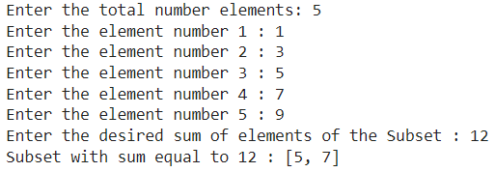**III. Sliding Window approach**

**Analysis:**

**I. Backtracking Approach**

**1. Description:**

The backtracking approach systematically explores all possible subsets to find the subset with the desired sum.

**2. Recurrence Relation:**

The recurrence relation is defined recursively based on whether the current element is included or excluded in the subset. It explores all possible combinations.

**3. Complexity Analysis:**

**i) Time Complexity:**

Exponential, O(2^N), where N is the number of elements in the input set. This is because the algorithm explores all possible subsets.

**ii) Space Complexity:**

O(N), where N is the depth of the recursion stack.

**II. Dynamic Programming Approach**

**1. Description:**

Dynamic Programming breaks down the problem into simpler subproblems and solves each subproblem only once, storing the solutions to avoid redundant calculations.

**2. Algorithm:**

Uses a 2D array to store whether a subset with a particular sum exists. It fills up the table iteratively.

**3. Complexity Analysis:**

**i) Time Complexity:**

O(N * S), where N is the number of elements in the input set and S is the target sum. This is because we fill up a 2D table of size N * S.

**ii) Space Complexity:**

O(N * S), for the DP table.

**III. Sliding Window Approach**

**1. Description:**

The sliding window technique maintains a window of variable size over a sequence and moves it incrementally to find the desired result.

**2. Algorithm:**

Maintains two pointers, start and end, and a variable to track the sum of elements within the window. It slides the window to find subsets with the desired sum.

**3. Complexity Analysis:**

**i) Time Complexity:**

O(N), where N is the number of elements in the input set. Each element is visited at most once.

**ii) Space Complexity:**

O(1), as the algorithm doesn't require any extra space apart from a few variables.

**Conclusion:**

The Subset Sum problem can be efficiently solved using different approaches. Backtracking offers a simple but exponential-time solution, making it suitable for small inputs. Dynamic Programming provides a more efficient polynomial-time solution, utilizing extra space for storing intermediate results. The sliding window approach strikes a balance between efficiency and space usage, making it suitable for certain scenarios with linear time complexity and constant space overhead.